WWF-MONGOLIA STRATEGIC PLAN
FY17-21
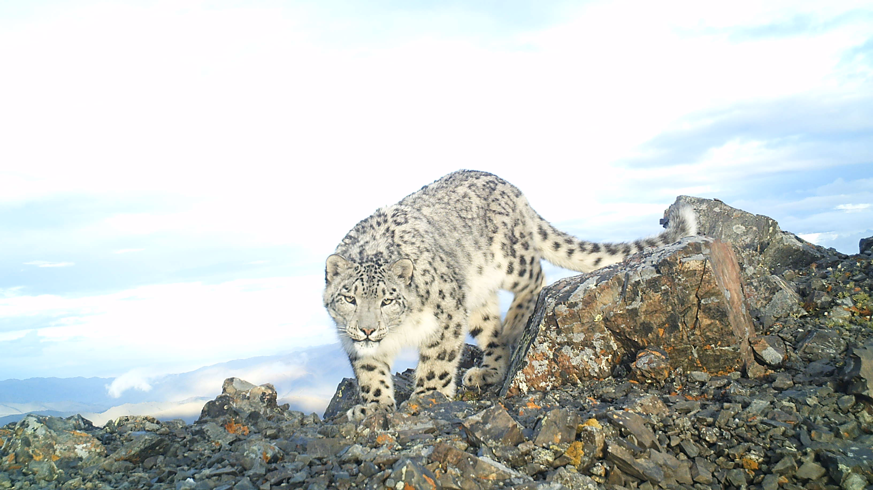

(Version 4.01. Full version)
Ulaanbaatar, Mongolia
Contents
Abbreviations 3
Executive summary 5
Background 6
Country context 6
Economy of Mongolia 8
WWF-Mongolia presence 10
Major achievements and key challenges of Conservation Strategic Plan FY12-16 12
Strategic Plan for FY17-21 and its development process 14
Scope 15
Vision 17
Conservation Targets and Goals 17
Situation analysis 24
Key drivers for threats for biodiversity 24
Major threats for conservation targets 27
Conservation strategies and planned objectives 32
Key actors and partners 40
Three main pillars to ensure conservation impacts 41
1. Fundraising Strategy 42
1.1. PSP - Public Sector Partnership Segment 44
1.2. WWF Network 46
1.3. Corporate engagement segment 47
1.4. Major Donor Segment 49
Risks and threats to the fundraising strategy 51
2. Communication Strategy 52
3. Operation and Finance Strategy 54
Monitoring and Evaluation 58
Overall risks to the Strategic Plan and mechanisms for mitigation 60
Implementation mechanism for strategic plan 61
References 62
Annexes 63
Annex 1. Conservation achievements for FY12-16 and ratings of previous five year conservation goal achievement 63
Annex 2. Results chains 68
Annex 3. Key partners for conservation programme and their engagement 70
Annex 5A. PSP situation analysis and engagement areas 70
Annex 5B. Major donor programme evaluation and progress analysis 78
Annex 6. Communication strategy for FY17-21 80
Annex 7. SPMS/SPMS for FY17-21 90
Annex 8. Risk management 90
Annex 9. Overall strategic plan implementation cost 90
Annex 4. Organigram of WWF-Mongolia 94

Abbreviations

Aimag – Largest Administrative Unit of Mongolia
AIM – Achievement and Impact Management
AHEC – Amur Heilong Ecoregion Complex
APMS – Annual Programme Monitoring System
ASER – Altai Sayan Ecoregion
CBNRM - Community based natural resource management
CBO – Community based organization
EIA – Environmental impact assessment
GPF – Global Programme Framework
GSLEP – Global Snow Leopard Ecosystem protection Programme
HNWI - High Net worth Individuals
HR – Human Resource
IT – Information Technology
ITR – Issue based Training
IRBM – Integrated River Basin Management
IWRM – Integrated Water Resource Management
KPI – Key Performance Indicator
MAPU - Mobile Anti-Poaching Unit
METT – Management Effectiveness Tracking Tool
MoU – Memorandum of Understanding
MPO - Mongolia Programme Office
NHK - Japan's national public broadcasting organization
NPO – Non-Profit Organizations
ODA – Overseas Development Assistance
PAs - Protected Areas
PAGE - Partnership for Action on Green Economy
PES – Payment for Ecosystem Services
PSP – Pubic Sector Partnership
RAMSAR – Convention on Wetlands of International Importance especially as Waterfowl Habitat
RARE – Remote and Rural Enterprise Programme
RBA – River Basin Administration
SEA – Strategic Environmental Assessment
Soum – An administrative unit within aimag
SPMS – Strategic Programme Monitoring System
TCP – Technical Cooperation Project
TNC – The Nature Conservancy
WWF - World Wide Fund for Nature

Executive summary

With economic development, will of humanity to prosperity and wealth, sometimes desperate move of poor to survival with any cost lead to environmental destruction. Therefore, conservation efforts through different means such as raising of environmental awareness for general public or targeted groups, training of professionals and others, various researches and studies for different purposes i.e. to know environmental, economic and social consequences of ecological processes, development of environmental legislation, norms, standards and rules and enforcement of laws is essential for long-term co-existence of human beings and nature. This Strategic Plan to be implemented during a period from 2017 to 2021 is all about a contribution of WWF Mongolia towards successful and thriving co-existence of human beings and environment in Mongolia, particularly in two areas, namely Altai Sayan and Amur Heilong Ecoregions those have been named as important hubs and potentials for conservation.
The Strategic Plan was developed on the platform that was already set up during WWF presence in Mongolia over the last 25 years. WWF-Mongolia has selected five conservation targets in the two ecoregions ASER and AHEC: Boreal coniferous forest ecosystem; Freshwater ecosystem; two GPF priority species namely Snow leopard (Panthera uncia) and Mongolian Saiga (Saiga tatarica mongolica); and Migration of ungulates, as an important ecological process. The selection of the specific conservation targets and the respective long-term goals were developed based on the recommendations from the independent assessment on last 5 year conservation strategic plan. Both the conservation targets and goals are fully aligned with the WWF Network Global Goals and key Drivers of environmental problems and WWF-Mongolia’s Critical Contributions build the basis for setting the objectives for the next conservation strategy.
Based on the results of various assessments and development of conceptual model and ranking of threats on targeted biodiversity carried out by prominent specialists, WWF Mongolia has identified needed objectives given availability of funding and human capacity that has been compiled within 4 general strategies. The newly created Strategic plan for FY17-21 includes 25 objectives in Conservation, 6 objectives in Fundraising, 6 objectives in Communication and 7 objectives in Operation and Finance parts with the frame of four strategies to ensure the conservation and sustainable use natural resources.

Background

Country context
Located between Russian Federation and the People’s Republic of China, in the heart of Central Asia, Mongolia spans across the Siberian taiga, Eurasian steppes and the Gobi deserts of Central Asia, and situated in the watersheds of the Arctic, Pacific, and Central Asian Internal Drainage basins. Mongolia covers an area of 1,564,118 sq. km and stretches for 2392 km from west to east and 1259 km from north to south. About 81% of the country’s altitude is higher than 1000 meters above sea level with an average elevation of 1580 meters. The highest peak is Khuiten in Altai Tavan Bogd Mountain (4,374 meters) in the west and the lowest point is Khukh Nuur (560 meters) in the east. The rivers of Mongolia belong to the inland drainage basins of Central Asia, the Arctic and the Pacific Oceans. There are some 6,646 rivers, of which 6,095 with permanent flow, 3,613 lakes, of which 3,130 with permanent water and 10,557 springs, of which 8,970 with permanent water were counted according to the national water survey of 2011.
The population of Mongolia reached over 3.1 million at the end of 2015, of which over 2.0 million or 68.5% live in urban areas and 41.5% reside in rural area (National Statistical Office, 2013). However growth rate has been decreasing during the last decades. Migration to urban centers, mainly for employment or education, is strong. The rural population is engaged in extensive herding, crop farming with micro and small scale enterprises and services in Soum and Aimag centers only.
The climate is harsh continental with sharply defined seasons, high annual and diurnal temperature fluctuations and low rainfall. Average annual temperature is 8.5 Celsius degrees in the Gobi and -7.8 Celsius degrees in the high mountain areas. The extreme minimum temperature is from -31.1 to -55.3 Celsius degrees in January and the extreme maximum temperature is from +28.5 to 44.0 Celsius degrees in July (MEGDT, 2014). Annual precipitation ranges from 600 mm to less than 100 mm in the Gobi. About 90.1% of precipitation evaporates, only 9.9% forms surface runoff, partially recharging into ground water aquifers.
The land use types of Mongolia were seen as 73.76% of the total land was under use of agricultural production including pasture land use and crop production, 0.45% of the land comprised of settled areas such as city, town or any other urban area, 0.28% of the land was allocated for road and other linear construction, 9.14% of the land was under forested or forest fund area, 0.43% of the land was water bodies and 15.94% of the land area was allocated for special needs (National Statistical Office, 2013) An area covering 17.4% of the total area is under protection as of 2014 (MEGDT, 2015) and Mongolia’s forest fund totals 18,658 thousand ha which comprises of 11.92% of the total area of the country.
With Mongolia’s unique geography, ancient traditions of nomadic livestock herding, culture and customs, and sparse population, Mongolia is an important focal point in Eurasia for both sustainable and parallel existence of human and nature and the conservation of degraded ecosystems and endangered animal and plant species (MEGDT, 2015) Mongolia contains 16 ecosystem types within its borders, which have been consolidated into four ecoregions, namely the Daurian steppe (28.2% of total area), Khangai (16.4% of total area), Central Asian Gobi Desert (16.4% of total area), and the Altai-Sayan (23.1% of total area), in order to increase integration between national conservation and development policies and plans (Chimed-Ochir B. et al., 2010).
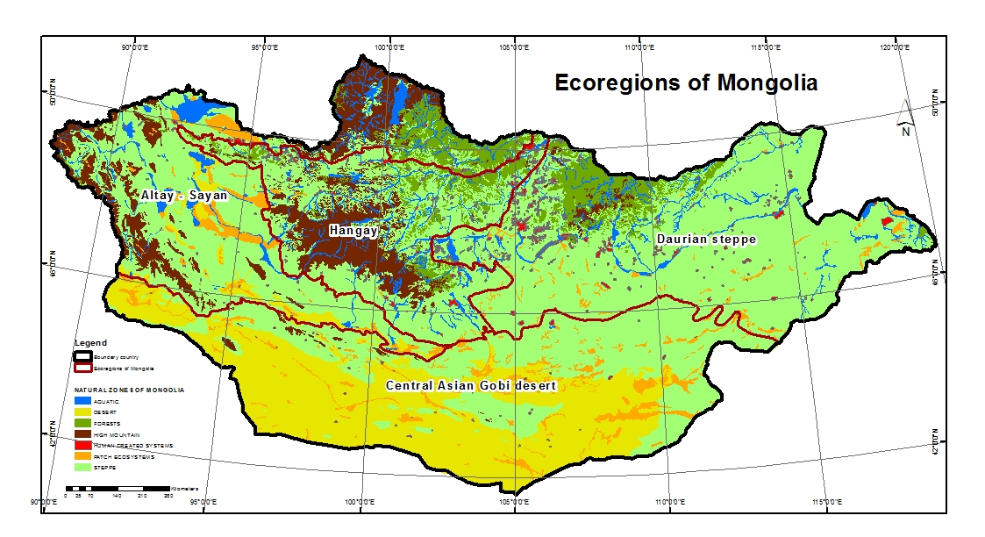
These ecoregions with its unique assemblage of ecosystems comprise variety of fauna and flora species which consists of 138 species of mammal, 75 species of fish, 22 species of reptile, 6 species of amphibian, 476 species of bird, over 13 thousand species of insect and 516 species of mollusk, 3127 species of vascular plants, 1574 species of algae, 495 species of moss, 838 species of fungus. Total of 110 species of fauna and 192 species of flora were deemed to be endangered and registered into the Mongolian Red Book (MEGDT, 2013) as either critically endangered or endangered. Main drivers for biodiversity loss are include mostly anthropogenic impacts such as unsustainable use of land, intensification of mining activities as well as climate change impacts.

Economy of Mongolia
Given its small, open economy with abundant resources, Mongolia faces the same boom-and bust cycles of any resource-dependent nation (Oxford Business Group, 2015). The country has the natural endowments to provide opportunities for its over 3 million citizens. However, managing fluctuating growth rates, ranging from -1.3% in 2009 to 17.3% in 2011, as well as investment, trade and fiscal revenues, remains a key challenge. Economic growth in Mongolia decelerated sharply in 2015, but so did inflation, and the current account deficit narrowed. Growth stagnates in 2016 under lower mining output and necessarily tight macroeconomic policies. Inflation will dip further before climbing again in 2017. 21.6% of the population lives below the national poverty line (ADB, 2016). While between 1994 and 1998 poverty appears to have stabilized, the depth and severity of poverty has increased, and the inequality gap between people has widened. Gini coefficient for Mongolia has increased from 32.9 percent in 2002 to 36.5 percent in 2013 (IMF, 2013), indicating increased income inequality.
Mongolia’s economy, fueled by a mining boom, grew at a record 17.5% pace in 2011 and slowed to 12.5% in 2012. In 2013, Mongolia’s economy grew by 11.7% GDP per capita at current prices reached MNT 6053.8 thousand and according to the World Bank Atlas method was USD 3,964 in 2013 (National Statistical Office, 2013). Number of livestock reached 45.1 million heads for the first time in history, of which horse was 2.6 million heads, cattle was 2.9 million, camel was 0.3 million, sheep was 20.1 million, and goat was 19.3 million heads. The socio-economic transformation started since 1990 in Mongolia has changed livelihood of rural population which in fact has an effect on environment. One of the consequences of this change is continuously growing number of a livestock and increase of number of goat in herd structure. Researchers concluded that in 2000s only 20% of total pasture land were degraded, whilst in 2010 this number increased to 70% of total pastureland (IFAD, 2010).
Mongolia's GDP grew in double digits until 2013. It fell to 3.5 per cent in 2015 and is projected to have zero growth in 2016, impacting on the government’s revenues and requiring reduced expenditure. Agriculture (primarily herding), once the mainstay of the Mongolian economy, continues to decline in terms of share of national employment and contribution to GDP. In 2014, less than 30 per cent of the workforce was employed in agriculture, down from 42 per cent in 2007. Agriculture comprises about 16 per cent of GDP, while services alone account for nearly 50 per cent of GDP and 56 per cent of national employment. Industry is estimated to account for 37 per cent of GDP (including mining with 19 per cent). Mongolia's mining sector continues to grow strongly, and approximately 90 per cent of Mongolian exports are resources, notably copper, gold and coal. The Mongolian economy is heavily reliant on foreign capital inflows. In the next five years, mining-related foreign investment in coal, copper and gold is forecast to exceed US$10 billion, roughly equivalent to Mongolia's 2012 GDP (current prices). This far exceeds ODA levels of $108mil in 2014, declining from $149 in 2013.
Mongolia is ranked 56 out of 189 countries on the World Bank's 2016 Ease of Doing Business index, up 30 places since 2012. China is Mongolia's largest trading partner, accounting for around 89 per cent of Mongolia's merchandise export revenues (predominantly through the export of copper and coal), and 37 per cent of merchandise import expenditure.
The Mongolian Government confronts major challenges in managing a growing economy, large-scale foreign investment and the rising expectations of Mongolian citizens. Mongolia’s greatest development challenge will therefore be to transform the benefits of the mining boom into equitable, inclusive and sustainable development for its entire population. Much of this endeavor will depend on the authorities’ will and capacity to improve its governance institutions in order to ensure transparent and accountable management of its mineral resource revenues. Mongolia became the first country to join the Partnership for Action on Green Economy (PAGE) in 2013, determined to place sustainability at the center of its economic policies. In 2014, the Parliament of Mongolia approved the National Green Development Policy and in January 2016 it approved an Action Plan to implement it. PAGE has since been helping the government unite and align national and international, public and private finance and investment players, supporting them in their efforts to give the Action Plan legs. The initiative will develop green and inclusive financial products and services, such as green bonds, to direct private finance towards projects that benefit the society and the environment. PAGE is working with the banking sector, the Mongolian Sustainable Finance Initiative and the UN Environment Finance Initiative to identify the opportunities for boosting green finance. Under PAGE and the GGGI partnered with the government of Mongolia to prepare guidelines develop the design and prototype for green school buildings.

WWF-Mongolia presence
WWF-Mongolia was established in 1992 by the invitation of the Government of Mongolia and later officially registered as branch of WWF-International. WWF-Mongolia is one of the most experienced conservation organizations in Mongolia and focuses its efforts on critical conservation issues in two of the world’s outstanding places for biodiversity conservation, the Altai Sayan Ecoregion (ASER) in Western Mongolia and Amur-Heilong Ecoregion Complex (AHEC) in Eastern Mongolia. Over the past 25 years, WWF-Mongolia implemented four 5 year conservation strategic programms and has grown to an organization with 22 highly experienced staff members located in head office in Ulaanbaatar and two branch offices; one in the city of Khovd of Khovd Aimag and a second one in Dadal soum of Khentii Aimag.
WWF-Mongolia prioritizes following activities in the context of its program areas and conservation thematic groups targeted on effective conservation challenges and threats of the vulnerability and sensitivity of Mongolia's environment:
- Species conservation by training, education, and enforcement of regulations/laws using an integrated approach of educational advertising and robust inspection activities;
- Freshwater ecosystem conservation on the base of IWRM and Water Stewardship standards by monitoring, evaluation and facilitation through capacity development measures;
- Protected Area Management including expansion of the PA network, improvement of legal framework and creation of sustainable financial mechanisms for PA, development of conservation planning, monitoring and assessment tools (CAP/Open standard, METT, Biosan), staff capacity building and development of PAA and promotion of the PA’s value and benefit and transboundary cooperation between PAs;
- Community based natural resource management using pasture, forest and aquatic ecological capacities by mechanisms of ecosystem services and adaptive economic benefit for vulnerable communities; activities in sustainable eco-tourism development are on-going issues of priority;
- Activities (indoor and outdoor training, education in water and conservation issues during summer festivals, etc.) in the field of Capacity Building and Development are closely linked with WWF’s conservation standards, awareness building of different target groups (Education for Sustainable Development, ESD) and law enforcement for future responsible mining activities from community level to political level;
- Activities in foundation and implementation of public and private partnerships become an increased importance for a sustainable financing concept to secure monetary benefit for conservation strategies and sustainable economic ecosystem service.
- Environmental public awareness and environmental education are built in every programme of WWF projects. Since 2005 WWF has started promoting “Education for Sustainable Development” concept in close collaboration with the Education Institute of Mongolia. ESD is now being piloted in 4 schools in Western Mongolia and 7 schools in Onon River Basin in Eastern Mongolia. WWF-Mongolia has already developed several curriculum and handbooks for teacher and pupils for integrating ESD principles in close collaboration with the respective aimag’s education departments. In parallel, WWF Mongolia actively supports ecological clubs at these schools.
WWF-Mongolia's overall governance is handled through Asia/Pacific Programme line manager that provides overall guidance and regional Steering Committees both on Altai Sayan and Amur Heilong Ecoregions that cover programme development, implementation and management issues. At the country level, the Senior Management Team, consisting of Conservation Director, Head of finance and operation, and Head of communication and fundraising led by the PO Representative, is responsible for discussing and reaching management decisions on key programme issues. At the ground level, the conservation work implements under the leadership of Conservation Director through two Programme managers of both ecoregions and two field offices and mobilizes short term external professionals as needed. WWF-Mongolia’s presence both at national and field level is considered as one of the key advantages of the office among other environmental NGOs and development agencies both in delivering project outputs and sustainability through long term commitment to the area.
WWF-Mongolia is funded by three main sources during the last decades, the WWF Network notably WWF DE, NL, SE and US, MAVA Foundation and case by case provision of professional services to multi-/bi-lateral donor projects executed by the MNET. WWF has extensive experience in implementation of international-funded projects supported by World Bank, ADB, UNDP, UNEP, USAID as well as other conservation organizations such as Saiga Conservation Alliance and the Nature Conservancy. WWF-Mongolia’s annual turnover is around € 1.5 m from its network and Government Aid Agencies and Foundations.

Major achievements and key challenges of Conservation Strategic Plan FY12-16
An independent assessment of the Conservation Strategic Plan for 2012-2016 was carried out with the objective to provide guidance and direction to the development of the new Strategic Plan. The assessment was requested to assess progress against the strategic goals and objectives, review the concept and design, activities and outputs, identify reasons for failure and success, lessons learned and assess the sustainability of programmes/projects. In addition, both, the Annual Programme Monitoring System and Strategic Programme Monitoring System (APMS/SPMS) reports served as a basis for identifying areas of to be further improved. Below we summarizes the major conservation achievements for the entire five years FY12-16. The detailed achievements and status of the fulfillment of previous five years Conservation Strategic Plan for 2012-2016 against set goals are listed in Annex 1.
Major achievements for the period of FY12-16 include:
- Legal framework for community-based natural resource management (CBNRM) and Water resource management are in place which allows local people participation in sustainable use and management of natural resources.
- Additional 2,335,040 ha of critical snow leopard, argali sheep, boreal forest and freshwater habitats were designated and extended as state PAs.
- 1.6 mln ha in AHEC and 2.1 mln ha in ASER areas identified as No-Go Areas for mining, accordingly Khentii Aimag Parliament officially approved 316,504 ha areas as No-Go Areas for mining.
- 25 reserve pastures and local protected areas covering 462,775 ha (38.5% of the saiga habitat) are officially established
- New national standards for migration passages for rail and highway roads for migratory ungulates in the steppe and Gobi region of Mongolia has been successfully approved according to the National Standards Council decree No 26 dated June 25, 2015.
- 11 km of critical trans-boundary migration route of Argali sheep between Russia and Mongolia kept fence free.
- Zero poaching of Snow leopard and Argali sheep since FY13 and transboundary population of Argali sheep population almost doubled within two years.
- Mongolian saiga population been saved from brink of extinction by increasing its number from 2,860 in 2007 to 14,600 individuals in 2014.
- A small population of Mongolian saiga with over 40 individuals is constantly recorded in its northern historical range since 2013
- Three documentary films addressing the issues of community based wildlife management and human snow leopard conflict were produced in cooperation with various stakeholders such as NHK and the film titled “The spirit of the mountain” won the prize “The best short film” in academy awards Mongolia.
- Anti-trap campaign initiated by school kids led to a decree to ban traps, signed by the Minister of Environment.
The above listed conservation achievements have been supported and enabled a strong Operational Plan, including the functional areas of Communication, Fundraising, Partnerships, and Human Resources. Finance and Administration. The achievements ratings of the different pillars together with Conservation based on the APMS/SPMS are shown below (Graph 1). Overall performance ratings have been on track showing ratings of 80% and higher in most years and for most functional areas. In cases were ratings were lower than 80% improvements were made in the subsequent year through targeted intervention resulting in improvements.
Graph 1. Strategic and Annual plan implementation assessment ratings

Despite the achievements made and the overall good performance ratings across years and functional areas, both an in-house and independent external assessment of current Strategic Plan highlighted a number of challenges and issues that were addressed when developing the new plan for the next 5 years. These included:
- While combating poaching and unsustainable resource use has been successfully leading to positive trends in Saiga, Snow leopard, Argali populations and expansion of the PA network, these achievements need further consolidation by staying and some cases strengthening involvement in law enforcement. It has been a weakness of WWF-Mongolia in the past to withdraw from such activities and related projects too early and before achievements were consolidated, e.g. closing the MAPU in ASER and AHEC too early.
- Initiatives for IRBM and grassland management are moving into the right direction, but IRBM activities should focus more on the implementation of climate change adaptation measures.
- Extractive industries (mining) and forest conservation issues are insufficiently addressed by the strategy. In view of limited funding extractive industries (mining) and issues related to this (infrastructure development and unsustainable water management) should be given priority.
- Steppe ecosystems, a unique feature of Mongolia and a high priority on an international scale, needs to be given high priority.
- Other key species such as Khulan and Mongolian gazelle should receive priority in the new Strategy, these species would lend themselves also to new fundraising initiatives.
- The office needs to increase the profile of WWF-Mongolia in the network through more frequent and strategic communications, speaking up at international and regional WWF meetings. WWF-Mongolia should also profile itself as a leader in Snow leopard, Saiga and Argali conservation, IWRM, Community based conservation initiatives, grassland/steppe conservation and as a hotspot for climate change impact.

Strategic Plan for FY17-21 and its development process

This 5-year Strategic Plan, covering the period 2017 to 2021, has been developed based on achievements and lessons learnt from the previous 5-year Strategic Plan using WWF’s Open Standards for the Practice of Conservation including WWF Network Standards of Conservation Project and Programme Management System-PPMS. A core team under the leadership of the PO Representative is responsible for the development of the Strategic Plan in different sectors such as Conservation work stream, Communication work stream, Fundraising work stream and Finance and Operation work stream. The planning process were involved key stakeholders in WWF network such as WWF Netherlands, Germany, Japan, UK, USA, Poland and Russia and other partners (TRAFFIC, TNC, WCS etc.). The development of the strategic plan is facilitated by independent expert, Georg Schwede and supported by Stuart Chapman, the line manager for the MPO and others at WWF-Greater Mekong and WWF International.
WWF Mongolia’s Conservation Programme (2012-2016) has been the basis for the development of the new strategic plan because conservation goals were set up for 10 years until 2021 to demonstrate progress towards MPOs longer-term vision. Therefore, the strategic plan for FY17-21 builds on the previous conservation strategy’s successes and addresses its failures. The conservation scope, strategies and objectives are identified based on the recommendations emerging from the external Conservation strategic programme assessment, an internal assessment and other evaluations and studies undertaken over the past few years. In addition, outcomes and lessons learned from a series of consultations and meetings both at ecoregional and national levels held throughout 2012-2016 are also incorporated.

Scope
The geographic scope of WWF-Mongolia’s Conservation Programme for FY17-21 remains the same as in the previous conservation programme focusing on conserving and managing two priority places namely the Altai-Sayan Montane Forests (ASER) and the Amur/Heilong Ecoregional Complex (AHEC). Both Ecoregions have been identified by the Global Program Framework (GPF) as one of the 35 priority places where WWF network will join its forces to ensuring that “Biodiversity is protected and well managed in the world’s most outstanding natural places” (Map 1. Geographical scope of conservation programme)
The conservation scope is fully aligned with WWFs Global Goals, namely Forest, Freshwater and Wildlife as targets in the conservation strategy; Climate and Energy is incorporated as cross cutting issues at the objective level.

Map 1. Geographical scope of conservation programme
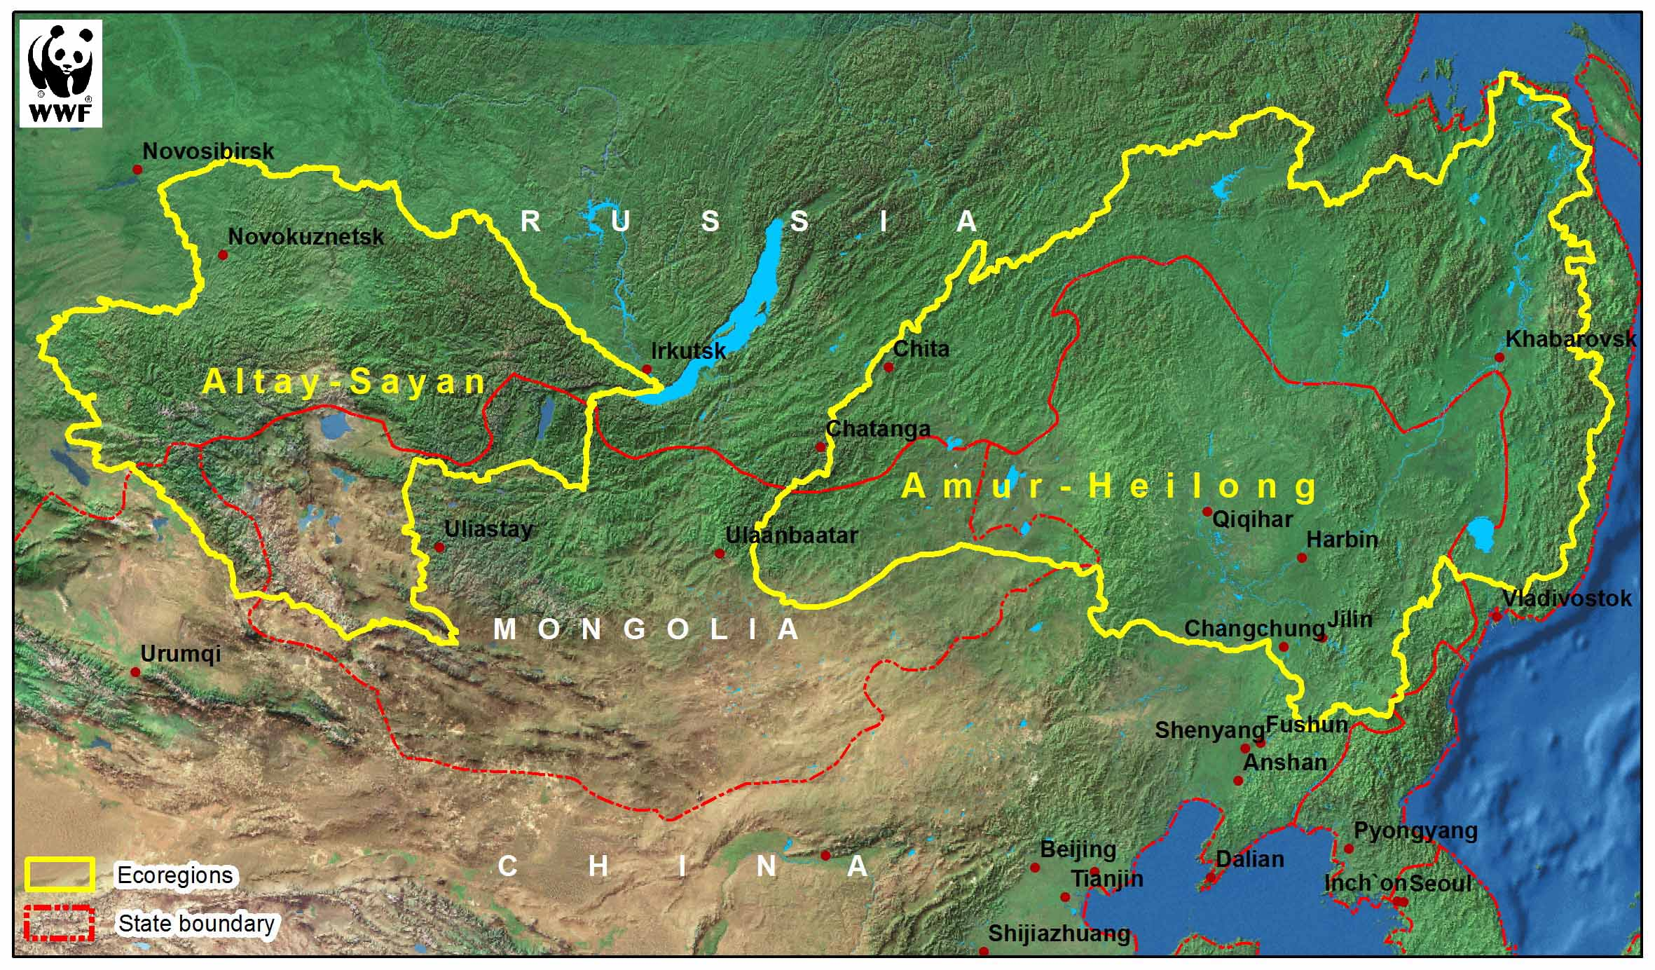

Within the big area covering 499,418 sq.kms (316,654 sq.kms and 182,763 sq.kms respectively) in ASER and AHEC, the key priority areas were selected both within the country and the transboundary areas as well as opportunities for successful conservation in close collaboration and partnership with local communities and other stakeholders where conservation interventions will have high impacts and contribute to multiple goals;
In Altai-Sayan Ecoregion WWF-Mongolia will focus on:
- Key river basins including three main river basins namely a. Khar Lake-Khovd, b. Khyargas Lake-Zavkhan, c. Khuisiin Gobi-Tsetseg Lake River Basins as a freshwater footprint,
- Priority habitats such as connectivity areas of snow leopard and its prey base include priority landscapes for snow leopard that identified by both GSLEP and WWF Snow leopard SAP including the transboundary areas of Siilkhem (1478sq.km) and Turgen-Tsagaan Shuvuut (5972sq.km), Munkhairkhan Mountain (5060sq.km) and important for connectivity areas of Altankhukhii, Tsambagarv, Khukh Serkh, Jargalant-Bumbat Khairkhan (2000 sq.km) and Baatar Khairkhan (1795 sq.km) Mountains.
- Priority areas for Mongolian saiga antelope conservation include its current distribution areas, namely, Sharga and Khuis Gobi, Chandmani Khuren steppe and new extension area to the north and south.
In Amur Heilong Ecoregion WWF-Mongolia will work on:
- Key river basins including two main river basins namely Onon and Ulz River Basins with special focus on Boreal forest and freshwater ecosystems as well as migration corridors of Mongolian gazelle in Eastern steppe ecosystem.
- Priority areas for Migration of ungulates include steppe ecosystem in eastern and south eastern Mongolia, taking into consideration that increase of development of numerous mining projects and the associated infrastructure such as road and railways present a potential barrier for migratory animals of the steppe ecosystem. The steppe ecosystem itself is unique with its low coverage of steppe ecosystems in the global PA network and the fact that all “steppe countries” lost most of their primary steppe habitats

Vision
Mongolia is a safe home for wildlife and a place where present and future generations enjoy a high quality of life, living in harmony with nature.

Conservation Targets and Goals
The setting of conservation targets and goals further described below needs to be seen in the context of the unique potential Mongolia still offers for conserving and restoring biodiversity of global significance. Due to the low human population density, Mongolia is one of last true wilderness areas of global significance with large areas of relatively unfragmented and intact habitats, populated with unique assemblages of charismatic and keystone species such as snow leopard and gray wolf which play a fundamental role in maintaining, functioning and stability of the ecosystem and overall landscape, and allowing natural migration of large herds of ungulates such as the as Mongolian saiga and Mongolian gazelle. Despite this, the consequences of changing livestock herding techniques and the over-exploitation of land and plant resources, unregulated licensing for exploration and exploitation of mineral resources, coupled with effects of climate change lead to decline of wildlife habitat areas and loss of resources, becoming the main contributing factor to the increase of species to be categorized as endangered. In addition, the socio-economic transformation started since 1990 in Mongolia have changed livelihood of rural population which results continuously growing number of a livestock and increase of number of goat in herd structure. Researchers concluded that in 2000s only 20% of total pasture land were degraded, whilst in 2010 this number increased to 70% of total pastureland. However, it is not the case that is unrecoverable situation and those that are impacted pastureland have the potential to recover and be restored, which is not the case in many other parts of the world.
The unique biodiversity values that Mongolia has to offer globally and the important niche and role WWF Mongolia has established among environmental NGOs in the country has been the main basis for defining what we will focus on over the next five years to make unique contributions to WWF Global Goals.
The selection of the specific conservation targets and the respective long-term goals were developed based on the recommendations from the independent assessment on last conservation strategic plan. Both the conservation targets and goals are fully aligned with the WWF Network Global Goals and key Drivers of environmental problems and WWF-Mongolia’s Critical Contributions build the basis for setting the objectives for the next conservation strategy.
Based on the above WWF-Mongolia has selected five conservation targets in the two ecoregions: Boreal coniferous forest ecosystem; Freshwater ecosystem; two GPF priority species namely Snow leopard (Panthera uncia) and Mongolian Saiga (Saiga tatarica mongolica); and Migration of ungulates, as an important ecological process. Table 1 below shows all the selected and defined conservation targets and corresponding conservation goals linked to Global goals set by the network.

Table 1. Conservation targets and goals

Global goals | WWF-Mongolia - Conservation targets | Conservation target current status | WWF-Mongolia - Conservation goals
Freshwater | Freshwater ecosystem Nested targets: Taimen (Hucho taimen) as a freshwater indicator and Crane species as a umbrella species of wetlands | Freshwater ecosystems—lakes, reservoirs, and rivers—are among the most extensively modified ecosystems on Earth. Transformations include changes in the morphology of rivers and lakes, hydrology, biogeochemistry of nutrients and toxic substances, ecosystem metabolism and the storage of carbon and loss of native species. Drivers are climate change, hydrologic flow modification, land-use change, chemical inputs, aquatic invasive species, and harvest. In Mongolia, with thriving extractive industry, ground as well as surface water ecosystems are in danger of being misused thus changes in morphology and quality of the ecosystems are foreseen. Despite an increase in surface water levels due to global warming, ground water levels continue to decrease. The use of water resources especially ground water use is steadily increasing due to intensification of mining activities.  North East Asia is home to eight crane species more than half of the world crane species. Five of these species are threatened because of development and habitat loss.  In Mongolia due to loss of wetlands and decrease of grain production in the north eastern tip, the majority of the crane shifted from the Ulz river basin to the Onon river basin. Thus, much of the breeding cranes has moved out of the Mongol Daguur SPA to Khurkh Huiten and Onon river tributaries that has no protection status and facing increased anthropogenic pressure. | By 2021, freshwater ecosystem functions are maintained at the 2016 level in the priority river basins in ASER and AHEC through increased protection of critical freshwater habitats and sustainable use of water resources.
Forests | Boreal forest | At the global level, the boreal ecosystem represents Earth’s most extensive terrestrial biome. However, in Mongolia boreal ecosystem represents only less than 8 per cent of area yet importance for being as a guardian for runoff generating areas of such mighty rivers as Amur, Yenisey at the global scale, and other big rivers within Mongolia. | By 2021, at least 80% of boreal forest in headwater of Amur is protected and sustainably managed through effective protected area network and community based forest management.
Wildlife | Snow leopard  Nested target: Prey base for snow leopard and Grey wolf (Canis lupus) as keystone species that play an important role on overall ecosystem health. | The snow leopard (Panthera uncia) range is found in 12 countries in the northern Asia (spanning the Tibetan Plateau and the Himalayan, Tian Shan, and Altai mountain ranges), though the animals are sparsely distributed. Mongolia hosts an about 20% of the estimated global snow leopard population of which 2/3 inhabits in the Mongolian part of Altai-Sayan Ecoregion. Snow leopards are declining across their range due to a wide range of threats including poaching and illegal trade, habitat loss due to overgrazing, depletion of prey species and conflict between snow leopard and human as well as climate change. Snow leopards are suspected to have declined by at least 20% over the past two decades due to habitat and prey base loss, and poaching and persecution. Potential change in the suitable habitat of the snow leopards to the year 2100 shows that 39% of the current snow leopard habitat in the world is vulnerable to loss under a high emissions climate scenario including Gobi and Khangai region of Mongolia which shows that Altai Sayan Ecoregion is an important habitat and last heaven for its survival. | By 2021, the Snow leopard populations in key areas in ASER (Priority landscapes under the GSLEP and WWF SAP) are stable and increasing compared to the 2016 level.
 | Mongolian saiga  Nested target: Desert steppe ecosystem | Mongolian Saiga (Saiga tatarica mongolica) is an endemic subspecies to Mongolia. It is registered by IUCN as “very rare”, and listed as such in the Mongolian Red Data Book. The species is extremely vulnerable to habitat competition with livestock, poaching, and extreme natural disasters such as cold winters and drought. All three factors together reduced the population to about 800 animals in 2001/2002. The status of the species has improved significantly since then, to about 15,000 animals, thanks to the conservation efforts of WWF, MAVA Foundation and other organizations. | By 2021, the Mongolian saiga population is increased by 30% compared to 2016 levels and key habitats of Mongolian saiga are well managed.
 | Migration of ungulates  Nested target: Steppe and desert steppe ungulates namely Asiatic wild ass – Khulan (Equus hemionus), Goitered Gazelle (Gazella subgutturosa) and Mongolian gazelle (Procapra gutturosa) | As conclusion of animal’ researchers, the animal species whose life histories entail long-distance movements may be especially sensitive to habitat fragmentation and associated human-generated barriers to movement. The development of linear projects in Mongolia such as road and railways present a potential barrier for migratory animals such as Asiatic wild ass - Khulan (Equus hemionus), Goitered Gazelle (Gazella subgutturosa) and Mongolian gazelle (Procapra gutturosa). After construction of the planned railroad in 2025, the Mongolian gazelle populations will be divided into 9 isolated populations separated by railway and border fences, while the Khulan populations will be divided into 5 and the Goitered gazelle populations into 7 populations respectively. The Mongolian saiga population will be isolated as 2 separate populations. | By 2021, key natural migration patterns of key ungulate species are maintained/restored by mitigating the impacts of linear infrastructure developments and effective management of connectivity areas.
Climate and Energy | Climate and Energy is incorporated as cross cutting issue at objective level, please see details at “Conservation strategies and planned objectives” section.

Situation analysis

Key drivers of threats for biodiversity
The main factors contributing to the loss of flora and fauna in Mongolia include mining and infrastructure development, poaching and trafficking of animal organs, climate change, overgrazing and agriculture. Besides, these major threats coupled by the poverty and unemployment lead to increased use of natural resource and become factor of environmental degradation.
Climate change: Mongolia is one of the most vulnerable to climate change countries in the world because of its specific geographical and climate condition. The climate change assessment outcomes suggest that the annual mean air temperature in Mongolia increased by approximately 2.14°C during the last 70 years (MEGDT, 2014), which is three times higher than the global average. Warming is projected to further increase by 5°C by the end of the 21st century. The area of glaciers decreased by 12.3% in 1940-1990, 9.8% in 1990-2000 and 11.7% in 2000-2010, totaling in 27.8% loss in the past 70 years with an accelerated loss noted in the past decade. Due to a drought period lasting until 2011, various lakes incuding Goviin Orog, Taatsiin Tsagaan, Adgiin Tsagaan, Khaya, and Ulaan, together with various rivers and the Ulaan Tsutgalan waterfall, ran dry. With higher precipitation starting from 2012, Taatsiin Tsagaan, Adgiin Tsagaan, Ulaan and Orog lakes became watered again, and water levels steadily rose. These changes, coupled with melting of glaciers and permafrost, is expected to seriously impact the hydrological regime.
Overgrazing: Overgrazing associated with livestock breeding practice exceeding pastureland carrying capacity degrades natural habitat for wildlife. It forces wildlife to migrate further in search for better habitats. About 70% of the country's pasture land is degraded due to overgrazing according to findings of scientists. The livestock number in Mongolia doubled between 1992 and 2007 – increasing from 22 million to 40 million and reached over 50 million in 2015 with the huge change in livestock herd composition. The goat population has increased rapidly to occupy 40% of herds and there is an excess of 32.5% or 16 million head of sheep over the advised national herd quota. Such increase of livestock and herd structure change will further exacerbate threats to wildlife through increased fragmentation of habitats, human wildlife conflicts, livestock and wild herbivore competition for food and habitat. For example, populations of Altai argali and Saiga antelope have coexisted with nomadic herders and their livestock for centuries, but today the impact of overgrazing by livestock on the habitats of these species is very high. The consequences of changing livestock herding techniques and the over-exploitation of land and plant resources, coupled with effects of climate change lead to decline of animal and plant habitat areas and loss of resources, becoming the main contributing factor to the increase of species to be categorized as endangered.
Mining: By 2015, 1,494 mining licenses had been granted. 33.5% of licenses were for the extraction of gold, 18.7% for coal, 20.7% for common minerals, and the remaining 27.1% were granted for other types of minerals. 57% of licensed mining areas were used for coal mining, and 20.4% for gold. There were 1.2 million hectares of licensed mining areas; accounting for 0.8% of the total territory of Mongolia. Of those, in AHEC region 155 mining license has been granted whereas in ASER it is 140 licenses. However, out of 24,636.8 ha of degraded land due to mining activities, 10,263.1 ha or 41.65% of land was undergone for technical restoration and 6,781.5 ha or 27.5% of land was biologically restored.
According to the Minerals Law, the Environmental Impact Assessment (EIA) is one of required documents to obtain a mining license. Together with EIA an environmental management plan shall be developed in order to protect and ensure appropriate use and rehabilitation of the territory where the project is to be implemented, to ensure the implementation of recommendations specified in the strategic assessment, mitigate, eliminate and prevent negative impacts that are identified by the detailed impact assessment, and monitor, identify potential negative consequences that may arise in the proposed project environment. The environmental management plan is the main document that permits the start and continuation of the project. However, public perception that the enforcement of environment protection and restoration is not enough and is related to the lack of provision of accurate information by environmental inspectors. This eventually becomes one of the sources of conflict between mining companies and the local community. Therefore, improving the participation and partnership of professional associations, general public in the process of decision-making, inspections and monitoring is essential to contribute for mitigation and prevention of negative impacts from mining.
Infrastructure: Mongolia is facing a period of rapid change, resulting from the need to strengthen its economy, provide services to its population, and create new infrastructure. Due to a growth in mining operations, the migration pattern of migratory wildlife such as fish and migratory ungulates is in alarm because of inappropriate infrastructure development. The barrier effect of the fenced Trans-Mongolia railroad between Ulaanbaatar and Beijing has already been demonstrated for the Mongolian gazelle (Ito. et al., 2005a. 2005b. 2006. 2008. 2009.). The lack of wildlife crossing structures or fence gaps for the existing Russia–Mongolia borders effectively divides wildlife populations inhabiting the regions, including argali. In the case of argali in Mongolia, the border fence prevents the animals from accessing the high quality habitat on the Russian side of the border, possibly limiting population growth. Adequate argali conservation management, therefore requires transboundary cooperation and joint conservation initiatives. Focusing on mitigation measures such as removal of border fences along some segments could represent a reasonable starting point for developing conservation programs aimed at maintaining argali meta-population structure and viability (Chimed-Ochir B. et al., 2010).
The national programme on “Water” (2010) foresees a review of energy potential of all rivers systems and their incorporation into national energy development plans. This includes feasibility assessments of potential hydropower sites on Chargait (58 МWt), Erdeneburen (65 МWt), Selenge (300 МWt) and Eg (220 МWt) rivers that either within ASER or originates from ASER Mountains. Taking into consideration the fact that existing hydro-power plants (HPP) mostly operate during the short summer season and impacts of the two larger HPP are still not known.
Agriculture: According to land usage statistics, 73.8 percent of Mongolia’s total area is used for agriculture, however only 0.5 percent of that (or 600,000 thousand hectares) is farmed. Compared to the 1990s, where almost 1.2 million hectares of land was used with crop rotation, total farmed land has almost halved, the main reason being the shift to the market economy leading to the breaking up of farming collectives. This has led to fragmented utilization of farmland, soil deterioration, and loss of soil fertility and fallowing of farmlands. As of 2013, about 40 thousand hectares of farmland are deemed to be degraded (National Statistical Office, 2013)State loans and subsidies have had a significant impact in supporting the farming industry, with 4.7% of total subsidies going to the agriculture industry (wheat and meat industry) during the period 2007-2013, according to statistics. These state policies have led to investment in farming increasing year-by-year, for example nitrogen fertilizer imports have increased in the last three years by about 10 thousand tons on average (National Statistical Office, 2013).
Poverty: The annual growth in gross domestic product (GDP) of Mongolia increased to 6.7 percent in 2005–2010 and then accelerated to 12.2 percent in 2010–2014. However, according to the World Bank, the growth in GDP is projected to have slowed to 2.3 percent in 2015 and to 0.8 percent in 2016 because of a sharp contraction in mining production despite a gradual recovery in non-mining sectors. In 2013, the average monthly monetary income per household reached 862.5 thous. MNT while the average monthly monetary expenditure per household was 864.9 thous.MNT and nearly one person in five is living below the poverty line which shows poverty remains widespread in the country. By taking this, it is clear that poverty is directly related to environment. Environmental degradation such as overgrazing, deforestation and worsening water availability is creating a vicious circle of declining rural income and further exacerbating pressure on the environment.

Major threats for conservation targets
The key threats to biodiversity were identified and assessed during the WWF Mongolia’s Conservation Strategy development process, using WWF’s Open Standards for the Practice of Conservation including WWF Network Standards of Conservation Project and Programme Management-PPMS. Based on a priority-setting exercise that involved the entire WWF-Mongolia conservation team, including staff from both field offices, a ranking of direct human activities or direct threats on defined conservation targets with the greatest impact on the ecosystems as a whole was conducted. Each target was assessed applying the following three criteria:
1. Scope: what % of each target is affected;
2. Severity: where the threat occurs, how much is the target affected; and
3. Irreversibility: how reversible are the impacts themselves
As the result, the following 11 key threats with series of interlinked contributing factors were identified (Figure 1.Conceptual model) for each of our conservation targets among which fire, infrastructure, overgrazing and glacier/ permafrost melting ranked as the highest threats (Table 2. Ranking of threats on target biodiversity).

Table 2. Threat ratings on conservation targets

 | Threats \ Targets | Freshwater | Boreal forest | Snow Leopard | Mongolian saiga antelope | Migration of ungulates | Summary Threat Rating
 | Fire |  | High |  |  | High | High
 | Pests/Disease |  | Medium | Medium | Medium |  | Medium
 | Illegal logging and unsustainable use of non-timber forest products | Low | Medium |  |  |  | Low
 | Poaching and trade | Low |  | Low | High |  | Medium
 | Harsh winter/droughts |  |  | Medium | High | Medium | Medium
 | Unsustainable use of water resource | Medium |  |  |  |  | Low
 | Infrastructure |  |  |  | High | High | High
 | HPPs/Dams | High |  |  |  |  | Medium
 | Overgrazing | Medium | Medium | Low | Very High | Medium | High
 | Glacier/ permafrost melting | Very High | Very High | Medium |  |  | Very High
 | Irresponsible mining | Medium | Low |  | Low | Medium | Medium
Summary Target Ratings: |  | High | High | Medium | Very High | High | Very High

Figure 1. Conceptual model
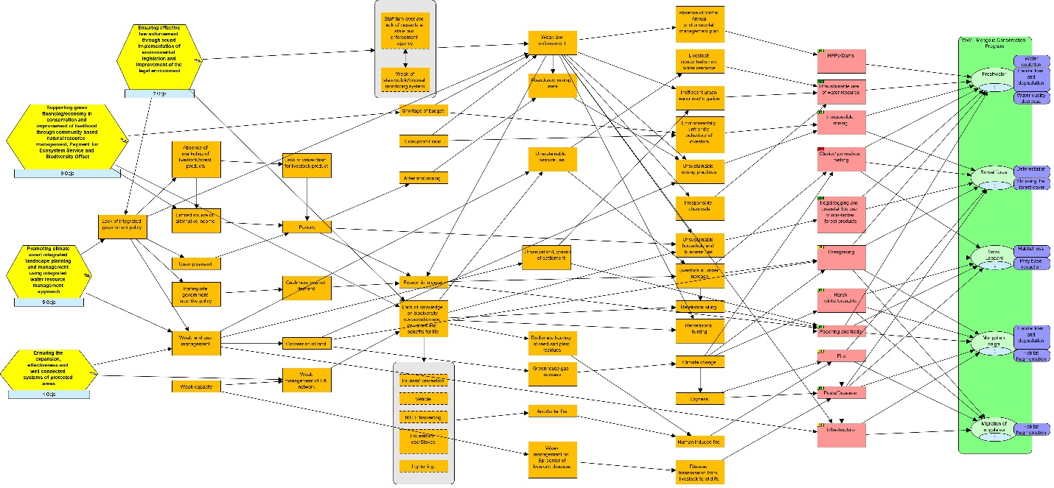

Conservation strategies and planned objectives
Based on the conceptual model above and the threat ranking, four strategies have been developed to address most effectively the most pressing issues and reduce and mitigate high and medium ranked threats and contributing factors impacting on defined conservation goals.
These are:
- Ensuring effective law enforcement through sound implementation of environmental legislation and improvement of the legal environment;
- Supporting green financing/economy in conservation and improvement of livelihood through community based natural resource management, Payment for Ecosystem Service and Biodiversity Offsetting;
- Promoting climate smart integrated landscape planning and management using the integrated water resource management approach; and
- Ensuring the expansion, effectiveness and well-connected systems of protected areas

In order to ensure maximum conservation impacts, WWF-Mongolia has prioritized the above conservation strategies. They represent an effective and comprehensive approach to the main contributing factors of the threats identified such as weak law enforcement, low government budgets allocated to environmental causes, lack of adequate incentives for environmental protection, unsustainable land management and ineffective protected area network and a lack of knowledge of biodiversity conservation and its values and social and economic benefits. By facilitating effective law enforcement through effective collaboration with the State Law Enforcement Agencies, setting up legal basis for Payment for Ecosystem Services to improve sustainable use and management of natural resources, introducing landscape level planning and management, strengthening integrated water resource management, ensuring effective management of protected areas and increasing knowledge of public and participation both, at the duty bearer and right holder level we are confident that the strategies selected further detailed below will help us to reach the conservation impacts needed to achieve the ambitious 2021 goals defined.

Conservation Strategy 1: Ensuring law enforcement through supporting sound implementation of environmental legislations and improvement of legal environment will be reached through the initiation and integration of key government policies and introduction of innovative approaches to law enforcement processes. Mongolia has strong legislation but poor track record of effective implementation, mainly due to lack of cross-sectoral policy integration, effective collaboration and synergies between law enforcement agencies as well as lack of capacities and resources at the state specialized inspection agency. Therefore, under this strategy we aim to ensure more effective cross-sectoral policy integration, collaboration and synergies between law enforcement agencies and to increase public participation in law enforcement and decision making process, including in mining and land use sectors. The work will be backed up and strongly supported by increasing the knowledge of public and its active engagement to law enforcement, both duty bearer and right holder level (Annex 2. Results chains).

# | Strategy | Planned objectives | Indicators
C1 | Strategy 1. Ensuring law enforcement through supporting sound implementation of environmental legislations and improvement of legal environment | - By 2018, legal environment on sustainable use of natural resources is improved and effectively implemented through more effective cross sectoral policy integration and improved collaboration and synergies between law enforcement agencies. | # of legislative acts amended  # of MoU and agreement between law enforcement agencies effectively implemented  # of law violations and incompliance
 |  | - By 2018, human-snow leopard conflict is eliminated at least in 2 target areas through piloting innovative measures and the results are disseminated in other high conservation value areas by 2021. | # of conflict cases (killed livestock and snow leopard)  # of successful pilot measures
 |  | - By 2019, zero poaching of snow leopard is maintained and poaching on the following key species’ is decreased by;  - 50% for Mongolian saiga,  - 100% for Argali in Transboundary areas  - 70% for Taimen,  - 5-10% for Mongolian gazelle compared to 2014 level and results maintained or improved annually. | # of reported poaching incidents
 |  | - By 2019, public monitoring and participation is increased in 3 key areas through sound implementation of EIA & SEA in mining, linear infrastructure and dam construction to ensure biodiversity protection. | # of acts and actions initiated by public  % of public knowledge on EIA and SEA law  # of incidents reported to court (acts and actions initiated by public)
 |  | - By 2019, public knowledge on law and fines of illegal wildlife trade and poaching in ASER and AHEC is increased by 20% and maintained annually. | % of increase in public knowledge  # of local residents engagement on illegal wildlife trade and poaching related activities
 |  | - By 2021, illegal wildlife trade in ASER and AHEC is decreased by at least 20% through innovative and collaborative approaches. | # of trade incidents  # of innovative and collaborative approach that reveal the incidents
 |  | - By 2021, forest fire and illegal logging in AHEC is decreased by 50% through effective collaboration among key stakeholders and communication measures. | Size of area affected by fires  # of illegal logging cases  # of MoU and agreement between stakeholders

Conservation Strategy 2: Furthering sustainable/green financing mechanisms for conservation and improvement of livelihoods of local communities through Community based natural resource management, Payment for Ecosystem Services and Biodiversity Offset schemes. This strategy builds on previous experiences in community based natural resource management (CBNRM) and aims at supporting green financing/economy and setting up a legal basis for Payment for Ecosystem Services (PES) in order to increase alternative income for herders and general public as well as the budget for environmental protection. Most importantly a legal environment enabling green financing through introduction of PES will be created in an integrated way including pasture, freshwater, wildlife and forest sectors which are the main source of livelihood in Mongolia. At the same time WWF-Mongolia is aiming to increase public involvement and participation as well as public monitoring system in mining sector and establishing a biodiversity offset scheme, allowing restoration of abandoned mining areas through increased financial means. Additionally, WWF-Mongolia will further promote and integrate community based forest, pasture and wildlife management, including climate adaptation measures through demonstration and replication its successes in other high conservation value areas (Annex 2. Results chains).
# | Strategy | Planned objectives | Indicators
C2 | Strategy 2. Supporting green financing/economy in conservation with improvement of livelihood through community based natural resource management, payment for ecosystem service and biodiversity offset | - By 2020, a legal environment to introduce Payment for Ecosystem Service is created in an integrated way including pasture, freshwater, wildlife and forest sectors. | # of Legislative acts
 |  | - By 2018, attitude of local residents on benefits of sustainable use and conservation of natural resources living in priority areas is changed by 40% compared to 42.7% by 2016 level. | % of change in attitudes
 |  | - By 2019, economic incentives for green financing initiatives to conserve and sustainably use biodiversity are defined and at least 2 incentives are introduced at the national level. | # of economic incentives initiated and proposed  # of introduced green incentives
 |  | - By 2020, sustainable use of natural resources in pasture, forest and fisheries are expanded and maintained in at least 4 key areas in ASER and AHEC through increased institutional capacity of local institutions-CBOs and alternative income sources. | # of alternative income sources  Amount of income generated by leading local institutions  # of forest, fisheries and pasture user groups
 |  | - By 2020, 589000 ha of boreal forest in Onon river basin is sustainably managed by local communities. | Size of CBO managed forest  METT score of CBOs
 |  | - By 2021, favorable attitudes and participation towards forest protection of the local communities increased by at least 30% from 2016 baseline. | # of initiatives by local communities  % of attitudes
 |  | - By 2021, responsible mining is showcased in 2-3 key areas through increased funding on community owned and managed restoration and offsetting. | % of implementation of environmental management plans
 |  | - By 2018, herders’ attitudes on carrying capacity of pasture are increased by 10% in key areas in ASER and AHEC compared to 2014 level. | % of attitudes
 |  | - By 2019, reserve pastureland is increased by 10% in key areas of target species and rotational/smart grazing system is in place by 2021. | Size of reserve pastureland  # rotational/smart management of pastureland

Conservation strategy 3: Promoting climate smart integrated landscape planning and management using integrated water resource management approach builds on our aim to introduce the landscape level conservation approach to be adopted by local communities and decision makers. The landscape level planning and its management will be closely linked with climate adaptation measures such as climate smart grazing practice given that climate change is predicted to have major impact on biodiversity and livelihoods of rural communities in Mongolia. At the same time, integrated water resource management approach will be strengthened with more focus on the implementation of climate change adaptation measures (Annex 2. Results chains).

# | Strategy | Planned objectives | Indicators
C3 | Strategy 3. Promoting climate smart integrated landscape planning and management using integrated water resource management approach | - By 2018, climate smart green development plans are developed for at least 3 administrative units in ASER and supported for being replicated into other priority areas. | Approved management plans  # of replicated measures
 |  | - By 2018, locally feasible and affordable climate adaptation measures are identified and implemented in selected priority areas till end of 2021. | # of climate adaptation measures identified  # of implemented measures
 |  | - By 2019, IWRM plans are fully facilitated in ASER and AHEC and implementation status of 50% is ensured at least in 2 key river basins through capacity building and effective collaboration between stakeholders. | # approved IWRM  % of implementation status of IWRM
 |  | - By 2021, no-go mining areas are officially declared protecting 2,000,000 ha of critical freshwater habitats. | size of protected critical habitats  # of national and regional decisions
 |  | - By 2021, sustainable use of water resources is ensured in 2 key river basins through effective policy integration. | # joint decree of local decision makers at basin level

Conservation Strategy 4. Ensuring an effectively and equitably managed and well-connected systems of protected areas. This will be reached by supporting both central and regional governments with the implementation of world class protected area management in selected protected areas, including national and local protected areas as well as wildlife connectivity areas in ASER and AHEC as well as expanding the network of protected areas. This approach is based on recommendations of Gap analysis produced by WWF-Mongolia in 2010 and which concluded that the PA network needs to be expanded and that management of the existing PA network requires substantial upgrading. In addition, Mongolia has pledged to expand its PA network covering up to 30 percent of the country and recent major environmental policy documents have been encouraging the expansion of the National Protected Area network. In this context, the expansion of PA network is crucial and WWF-Mongolia in cooperation with TNC has identified 216 biodiversity hot spots to be included in the PA network of Mongolia. At the same time, WWF-Mongolia will be introducing a connectivity conservation approach with special focus on critical habitats of migratory ungulates. This will be done by identifying and supporting a sustainable management scheme that complies with national and international guidelines and standards (Annex 2. Results chains).

# | Strategy | Planned objectives | Indicators
C4 | Strategy 4. Ensuring effectively and equitably managed and well-connected systems of protected areas | - By 2018, the PA network is expanded by:  - 600,000 ha for Steppe ecosystem,  - 100,000 ha for Forest ecosystem,  - 100,000 ha for Wetland ecosystem in AHEC and ASER. | Size of PAs
 |  | - By 2020, management of at least two RAMSAR designated wetland areas in ASER and AHEC is improved through community based conservation. | METT score
 |  | - By 2021, management effectiveness (biodiversity monitoring, corporate planning and monitoring and evaluation) of all protected areas including transboundary PAs in ASER and AHEC is increased by 10% compared to 2016 level. | METT score
 |  | - By 2021, migration corridors including transboundary areas ensuring continuous connectivity for xxx ha of key habitats for steppe ungulate are sustainably managed in compliance with national and international guidelines and standards. | Size and description of proposed corridors/connectivity areas

Key actors and partners

Identifying, forging and strengthening strategic partnership at every level has been one of the core approaches that WWF-Mongolia takes in conservation. WWF-Mongolia’s overall approach and partnership engagement under the new strategic plan is outlined in the Annex 3 (Key Partners for Conservation Programme). The following section highlights KEY actors that are vital for WWF Mongolia’s conservation success.
At the National level, the Ministry of Environment and Tourism, Ministry of Food and Agriculture, Ministry of Transpiration, General Police Authority and the State Specialized Inspection Agency will continue to play an important role in the implementation of WWF Strategic Plan. These government organizations are central players in policy level activities and are important counterparts for policy change. The decisions and recommendations made by them have serious long lasting impacts both in positive and negative ways. WWF-Mongolia will constantly engage with these national institutions through advocacy work and provision of professional services. WWF also recognized that the development pressure has been increasingly high, such as extractive industry practice, hydro-power which goes beyond the realm of these national decision making bodies. It’s critical to build allies such as the Ministry of Economy and Finance to ensure development planning takes natural capital as national assets into consideration.
Multi- and bilateral international organizations such as GIZ, SDC, UNDP, and International conservation NGOs represented by TNC and WCS are important both in terms of resources mobilization, especially mitigation of infrastructure development, pasture management and joint advocacy and promotion of enabling environment for sustainable management and conservation of biodiversity. At the Local level, both Aimag and Soum Local Citizens Khurals, Environment and Tourism departments of Khovd, Bayan-Ulgii, Gobi-Altai, Uvs, Khentii and Dornod aimags, staffs from the Protected Area Administrations, River Basin Councils of Khar Lake-Khovd, Khuisiin Gobi-Tsetseg Lake, Khyargas lake-Zavkhan River and Ulz and Onon river basins and Soum governor’s office in intervention areas have important roles in successful implementation of project and buy-in and replication of pilot demonstration results. Without the full support from these local government structures the success of any intervention and its sustainability will be at jeopardy. Therefore, WWF-Mongolia works closely with those institutions both as target groups for building their capacity and as a partner for advocacy.
The actual conservation and sustainable management of biodiversity at the sites will mostly be at the hands of local institutions who is umbrella organization of community based organizations whose livelihoods are fully woven with the traditional use of the surrounding natural resource. Local communities as a group or as an individual household have used the surrounding natural resources for livestock grazing, hay making, subsistence hunting, and collection of non-timber forest products (NTFP). WWF-Mongolia’s engagement with local communities will therefore focus on supporting them in sustainably managing their surrounding natural resources by revitalizing the millennia’s long tradition for transhumance and wildlife adapted to the eras of globalization and free market economy.
The private sector has an important role both at a local level and a national level in promoting sustainable development and green economy. At the local level private sectors represented by the herders’ cooperatives and tour operators who play important role in improving livelihoods of local communities and diversification of livelihoods. WWF-Mongolia will work with these private sectors in the intervention areas to build their understanding and capacities for the wellbeing of the local communities. At the national level, the business sector and investors are instrumental to implementing market-driven conservation approaches and to positively influence the design of appropriate policies such as the green economy. At Ecoregional/transboundary level, WWF network families has internally established an internal strategic partnership through the ecoregional Steering Committee that consists of representatives from WWF-International, WWF-DE, WWF-NL, WWF-US, WWF-UK, WWF-Japan, WWF-Russia and WWF-Korea. These internal partners have key role in resources mobilization within the network, PSP and foundations in addition to provision of technical backstopping. WWF-Russia and WWF-China are considered the key partners for promoting transboundary and or ecoregional level interventions.

Three main pillars to ensure conservation impacts

Implementation of the WWF Mongolia Conservation Strategy will be supported by the following three functional pillars:
1) Fundraising - to ensure sufficient and diversified funds for conservation;
2) Communication - to catalyze the change through focused public outreach and influencing key target groups, to ensure conservation impact and success from community level to political level and to increase WWF-Mongolia’s profile and
3) Operation - to maintain efficient finance and governance management in accordance with WWF Standards and to ensure high performance in other key functional areas such as HR, and IT.
Both, the Fundraising and Operation strategy were developed in close cooperation with specialists from WWF-Greater Mekong office while Communication strategy was formulated by internal specialists. All three functional areas were subject to an in house assessment and independent external expert’s review that resulted in the following recommendations;
- Moving to a bigger program with current staff requires positions with more managerial responsibilities and improvement of the overall efficiency by changing the organizational structure. As a result a new structure has been discussed and agreed with the staffs – see Organizational chart – Annex 4.
- In line with the aim to grow the overall annual budget up to at least 2.5 million USD over the next 5 years, the office has to set itself up to do this effectively and efficiently.
- Need to strengthen the brand image and profile of WWF-Mongolia in WWF Network scene and in the country
- Diversify funding by focusing on WWF Network, PSP, Corporates and major donors, and Government of Mongolia.

Fundraising Strategy

As an integral part of this strategy, WWF-Mongolia’s fundraising pillar focusing on four segments: PSP, WWF Network, Corporate engagement and Major donors. In this strategic cycle, WWF-Mongolia embarks on an ambitious five-year plan to challenge conventional thinking, invest in the future, aiming to raise annually 20% of annual budget from Network, PSP, Corporates and Major donor base by 2021 (Graph 2 and Annex 9). Diversification of income is crucial for the office as it is highly dependent from a single source, for example with 67.6% of total income generated from WWF network from FY12 to FY15.
The overall goal of the fundraising strategy is that by 2021, income of WWF-Mongolia is increased up to 2.5 million USD per year to enable full implementation of the conservation strategy with following three interlinked sub goals:
- Strengthen WWF Mongolia’s conservation impact by engaging strategic business sectors and high net worth individuals (HNWIs) to transform, influence and grow income;
- Diversify funding to WWF Mongolia reducing risk and dependence on network funds;
- Establish sustainable funding mechanisms to support WWF Mongolia’s conservation work in the long-term.
Graph 2. Fundraising goal (FY17-21)

WWF commissioned market assessment in 2013 and brand research in 2016 revealed important insights to the market and demonstrates the potential of the market to some extent.
Important findings from the market assessment, carried out by the Daryl Upsall Consulting International in 2013, commissioned by APGT and WWF-Mongolia are outlined below:
- Compared with other markets, there is little or no evidence of fundraising infrastructure such as fundraising suppliers;
- The technological infrastructure has developed fast like high mobile phone penetration;
- There is a lack of understanding of fundraising and the need for funds by NPOs. It is important to educate future donors;
- Professional fundraising does not exist and fundraisers need to be recruited from other sectors;
- Fundraising opportunity is very much open for WWF-Mongolia as far as environmental issues are concerned;
- WWF-Mongolia should position itself as a Mongolian organization;
- Environmental concern is high in Mongolia and is one of the highest priority causes in the country. This finding was confirmed by the brand research, commissioned by WWF-Mongolia and carried out in 2016, showing that 96.5% of total respondents cared about the environment to some extent.

PSP - Public Sector Partnership Segment

Environmental degradation is affecting the country’s development and contributing to poverty levels, including e.g. land degradation, water pollution (associated to the mining industry and very low levels of sewerage coverage), air pollution in urban centres and deforestation. Moreover Mongolia is highly vulnerable to climate change as its economy depends on pastoral livestock, rain-fed agriculture and the uneven distribution of water resources.
Although most of the development actors will be focusing their development assistance strategy on economic and social development, the need to address environmental degradation and climate change impacts must provide entry points into dialogues with local representations of these agencies.
Concerning ODA landscape, Mongolia is Lower Middle income country (per capita GNI $1 046-$4 125 in 2013) which means that the Government of Mongolia is still eligible for loans from various bilateral and multilateral donors. WWF Mongolia legal status need to be taken into account when accessing funds. As a branch of WWF International and being a MIC, some restrictions may apply potentially by certain donors (e.g. EU).
The top ten donors to Mongolia in terms of foreign aid are the Governments of Japan, USA, Germany, Korea, Switzerland, Australia, Turkey & Kuwait, and the multilateral financial institutions Asian Development Bank and World Bank (see graph below).
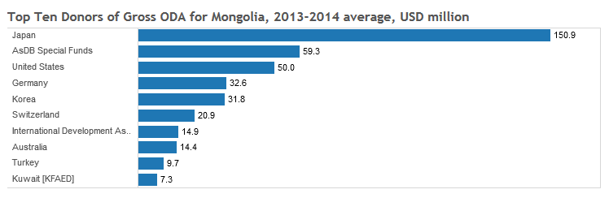
Source: 2016 OECD DAC statistics

WWF as a network has good working relationships and formal partnerships with some of them. The table below summarizes the current state of WWF network and WWF Mongolia engagement with these actors.

PSP | WWF relations at global level | WWF relations in Mongolia? | Dialogue Mongolia WWF NO responsible for PSP?
Japan | No | No | No
ADB (AsDB special fund) | Yes | Japan poverty reduction funded project  No ongoing dialogue | New Contact: Jose Cantos (WWF Philippines)
US | Yes | Current 2 US grants USAID + USFWS  US mission closing in Sept 2017 | No
Germany | Yes | BMZ, BENGO (development support project), KfW | Yes
Korea | Exploring? |  | WWF Korea visit in 2017
Switzerland | Yes | No active cooperation – one SDC project in 2013 on FW (now closed) | No
IDA (World Bank) | Yes | No active cooperation - Wildlife monitoring & assessment closed projects | No
Australia | Yes | No information no contacts | No
Turkey | No | No | No
Kuwait | No | No | N/A

All these actors have well defined their assistance strategies that provide the framework for their development cooperation for their budget cycle (typically 4 to 5 years). It would be important for WWF-Mongolia to further investigate with local resident missions on:
- Future strategy development in the pipeline (e.g. ADB, Germany, Switzerland) and engage in dialogue on key priorities,
- Future budget envelopes and development of pipeline of projects based on their current engagement and strategy (Annex 5A).

WWF Network

WWF’s work in Mongolia began in 1992 with initial funding from WWF Germany focusing on establishing new protected areas. In 1997, WWF Mongolia Country Office was established and was then upgraded to a Programme Office (PO) status in 2002 and legally registered as an affiliate of WWF International. Over the past decades, funds came from three main sources, the WWF Network (WWF Germany, the Netherlands, Sweden, and US), the MAVA Foundation and other donations or PSP through the Government of Mongolia. Within the WWF Network currently only WWF Germany and WWF Netherlands play important role for conservation work in Mongolia. In order to achieve the fundraising overarching goal, WWF Mongolia will focus on increasing and maintaining WWF network support. WWF Mongolia will use WWF network funding mostly as seed money for attracting additional resources at 1:3 ratio with the objective of stable or increasing programme funding year on year compared to current level. However, over the last programme cycle due to changes in individual country and institution’s development cooperation policies and ongoing global financial crisis, the financial support from WWF network and foundations has decreased. If this trend continues, the overall funding for WWF Mongolia will become over reliant on a very limited number of WWF Network donors and susceptible to future funding cuts due to priority shifts. In order to ensure long term sustainability, WWF Mongolia will focus both on securing optimal funds for programmes and diversification of funding sources especially within the WWF Network. WWF Mongolia has continuously been strengthening its capacity in human resources, operations and financial management to fully align to the Network operational policies and standards since the establishment. WWF will establish a country level advisory board which consists of a few prominent high level and influential people in the area of environment and economic development to help guide our policy advocacy and fundraising efforts.

Corporate engagement segment

Few examples of prior experience of WWF-Mongolia in collaborating with corporations exist: (1) Tripartite Endowment Fund with XacBank and a high-end tour operator Nomadic Journeys was established to support mobile anti-poaching activities in the headwaters of Amur in October 2010. Interests have been accumulated since then and no funds are used so far; (2) The MCS Coca Cola Company was a four-year partner for the Earth Hour from 2010 to 2013; several other projects were discussed without tangible outcome;
WWF-Mongolia aims to engage corporations to (1) grow income and (2) influence change. The APGT-commissioned market assessment gave thought-provoking insights that proves the importance of the office to tap on the market and find its niche. Those include:
- Companies appear eager to engage with NPO (Non-Profit Organization) but there is a lack of experience and understanding about how to go about doing this;
- Most activities are based on short-term collaborations (e.g. event sponsorship) with little strategic thinking about mutual benefit;
- There is an opportunity for any NPO willing to invest time in working with companies in an active and strategic way. WWF-Mongolia is well placed to take leadership in guiding companies on key environmental priorities.
That said, WWF Mongolia needs to seriously consider investing time (a dedicated staff) and think strategically. Prioritization exercise of the companies has been carried out among few staff and needs to be re-done if deemed necessary. The initial listing prioritizes the Khaan bank and Trade and Development Bank from the financial sector, the Mobicom and Unitel from telecommunications sector, Oyu Tolgoi from mining sector and several other corporations from beverage, textile and aviation as high footprint. Prioritization exercise includes the assumptions for each type of engagement i.e. green load, coms/product, philanthropy and transformational. The latter type of engagement predominates, followed by product/coms and philanthropy (Figure 2).

Figure 2. Type of engagement

Important market impact WWF Mongolia hopes to achieve is to raise awareness in the HNWI/corporate market in Mongolia of the need to support conservation. Support for conservation is beginning to emerge. Mobicom, the largest mobile provider in the country, started to donate annually to the Mazaalai (Gobi Bear) conservation. If WWF Mongolia can target CEOs of other corporations, it may be able to grow the pie of funds to conservation.

Major Donor Segment

WWF-Mongolia has never strategically tapped the major donor market, focusing on GAAs, foundations and network funding. Thus, there is little track of records on individual (international) donors. For over 15 years, from FY01 to FY15, there were six individual donors only with average gift of 79,000USD.
Hence, Mongolia has been a destination country for network major donors from the US and Europe. The country offers the unique selling proposition of the opportunity to see charismatic and iconic species in some of the most spectacular habitats on the Planet – the 2nd largest population of snow leopards after China (still uncounted in China), Mongolian gazelle resembling Asian prototype of great migration in eastern Africa, the endemic Mongolian Saiga, etc. WWF US, NL and SG offices have capitalized on this opportunity to cultivate their major donors by organizing trips to Mongolia.
In FY15, WWF-Mongolia finally organized its first major donor trip for the snow leopard collaring for Dutch and Singaporean HNWIs. The trip resulted in 35,000USD gift from the Silent Foundation, Singapore, subject to extension for two more years based on performance. The office is keen to capitalize on this success and develop more major donor trips as a cultivation tool, as well as a revenue generating ‘product’.
WWF network offices are relatively well aware of the Snow Leopard, however Mongolian Gazelle, Cranes and Taimen fish are not well known. The Taimen (Hucho taimen) is one of the world’s most charismatic fishes. This is an indicator species of freshwater ecosystems and WWF works collaboratively to conserve taimen and the ecological integrity of its habitat along the course of Mongolia’s Onon River.
The Mongolian Gazelle (Procapra gutturosa) is a medium sized antelope native to semi-arid steppe ecosystem and it once ranged from western Kazakhstan and most of Mongolia to southern Russia and northern China, but it is now restricted to the eastern part of its original range – Steppe ecosystem of Mongolia. The Mongolian gazelle is one of the last great migratory species of Asia and one of the world's last great wildernesses which migrates hundreds or thousands of kilometers seasonally.
MD base is one existing donor from Singapore, cultivated from the last year’s snow leopard collaring expedition. We expect to retain our MD and gain one new MD each year. By the end of FY21, we expect to have at least five donors giving at least 27,500USD per year. Consolidated income of 271,144USD is expected from both cost recovery and major gifts.
There is a high chance for the strategy to succeed because no other country from 12 snow leopard range countries offer collaring expedition, and therefore WWF-Mongolia’s unique selling point for major donors shall be these unique trips that can be offered only through our office.
Target market for this program are network major donors, local High net worth individuals from top corporations, other HNWIs reached by tour agencies that could help market WWF’s trips. By 2021, WWF-Mongolia aims to become a two and half-million USD office where about 20% of income is expected to come from the corporations and major donors (Annex 5B. Major donor programme evaluation and situation analysis).

Fundraising strategy
Fundraising goal: By 2021, income of WWF-Mongolia is increased at least up to 2.5 million USD per year to enable full implementation of the conservation strategy.
# | Strategy | Planned objectives | Indicators
Segment 1: Public Sector Partnership (PSP)
F1 | Increase and maintain funding from multi and bilateral PSPs. | - By 2017, PSP fundraising strategy is developed and structure and capacity is established for PSP together with WWF NOs | Amount of funds from PSP
F2 |  | - By 2021, income from PSP is increased by at least 50% compared to FY17 level
Segment 2: WWF Network
# | Strategy | Planned objectives | Indicators
F2 | Maintain WWF Network funding | - Network funding is stable and maintained at the level of FY17 | Amount of funds from Network
Segment 3: Corporate Engagement
# | Strategy | Planned objectives | Indicators
F3 | Establish long-term partnership with high-impact corporate entities to diversify income with fundraising from corporate entities | 3.1. By 2019, long-term partnerships are established with at least 3 mining companies to provide revenues for conservation measures | # of agreements that bring the funding for conservation  Amount of revenue for conservation fund
 |  | 3.2. By 2021, corporate income represents at least 10% of WWF Mongolia’s income, delivering unrestricted income of 100,000+ USD | Amount of funds from corporates  Share within income
Segment 4: Major Donors
# | Strategy | Planned objectives | Indicators
F4 | Cultivate new donors through major donor programme | 4.1. By 2021, major donor programme generates at least USD 200,000 in gross income (representing at least 8% of income), of which at least 40% is unrestricted cost-recovered from various major donor products such as donor trips, camera trapping and tracking animals. | Amount of funds from major donors

Risks and threats to the fundraising strategy

The major threat would be the economic downturn that threaten corporate giving. However, corporations are an important segment and therefore WWF Mongolia must build partnerships.
For the corporate engagement segment, in FY17 WWF Mongolia aims to establish structure and build capacity, establish initial contacts with priority companies, raise awareness of WWF in the business sector through round-tables, industry groups, public sector bodies and events.
The overall risk assessment for the major donors programme is medium. One of the highest risks is the availability of personnel in charge of major donors programme. Another high risk is the market readiness as although Mongolia has started to build reputation for snow leopard trips within the network, WWF Mongolia needs to expand to a wider audience.
Lack of experience of WWF Mongolia in setting up 5-star trip for HNWIs and low expertise in marketing and sales for trips is another risk. However, capacity building efforts in this area, following a successful first trip with Singaporean HNWIs last year, and future work with the network to train on major donor trip logistics and organizations will greatly support. Another channel to build capacity is to partner with an experienced tour operator to handle logistics for 5-star luxury trips to our project sites. Risks should be considered such as high probability for cancellations and risk to income projections if trips are cancelled.

Communication Strategy

Communication strategy of WWF Mongolia is aimed in achieving of twofold goals – internal and external. On one hand it is essential for success of achieving conservation goals through joint conservation planning processes with local communities and other stakeholders, implementing it jointly with planners, catalyzing of achieved results to public in order to receive accelerated support from them, and influencing key target groups particularly decision malers. On the other hand to increase WWF Mongolia’s profile among all partner and non-partner groups including major targets for fundraising to get more supports not only monetary but emotional nature so that the other donors or interested groups will start to considering and looking for different means of support.
The target audiences for communication are: internally – WWF International, WWF offices that shares common interests in conservation impacts via Altai Sayan and Amur Heilong scopes namely WWF Russia and China, WWF offices traditionally support WWF Mongolia including, WWF Netherlands, Germany, Singapore and USA, other potential offices such as WWF Korea,
Externally – government and non-government organizations of Mongolia particularly Ministry of Environment and Tourism, State Specialized Inspection Agency, Genral Police Authority, local governments of Khovd, GobiAltai, Uvs, Bayankhongor, Zavkhan aimags in Altai Sayan ecoregion and local governments of Khentii, Dornod and Sukhbaatar aimags in Amur Heilog Ecoregion, and local communities from the two ecoregions.
General message to be disseminated to the target groups: internally – WWF Mongolia is trusted and credible partner that is professionally experienced, strongly committed for conservation, with robust and participatory planning and with strong mutual partnership at all levels including high level at the government of Mongolia and well built up team; and externally – WWF Mongolia is the most credible and reliable non-profit environmental NGO that has long-lasting tradition and experience within the environmental communities in Mongolia.
For communication purposes, widely used channels such as lobbying, media, newspapers, building up dialogue platform for particular purposes, film production etc. shall be used to reach decision makers, government and NGOs, local communities, general public and other target groups within Mongolia with particular emphases given on relatively weak performances in the past on digital networks, new IT tools, marketing communications, limited communication contents, lack of continuity after campaigns and need to reach not only Ulaanbaatar area but also other appropriate target audiences. Asian mentality that is only expressed in Asian might be Asian contexts an and to be need to be more outspoken, more assertive / "aggressive" and representing WWF Mongolia in network and with private sector also should be considered profoundly (Annex 6. Full communication strategy).
Communication Strategy
Communication goal: By 2021, WWF-Mongolia’s conservation priorities are fully supported through targeted and innovative communications catalyzing change and strengthen the WWF brand.
# | Strategy | Planned objectives | Indicators
Com 1 | Inspire change of target audiences through effective media strategy | - By 2021, at least 10% of national media institutions have included environmental topics into their policies. | # of media institutions that have policy on environmental topics
Com 2 | Increase WWF-Mongolia’s profile through effective branding strategy | - By 2021, brand KPI is increased by 10% against 2016 level. | % of brand KPI
 |  | - By 2018, conservation messages are conveyed through increased social media channels (Facebook, twitter, Instagram, and YouTube) reaching at least 50.000 users with target to reach 300.000 users by the end of 2021. | # of users (# of likes & # of followers on 4 social media channels)
 |  | - By 2018, WWF-Mongolia’s profile is increased within WWF networks and beyond. | # of stories and press releases that driven to cooperation and fundraising
Com 3 | Engage partners for effective conservation (internal-external) | - By 2019, youth (13-35 years old) participation in conservation is increased by 10% against 2016 level and increase 10% year on year to enhance the conservation effectiveness. | # of participation of youth  # of initiatives by youth
 |  | - By 2019, the Advisory Council is established and functional to support WWF-Mongolia’s profile and activities among decision makers. | Decision on establishment of advisory council  # of minutes on collective decisions made by advisory council

Operation and Finance Strategy

Between FY07 and FY16, WWF Mongolia implemented 36 projects in two ecoregions (ASER and AHEC) with a total funding of 4.5 million Euros. 28 staff members are based in the main office in Ulaanbaatar and two field offices. WWF Mongolia has continuously been strengthening its capacity in human resources, operations and financial management to fully align to the Network operational policies and standards since its establishment. Major achievements include the establishment of the field offices and capacity building of field staff to help implement effective operation and financial management systems. While PO levy was the only steady unrestricted funding source, the office managed to keep unrestricted reserves at a sufficient level through an efficient cost recovery system. This unrestricted reserve in turn allowed WWF Mongolia to implement PSP projects through a reimbursement scheme. The culture of active participation of field staff into the review and planning process instilled during the previous programme cycle has resulted in improving the quality of annual planning. The quality of project reports, contract management has been greatly improved, reflected in both annual internal financial audits as well as conservation programme audits.
In this new strategic plan, WWF Mongolia will focus on a) an effective governance structure that enhances the direction for conservation and operations; b) a high performing office with capable and skilled staff and with a more achievement-oriented culture through the new performance management system (AIM) c) an effective finance, administration and internal control system as a foundation of support to conservation.
The overall goal for operation is that by 2021, sustainably growing office is ensured through effective HR programs and sound financial management. In order to implement operation strategy successfully, WWF-Mongolia aim to increase governance and capacity at following two different functions;
Human resources function

Key Strategic Focuses
- Focus 1- Focusing in the first next 2 years to set the basic blocks in place again to strengthen the governance process (policy, procedures, board of advisors)
- Focus 2- Really spend time to improve the quality in executing these different process, for example
  - Talent management- with the benefit and direction set out. This includes talent acquisition, building and retaining, and succession planning.
  - Building up a mentoring and coaching culture, with a more quality AIM evaluation process backed up by a clear talent management career development direction
  - Revise of the new organization structure, TOR aligned with it and the IPE assessment with a formula to incorporate the inflation fluctuation in the country and consider the other benefits.
  - Assessing the organization skills and evaluate whether to bring in new staff or acquiring skills via consultancy or building up current staff with these new skills.
  - Hiring- Proactive in talent acquisition and check reference and declare the conflict of interest
  - Training for staff- Training plan linked to AIM and be evaluated, continue the corporate sponsorship program for higher education, thorough induction for new staff, Promotion of E learning campus platform and group English training. The structure of staffing, will move towards more managerial role with one more layer of the staff as project assistance.
  - Two field offices are maintained and equipped with more capacity.

Finance and Admin Function
Key strategic focuses
- The vision of the office is to manage a sustainably growing office and achieving at least 2 million Euro in 2 years. The structure of staffing, will move towards more managerial role with one more layer of the staff as project assistance. There will be maintenance of the field office. The administration of financial spending will be continued done centrally from UB.
- All of these pillars in finance management in FY12-FY16 will be continued in the next SP
  - Prepare and deliver all standard financial reports, Gap analysis for implementation, TB, consol. package, R reports, Dashboard/ WWOV to Insight, ending balance for cash and bank, other assets, liabilities, income and expenditures
  - Contract management system updated according to new standard, financial part of C2G is implemented
- Implement and strengthen a few critical processes, including
  - Procurement process,
  - Simplified and up to date C2G log for visibility of the future funding
  - Review and update of cost norms for third party, compatible with market rate. This rate will need to be used in proposal development
  - Finance engagement in budget development for new proposal. Develop a Criteria/ Thumbs of rule for cost recovery ratio that incorporates the full loading cost of the office. These criteria need to be used when designing new proposal and reviewing/ signing off pipelines before submission
  - Risk management: FX management, have a risk management plan in place for big project and better analysis of KPI showing real health of office
  - Capacity building in finance management and policy update for all staff
  - Maintain the current level of support for the IT system

Operation and Finance Strategy
Operational goal: By 2021, sustainably growing office is ensured through effective HR programs and sound financial management.
# | Strategy | Planned outcomes/objectives | Indicators
Op1 | Ensure effective organizational structure and human resource to strengthen managerial role for support of conservation impacts | - By 2017, talent management scheme including talent acquisition, building and retaining, and succession planning is set up and fully implemented and maintained annually. | Approved talent management plan  % of implementation
 |  | - By 2018, staff capacity gaps are identified and effectively addressed through capacity building training and mentoring and coaching culture | # of gaps to be in line with emerging situation per staff  Performance of development plan vs AIM
 |  | - By 2021 office ability to attract staff with the right skills and capacity is increased by at least 30%. | Value and description of benefits  working condition
Op2 | Ensure effective financial management of sustainably growing office | - By 2021, office capacity in finance management is improved to manage at least 2.5 million USD per year. | Quality and timely delivery of finance report;  Level of confidence in finance technical areas
 |  | - Annual all Key financial KPIs are met with on target rating through necessary measures in line with Intl standards. | KPI ratings
 |  | - By 2017, risk management plan is developed and fully implemented and monitored annually. | Assessment of risk management
Op3 | Maintain sound IT system in accordance with international standards | - By 2017, IT system is fully operational and upgraded on continues basis as required. | Functionality of IT infrastructure

Monitoring and Evaluation

WWF-Mongolia’s new strategic plan will be subject to well established multi-layered routine monitoring and regular assessment & evaluation processes for increased operational transparency and enhanced conservation programme effectiveness through monitoring of SPMSS/APMS. The current system titled SPMMS/APMS monitoring and evaluation (M&E) procedure for WWF-Mongolia is well systematized and synchronized with WWF’s Network Standards of Conservation Project and Programme Management (PPMS) as well as the FOM, as such WWF-Mongolia programme will fully comply with the M&E requirements.
The overall M&E of conservation programmes will be led by a Conservation director and Country Representative, supported by programme staff which will have M&E responsibilities integrated into the individual work plans. The Head of the Finance Administration will be responsible for ensuring F&A compliance including the programme and finance auditing and will serve as a focal point for POM Dashboard.
An integrated Strategic Planning and Monitoring System (SPMS) and Annual Planning and Monitoring System (APMS) (see Annex 7) that incorporates both Programme and Operational strategies and objectives will be reviewed and analyzed by the SMT at least in semi-annual basis to ensure adequate adjustment and adaptation according to the changing situation both outside and inside of the organization.
The strategic plan will be translated into annual KPI targets to guide the organization in delivering the necessary conservation and operations impact. These will be included within the SPMS/APMS and POM Dashboard tool and quarterly review process by the SMT. This programme level monitoring will build on the quarterly and half-yearly financial and technical progress reports of projects and ecoregional programmes and their analysis. These annual and semi-annual technical progress reports (TPRs) will be shared with key stakeholders including WWF network donors and WWF International.
Findings of these reports and analysis will serve basis for WWF Mongolia Senior Management Team’s (SMT) corrective actions and decisions. In the new programme cycle WWF Mongolia will ensure that there will be a formal, documented quarterly review process, led by SMT, and using the new POM Dashboard strategic plan reporting tool. The progress of the ecoregional programmes will be reported to the Steering Committees at least once per year, ensuring the adaptive management of the programme.
During the programme cycle WWF-Mongolia is budgeted to have mid-term and final programme evaluations for the entire programme in addition to any project specific evaluations. WWF-Mongolia will be responsible for facilitating the external evaluation and provide all necessary documents, information and logistics. A separate evaluation could be conducted if it deemed necessary. As part of this evaluation, WWF Mongolia will perform a detailed impact monitoring based on the indicators defined in the monitoring plan.
The experience and best practices gained during the programme implementation will be shared with all stakeholders through the standardized progress reports including the evaluation report as well as in the form of various technical reports. At the same time, a cross learning and sharing culture will be created among staff and the SMT members through quarterly APMS review and all the documentation and tools will be stored in Mongolia’s Office Google site. At corporate level these reports will be shared via “OneWWF” and at AHEC level via Amur Information center. At national level the lessons and best practices gained from the programme will be shared through websites and technical report launching as well as through targeted training and workshops.
Key Strategy Focuses:
- M&E work for the office, in conservation lead by Conservation Director and in opearation lead by Operation and Finance director according to KPI and SPMS/APMS. The projects and staff all engage in collecting M&E data for their work. Thus, there is no need for a dedicated M&E person but they might need support in designing better indicators
- Continue leverage and lead the NGO working group and maintain MoU with strategic agencies for sharing data and better synergy in implementation
- Improving in the area of generating and learning on Grass lands, Ungulates, Ecosystem, CC issues, dissertation to inform its strategies and advocacy work.
- Integrate M&E work during budgeting process

Overall risks to the Strategic Plan and mechanisms for mitigation

WWF-Mongolia has installed a sound management control system that serves as good pre-warning for any potential risks enabling the Office to take pro-active actions to prevent or mitigate risks to the conservation targets and goals. At programme level, close peer review of any new projects and programmes at design stage allows avoiding possible pitfall while at operational level close review of financial planning and HR allows the office take proactive actions to prevent any challenges arising.
During the preparation of the new strategic plan several potential risks have been identified and mitigation actions are proposed as summarized in the Annex 8.

Implementation mechanism for strategic plan

WWF-Mongolia's overall governance is handled through Asia Pacific Programme line manager that provides overall guidance and regional Steering Committees on Altai-Sayan and Amur Heilong Ecoregions that covers programme development, implementation, monitoring and management issues. At the country level, the Senior Management Team, consisting of Conservation Director, Administration Director and Development Director led by the PO Representative, will be responsible for management decisions on key programmes. Key specialists and focal points in connection with global goals led by ASER and AHEC managers will be responsible for implementation for ground based conservation work and deliverables issues (Annex 4).

References
Asian Development Bank, 2016, Basic Statistics.
Chimed-Ochir, B., Hertzman, T., Batsaikhan, N., Batbold, D., Sanjmyatav, D., Onon, Yo. and Munkhchuluun, B., 2010, Filling the Gaps to Protect the Biodiversity of Mongolia.
IFAD - The International Fund for Agricultural Development, 2010, Project report for market and pasture management development
International Monetary Fund, 2013, Mongolia Country Report.
Ito, T. Y., N. Mura, B. Lhagvasuren, D. Enkhbileg, S. Takasuki, A. Tsunekawa, and Z. Jiang, 2005a, “Preliminary evidence of a barrier effect of a railroad on the migration of Mongolian gazelles”, Conservation Biology, 19(3):945–948.
Ito Takehiko, Naoko Miura, B. Lhagvasuren, D. Enkhbileg, Atsushi Tsunekawa, Seiki Takatsuki and Zhaowen Jiang, 2005b, Analyses using satellite technologies on relationship between migration routes of Mongolian gazelle and relative primary productivity in their habitat, International conference, Seoul, South Korea.
Ito T., Ayumi Okada, Bayarbaatar Buuveibaatar, Badamjav Lhagvasuren, Seiki Takatsuki, Atsushi Tsunekawa, 2008, One sided barrier impact of an International railroad on Mongolian gazelles, Journal of Wildlife Management, 72(4): 940-943
Ito T., A.Tsunekawa, B.Lkhagvasuren. 2009. Monitoring movements and habitat of Mongolian gazelles using satellite technologies, Proceedings of the International Congress for Conservation Biology, 13 JUL 2009, Beijing.
Ministry of Environment, Green Development and Tourism, 2013, Mongolian Red Book, Ulaanbaatar.
Ministry of Environment, Green Development and Tourism, 2014, MONGOLIA: Assessment report on Climate change, Ulaanbaatar.
Ministry of Environment, Green Development and Tourism, 2015, National Biodiversity Program (2015-2025), Ulaanbaatar.
National Statistical Office, 2013, National Statistical Yearbook, Ulaanbaatar.
Oxford Business Group, 2015, The Report Mongolia.

Annexes

Annex 1. Conservation achievements for FY12-16 and ratings of previous five year conservation goal achievement

Year | Achievements
FY12 | - 10 new PAs and extensions of 5 PAs in ASER and AHEC covering additional 2,061,308 ha of critical snow leopard, Argali sheep and Freshwater habitats  - Positive trends in the development of populations of Argali sheep, Snow leopard and Mongolian saiga
FY13 | - First snow leopard collared in ASER in 2013  - Extension of existing PA covering a total of additional148.866 ha of critical habitat of Snow Leopard and its main prey species in ASER (124866), and Trans-Siberian boreal forest in AHEC (24,000 ha)  - “Snow Leopard Compensation Fund” piloted with 60% of the funds endowed by the community  - Zero poaching of Snow leopard and Argali sheep  - transboundary population of Argali sheep increased to 2000  - Legal framework for community-based natural resource management (CBNRM) is in place  - River Basin Authorities (RBA) of Khar Lake-Khovd, Khyargas Lake-Zavkhan in ASER and Onon in AHEC established
FY14 | - Agreement between main stakeholders established on managing fish resources in the Onon River Basin sustainably  - Mongolian saiga population saved from brink of extinction by increasing its number from 2,860 in 2007 to 14,600 individuals in 2014  - Establishing an Best Practice example for integrated communication work – WWF/RARE campaign on Taimen  - Two documentary films – Argali sheep and Snow leopard by NHK with support of WWF-Mongolia
FY15 | - Adoption of national standards for migration passages for steppe and Gobi ungulates  - Transboundary Argali sheep population increased almost doubled within two years  - 11 km of critical trans-boundary migration of Argali between Russia and Mongolia kept fence free  - No-Go areas for mining – Methods approved and National level analysis conducted  - National Biodiversity Program for 2015-2025 developed by WWF-Mongolia and approved by the Government of Mongolia  - Key species’ population trends are positive
FY16 | - 1.6 mln ha in AHEC and 2.1 mln ha in ASER areas identified as No-Go Areas for mining, accordingly Khentii Aimag Parliament officially approved 316,504 ha areas as No-Go Areas for mining  - First snow leopard donor trip successfully organized  - Anti-trap campaign initiated by school kids led to a decree to ban traps, signed by the Minister of Environment  - “The spirit of the mountain” - “The best short film” produced addressing conflicts between human and snow leopard  - 3 Snow leopard, 8 Mongolian saiga and 10 Mongolian gazelles collared in ASER and AHEC  - A small population of Mongolian saiga with over 40 individuals is constantly recorded in its northern historical range since 2013  - 25 reserve pastures and local protected areas covering 462,775 ha (38.5% of the saiga habitat) are officially established

Below we summarize achievements over the entire 5 year period against set conservation goals:
- Goal 1: By 2021, protection of forests in AHEC is increased by at least 145,000 hectares over the 2011 levels.
Implementation status: 37.8% achieved.
During the last 5 years, 54,894 ha area is designated as state protected area in AHEC. In addition, there are 124 forest community-based organizations (FCBOs) established to manage 478,270 ha forests.
- Goal 2: By 2021, the freshwater ecosystem functions of the priority river basins in ASER (Khar lake-Khovd River, Khyargas-Zavkhan River Basins) and AHEC (Onon and Ulz River Basins) are maintained at the 2011 level, and the wetland areas in AHEC and ASER are increased by at least 265,000 ha over the 2011 level.
Implementation status: 100% achieved.
The amendment of law on Water provides a legislative background for establishing River Basin Administration. According to the law, RBAs for priority river basins in ASER and AHEC were established and and the IWRM plans were developed and approved by the Minister of Environment and implementation is ongoing. The wetland areas that is included into PA Network is increased by 178 306 ha (11923 ha in ASER, 166383 ha in AHEC) over the 2011 level.
- Goal 3: By 2021, the percentage of steppe habitat in a favorable or high conservation status is increased by 35% in ASER and by 10% in AHEC over the 2011 levels.
Implementation status: 100% achieved both in AHEC and ASER.
The steppe ecosystem protection is increased by 688,518 ha (39.8% increase compared to 2011 level) in ASER and 717,814 ha (58% increase compared to 2011 level) in AHEC covering the important habitats of Mongolian gazelle, Argali sheep and Mongolian saiga.
- Goal 4: By 2021, key habitats of Mongolian gazelle and Asiatic Wild Ass are connected and protected from linear infrastructure development (railways, roads, fences) in South Gobi and Mongol-Manchurian grasslands.
Implementation status: 50% achieved.
As a result of 2-year efforts of facilitation and lobbying by WWF-Mongolia, the new mandatory Standard for Passages of Rail and Highway roads for ungulates in the steppe and Gobi region of Mongolia has been successfully approved according to the National Standards’ Council decree No 26 dated June 25, 2015. This standard includes basic principles to mitigate impacts from the road sector to the wildlife habitat and migration through building 3 types of wildlife passages in particularly cross level, overpass and underpass passages. The new standard is definitely a historical milestone that would keep such important ecological process as migration of steppe ungulates if implemented appropriately. Therefore, implementation of standard and law enforcement and monitoring is crucial.
- Goal 5: By 2021, the Argali sheep population is increased by 30% in priority areas over the 2009 level.
Implementation status: 100% achieved.
Annual census of the Argali sheep in trans-boundary areas between Mongolia and Russia revealed that the population number reached 2,813 individuals in the Mongolian part of ASER. This indicates that the argali population in trans-boundary areas increased 3 times compared to 2009.
- Goal 6: By 2021, the Saiga antelope population is increased by 30-50% over the 2010 level. Nested target: Desert steppe ecosystem.
Implementation status: 100% achieved.
The population has nearly doubled in 2015 compared to the 2010 baseline e.g increase from 8000 to over 15000 heads and the range is extended by 13% since 1998. A small population with over 40 individuals is constantly recorded in the northern historical range of Saiga since 2013 and witnessed by locals, where no individual been recorded over the last 60 years. This demonstrates on how conservation and management measures applied to the Desert steppe ecosystem, as nested target for Saiga is yielding in the increase of the Saiga population and extension of the range.

- Goal 7: By 2021, the Snow leopard population is stable at the 2010 level.
Implementation status: 100% achieved.
The minimum number of the snow leopard in 8 priority areas for snow leopard conservation is stable and even little increase is recorded compared to 2010 level. However, modern methodology such as camera traps and noninvasive collection of scat sample may reveal higher number of snow leopard (Table 2).

Table 2. Snow leopard numbers in key areas in ASER
# | Area name | Baseline (2010) | Current status (2016)
1 | Altan Khukhii | 25 individuals | 25/no update
2 | Jargalant-Bumbatkhairkhan | 28 individuals | 40 individuals
3 | Munkhkhairhan | 18 individuals | 18/no update
4 | Baatarkhairkhan | 9 individuals | 8 individuals (only in 1/3 parts of the mountain)
5 | Siilhem B | 9 individuals | 10 individuals
6 | Tsagaan Shuvuut | 17 individuals | 17/no update
7 | Tsambagarav | no data | no update
8 | Turgen | 45 individuals | 45/no update
 | TOTAL | 151 individuals | 163 individuals

Annex 2. Results chains

Figure 3. Results chain for delivering the impacts of law enforcement strategy
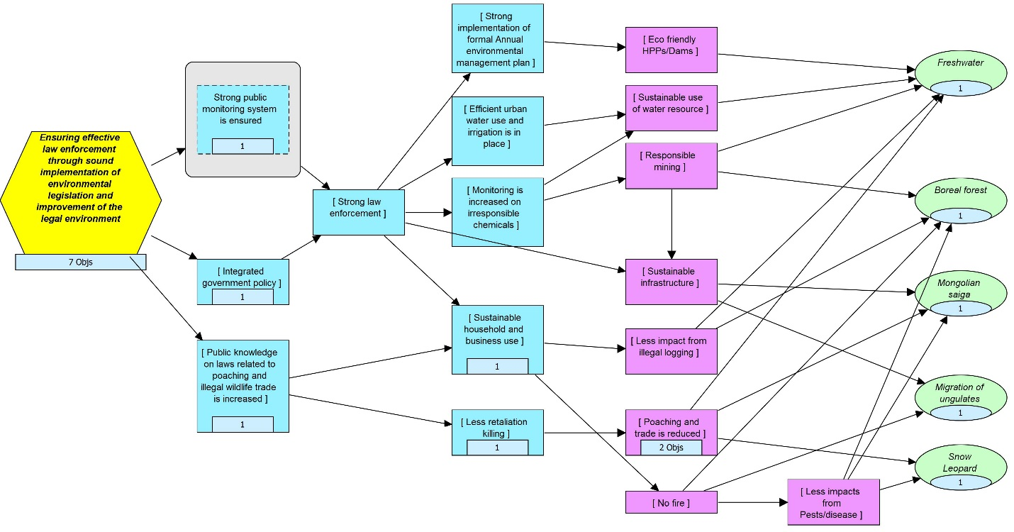

Figure 4. Results chain for delivering the impacts of supporting green financing in conservation strategy

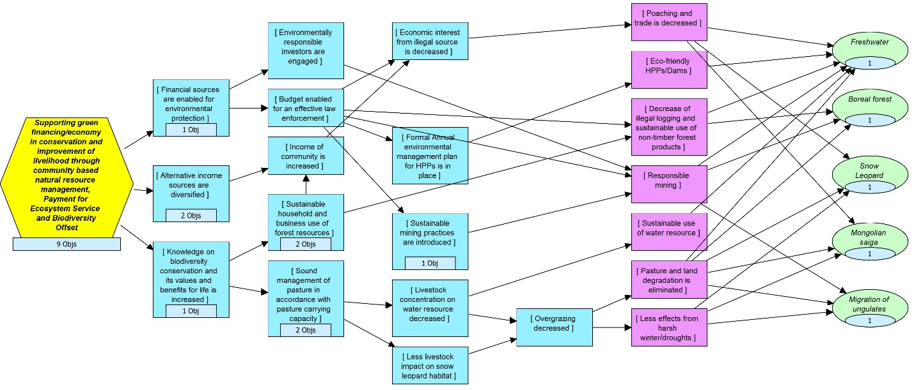

Figure 5. Results chain for delivering the impacts of climate smart landscape planning and management strategy

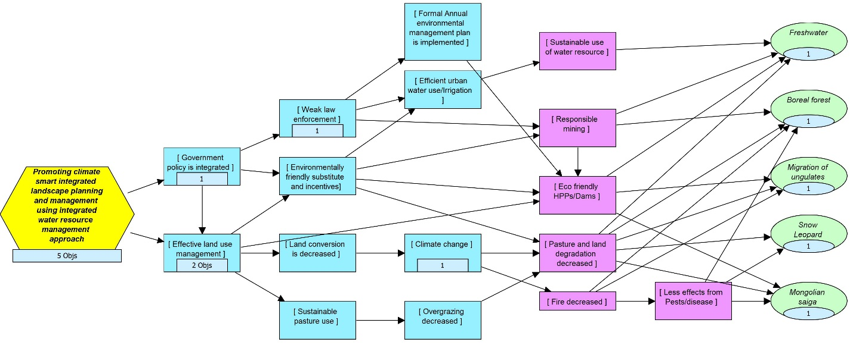

Figure 6. Results chain for delivering the impacts of well-connected system of protected areas strategy
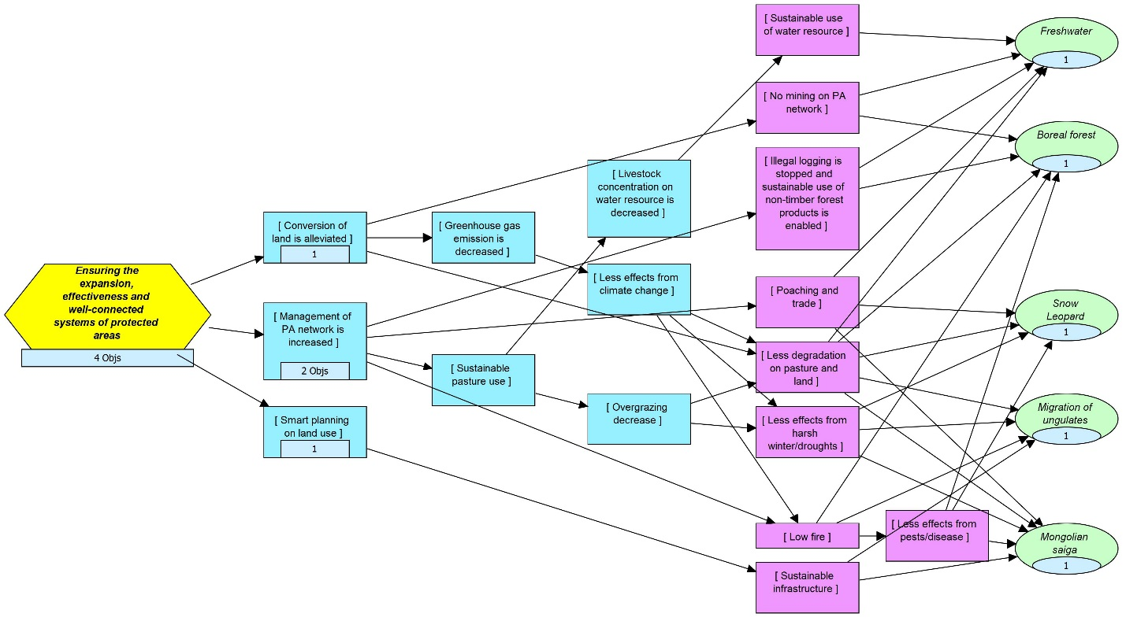

Annex 3. Key partners for conservation programme and their engagement

Please refer attached Excel file for details

Annex 5A. PSP situation analysis and engagement areas

Japan: Focal areas of JICA Country assistance are:
- Sustainable development in the mineral resource sector and stronger governance: creating systems and training human resources for sustainable mineral resource development, the key to Mongolia's economy. Also, the creation of a system and other measures for properly managing resource revenue.
- Support toward inclusive growth: creating employment and improving basic social services, with a focus on micro, small and medium-sized enterprises to create a diversified industrial structure.
- Strengthened urban functionality in Ulan Bator: improving the infrastructure of Ulan Bator, along with urban planning and management capacity.
From the list of existing projects supported by JICA (please see link at: http://www.mofa.go.jp/files/000048304.pdf), there is potential scope to engage with the resident mission on agriculture/rural development and natural environment conservation on:
- (TCP) Enhancing the Extension System for Comprehensive Crop-Livestock Management,
- (ITR) Training of Veterinary Specialists on the Reliable and Instantaneous Diagnosis of Animal Infectious Diseases and
- (TCP) River Basin Management Model Project for the Conservation of Wetland and Ecosystem and its Sustainable Use in Mongolia.
Another potential avenue would be to explore scope for engaging JICA volunteers (see JICA Volunteers). This could: Enhance technical capacity of WWF-Mongolia and enable closer ties with Japan cooperation and investigate further financing potential. Finally a map of JICA funded projects is also available: Map of JICA Major Projects in Mongolia (PDF/42KB).

Asian Development Bank: The interim country partnership strategy (ICPS), 2014–2016 for Mongolia provided two strategic adjustments to the country partnership strategy (CPS), 2012–2016. These adjustments reflected government priorities for the inclusion of two additional sectors; (a) agriculture, natural resources, and rural development; and (b) finance-to support economic diversification and job creation. The ICPS addresses infrastructure gaps, regional economic integration, access to basic urban services, and the efficient delivery of social services. ADB is currently preparing a new CPS for 2017–2020, starting with a comprehensive review of the current strategy’s relevance and effectiveness.
As part of the new CPS, ADB may extend a broader range of assistance to the country, particularly in power, heating, renewable energy, water, education, health, and other municipal infrastructure. The aim will be to help transform service delivery, stimulate participation by the private sector, and promote green development in a country that is one of the most affected by climate change. ADB also hopes to intensify its co-financing partnerships, providing additional resources and knowledge products to address Mongolia’s most pressing development issues.

World Bank: The World Bank Group’s CPS is aligned with Mongolia’s Comprehensive National Development Strategy. It identifies three areas which the World Bank Group supports over the five years between FY13 and FY17: (Please see at link: http://documents.worldbank.org/curated/en/687471468053969480/Mongolia-Country-partnership-strategy-for-the-period-FY2013-2017)
- Enhance Mongolia’s Capacity to Manage the Mining Economy Sustainably and Transparently with two outcomes: (i) supported the country in developing a regulatory environment, institutional capacity, and infrastructure for world-class mining, and (ii) supported the Government in designing and implementing policies and systems for a more robust, equitable, and transparent management of public revenues and expenditures.
- Build a Sustained and Diversified Basis for Economic Growth and Employment in Urban and Rural Areas with two outcomes: (i) enhanced the investment climate and financial intermediation, and (ii) created more opportunities in the rural economy for enhanced livelihoods.
- Address Vulnerabilities through Improved Access to Services and Better Service Delivery, Safety Net Provision, and Improved Disaster Risk Management with three outcomes: (i) worked with the Government on the design, adaptation, and implementation of a comprehensive social protection system that supports the poor, (ii) supported better delivery of basic services (education, health, justice, and infrastructure), and (iii) reduced vulnerability of households exposed to natural hazards and pollution.

Germany: Mongolia is one of the cooperation countries of the German development cooperation. Germany is the biggest European partner by far and is its third largest donor country after Japan and the USA. The focus of cooperation is on sustainable economic development with priority placed upon extractive sector, protecting biodiversity and improving energy efficiency. German development cooperation is helping the Mongolia’s government to establish a sustainable management system for ecologically significant regions, and advise on climate and environmental policy, aiming at building capacities, such as a national system for monitoring biodiversity and a management system for protected areas. GIZ has been present in Mongolia since 1991 (https://www.giz.de/en/worldwide/384.html) and key ongoing projects include: https://www.giz.de/en/worldwide/17729.html. With the Ministry for Environment & Tourism: biodiversity and adaptation of key forest ecosystems to climate change II expected to end in 2018 and REDD+ national forest inventory in Mongolia expected to end in 2016.

USA: The U.S. Agency for International Development (USAID) has phased out more than two decades of development assistance programming and the Peace Corps has an active program in Mongolia. The United States and Mongolia implemented important, long-lasting development projects through a Millennium Challenge Compact between September 2008 and September 2013 and began development of a second compact in January 2015. Please go for more info on: http://www.state.gov/r/pa/ei/bgn/2779.htm

Switzerland: Swiss Agency for Development and Cooperation (SDC) - Switzerland’s international cooperation agency under the Federal Department of Foreign Affairs (FDFA) – is the implementing body of the Swiss official development assistance in Mongolia.
In the latest Swiss Cooperation Strategy with Mongolia 2013-2016, SDC has prioritized: (1) Mongolia’s agricultural development, ensuring food security and better livelihoods for the most vulnerable of the population; (2) Greater involvement in vocational education and skills training for unskilled youth and adults in order to improve their employability; and (3) Strengthening good governance and civil society development, in particular through support for reforms related to decentralization, direct democracy and civic participation.
The Strategy draws on interesting lessons and focuses on natural resource management and strengthening local civil society organizations in advocacy. SDC supported pastoral groups and the creation of water user groups in order to promote better water management and reduce conflict. Given the strategy about to expire, it looks proper to engage into a dialogue now with the local resident mission on the development of the next country assistance strategy. Link: https://www.eda.admin.ch/countries/mongolia/en/home/representations/cooperation-office.html

Australia: The Australian Government will provide an estimated $10.0 million in total ODA to Mongolia in 2016-17. This will include an estimated $5.9 million in bilateral funding to Mongolia managed by DFAT. The bilateral program has consolidated to assist two sectors—human resource development and the extractives sector. The focus of the relationship between Mongolia and Australia to date has been on development assistance and commercial activities in Mongolia's resources sector. Australia opened an Embassy in Ulaanbaatar in December 2015.
Australian Volunteers for International Development in Mongolia are placed in sectors which align with both Australian and Mongolian Government development priorities, including human resource development, extractive industries, water and sanitation, and disaster risk reduction. Host organisations can be government agencies, local NGOs or INGOs and multilateral agencies. The Australian Centre for International Agricultural Research project on grassland management in Mongolia and China is working to improve livelihoods for herders.
Australian companies are well-placed to assist in developing Mongolia's resources, and there is strong commercial interest and investment potential in Mongolia's minerals and energy sector. About 50 Australian companies are present mostly in the mining and contracting sectors and supported through the Australian Trade Commission. The Oyu Tolgoi copper and gold mine alone is expected to account for as much as 30 per cent of Mongolia's GDP once full commercial ore production starts

Korea: Korea’s partnership strategy traditionally aimed to contribute to the implementation of Mongolia’s development plan. The priority areas for the period of 2012-2015 in the CPS were established through close collaboration between the governments of Korea and Mongolia with regular consultations and policy dialogue. Based on the development priorities and the needs of Mongolia, Korea’s existing projects in Mongolia and comparative advantage were reflected in the process of establishing the CPS. Thus, Korea was focusing 70% of its budget for development cooperation priority programs namely, Governance, Urban development and Agriculture and this trend will likely be kept, given well established traditional relationship between the two countries.
- Enhancing the productivity and transparency of the public sector through the development of an e-Government master plan, widely adopting e-Government and capacity building for IT development and management (Sector: Governance).
- Promoting balanced and sustainable economic development through urban development; in particular, supporting Ulaanbaatar city development for the reduction of urbanization problems, and supporting comprehensive urban development in accordance with the regional development plan (Sector: Urban Development)
- Strengthening food security and increasing income of farmers through improved agricultural value chain and enhanced agricultural productivity, and supporting livestock development programs (Sector: Agriculture)
In addition to the existing top ten donors, it is also important to note other actors that could potentially be relevant for WWF to engage in Mongolia. This section provides a short description of some of these.
European Union:
In the absence of a European Union Mission in Mongolia, its annual programme for Mongolia is managed with the limited human/financial resources based in the EU Delegation in Beijing. Please see Multiannual indicative programme 2014-2020 for Mongolia at: https://ec.europa.eu/europeaid/multi-annual-indicative-programme-mip-mongolia-2014-2020_en

Under governance, assistance is envisioned to create stronger governance of mining revenues through the establishment of a sovereign wealth fund. In this respect, it’s worth noting that WWF has been successfully engaging with the Norway SWF to influence their investment portfolio away from fossil fuels. Lessons could be shared with WWF Mongolia in this respect by WWF Norway.
The governance agenda in support of sustainable and inclusive development encompasses also improving policies and regulations in a number of areas, e.g. related to environmental protection, fiscal arrangements and spending policies. The focal sector foresees broad based support to build capacity in the Government administration, both at central and sub-national level, underpinning more adequate policies and regulations towards inclusive and sustainable development. A budget envelope of EUR 34 million was provisioned. Further assistance will be provided on capacity building to improve the formulation of policies and legislation in prioritized fields for economic, social and environmental governance (including support with the implementation of multilateral environmental and climate-related agreements) to support Mongolia in its aim to draw on European norms and standards including in the areas of competition policy and state aid control. Improved environmental governance will further substantially reduce the negative impact of mining industries on the environment.
Under Focal Area 2 the objective is to increase employment opportunities, which are not harmful to the environment, to help reduce poverty and income inequality with a primary focus on those rural areas that do not benefit from the mining and construction boom. One expected result is to support Value chains in rural areas and promote green and decent jobs through technical and vocational training. A budget of EUR 30 million is provisioned.
The Mongolia Government has so far neither taken a lead in donor coordination nor in initiating joint action plans with any donor concerning the implementation of aid effectiveness principles. In the absence of an EU Delegation in Ulaanbaatar and given the fact that programming cycles of other relevant donors, including of EU Member States where only Germany is a major donor, are not synchronized with the DCI, the conditions for Joint Programming are not there at present.

Based on alignment with development strategies of the Mongolian Government, the EU will explore possibilities for a more coordinated approach with Member States and other donors.
Germany’s country strategy for cooperation with Mongolia ends in 2016; options for closer cooperation with large donors amongst member states will be explored between 2014 and 2017.
Engaging into a dialogue with the German resident mission to discuss core conservation priorities appears therefore very timely to help inform the new German Country Strategy.
Under the current EU Budget Cycle 2014-2020, a number of thematic and geographic programmes related to the environment and civil society have been set up and could be explored for accessing finance. The WWF European Policy Office provides information on these global and regional opportunities. https://sites.google.com/a/wwf.panda.org/psp-share/team-pages/european-policy-office

Global Environment Facility (GEF): The Global Environment Facility Trust Fund (GEF) acts as the financial mechanism for five international conventions. The GEF provides grants to meet the incremental cost of converting projects with national benefits into projects with global environmental benefits. Project proposals have to address one of its focal areas: biodiversity, climate change, chemicals & waste, land degradation, international waters & sustainable management of forests/REDD+. This is in addition to a number of GEF program areas that are more multi-focal and cross-cutting in nature, for example food security and public-private partnerships. WWF US is a GEF Agency and developing a pipeline of projects together with WWF network offices and other partner organizations. It may be opportune to contact the GEF Operational Focal Point in the country and discuss the country allocation to date under the GEF6 budget, as well as preparing ground for GEF7 (2018-2020).
Green Climate Fund
The Green Climate Fund is an international public sector fund established by 194 governments that is focused on low carbon and climate-resilient development in developing countries. The GCF aims to deliver equal amounts of funding to climate change mitigation and adaptation with a reasonable and fair allocation across a broad range of developing countries. Its investment criteria are: country ownership, climate impact potential, paradigm shift potential, sustainable development potential, needs of the recipient, economic efficiency and financial viability for revenue-generating activities (see the full investment framework). The fund also has a target to maximise engagement with the private sector, including through allocating funds to the Private Sector Facility.
Fund mechanism: To-date the GCF has raised US$10.3 bn in pledges from 43 state governments, notably from the USA, Japan, UK, France and Germany (it also accepts pledges from regional governments and cities). Projects can access grant funding from the GCF at the following scales: micro projects ≤$10m; small projects >$10m and ≤$50M; medium projects >$50m and ≤$250m; large projects >$250m. US$16 million is available as grants for readiness and preparatory support activities (capped at US$1 million per year to individual developing countries). A minimum of 50% of this fund is targeted at particularly vulnerable countries.
Proposal process: Each developing country allocates a National Designated Authority or Focal Point which are the interface between each country and the fund to ensure that funds are allocated in line with the country’s strategic priorities. Every proposal to the GCF must be accompanied by a “no-objection letter” signed by this authority evidencing the country's support for the proposed project.
Projects and programmes can then access funding by going through a process of accreditation or by working together with accredited implementing entities and intermediaries (these might be private, public, non-governmental, sub-national, national, regional or international). WWF US was just accredited at the December 2016 GCF Board Council. Click here for the more information on the WWF-GCF webpage engagement and advice on project development.

Sustainable Water Fund (FDW) – Netherlands
The Sustainable Water Fund-programme (FDW) is a Public-Private Partnership facility, ran by the Netherland Enterprise Agency, which aims to contribute to water safety and water security in developing countries. In real terms this means support to collective initiatives between governmental bodies, industry and Non-Governmental Organisations (NGOs) that focus on the following subthemes:
• Improved access to drinking water and sanitation (including solid waste)
• Efficient and sustainable water use, particularly within agriculture
• Safe deltas and improved basin management.

Japan – Keidanren Nature Conservation Fund (KCNC)
KCNC was established in 1992, in the same year as United Nations Conference on Environment and Development at Rio de Janeiro was held. Since its establishment, 32 million US dollars have been granted to approximately 1,000 projects through KNCF (Keidanren Nature Conservation Fund). KNCF/KCNC supports a wide range of projects mainly on biodiversity conservation including natural resources management and rare species conservation and others such as plantation or environmental education.

Annex 5B. Major donor programme evaluation and progress analysis

There are two strategies to be adopted by major donor programme: cost recovery from the trips and major gifts:
Cost recovery: We expect to carry out one trip in FY17 and two trips in FY18, three trips in FY19 and four trips each in FY20 and FY21. The cost recovery for FY18 shall be 44,100USD, gradually increasing to 117,394USD by FY21. One trip itinerary is focusing on the snow leopard in the Altai-Sayan eco region. Another itinerary, featuring Mongolian Gazelle in the grasslands, Crane-watching and Taimen fish in the headwaters of Amur and is considered to be developed for major donor trip.
Targets and Milestones - Key Performance Indicators (KPIs)
Timeframe | Trips
FY17 | Development team hired for corporate engagement and major donors
FY17 | Two best-in-class trips in the Altai-Sayan and Onon River Basin developed
FY18 | 2 Major donor trips delivered
FY19 | 3 Major donor trips delivered
FY20 | WWF Mongolia delivering 4 Major donor trips annually – 2 in the Altai-Sayan and 2 in the Onon River Basin

KPIs for Major Donors booked:
 | FY17 | FY18 | FY19 | FY20 | FY21
Existing | 1 | 1 | 2 | 3 | 4
New |  | 1 | 1 | 1 | 1
End of Period | 1 | 2 | 3 | 4 | 5
In 2013, the country saw more than 415,000 incoming visitors and a reported market turnover of $263m, which represented around 4% of GDP at the end of the year. Indeed, in 2015 Mongolia served as the partner country at ITB Berlin, the world’s largest travel and tourism conference which is expected to boost figures further in the coming years.
While the number of tourists to Mongolia has undoubtedly increased in recent years, the available data about incoming visitors is widely acknowledged to be somewhat misleading. This is due primarily to the fact that visitors from China and Russia, which have accounted for more than 60% of incoming visitors in recent years, generally enter the country to carry out business.
The tourism sector is broadly organized into a handful of key segments. Leisure tourists account for between one quarter and one third of total incoming visitors. Over the past decade, Mongolia has earned a reputation as a key destination for outdoor and adventure sports and other related activities, including trekking, climbing, fishing, hunting and bird-watching, among many other things.
Most local players agree that Mongolia has the potential to eventually become a sizeable and highly profitable tourist destination. “Mongolia is not a mass-market destination and it never will be, so we need to focus on areas where we offer something unique”, said B.Indraa, Director of the Governing Board, Mongolia National Tourism Organization.
Source: Oxford Business Group, 2015

Income: We assume one new donor will be booked a year starting from FY18. We assume 6 guests/trip of which, at least one guest is a prospect while the others are family and/or friends of the prospect. If we book 1 new donor/year out of 4 prospects/year that would be 25% response rate.
One of the fundraising goals of WWF-Mongolia is to strengthen WWF Mongolia’s conservation impact by engaging strategic business sectors and high net worth individuals (HNWIs) to transform, influence and grow income. Within this goal, we aim to engage one major donor each year through our unique donor trips by FY21. Investment to MD programme is expected to generate about 11% (10.8% to be exact) of WWF Mongolia’s income by the end of FY21 diversifying funding and reducing risk and dependence on network funds (Table 1).
Table 1: Income diversification by FY21
Source | FY16 | FY21
Network | 67% | 27%
PO Levy | 10% | 5%
Foundations | 14% | 36%
PSP/GAA | 9% | 18%
Corporations | 0% | 15%
Major Donors | 0% | 11%

In FY18, WWF-Mongolia will aim to negotiate and close one product/communications for at least 2 transformational partnerships. In FY19, we will deepen relationship with engaged corporations and industry groups to achieve large-scale sustainable outcomes and conservation wins. In FY20, we will ensure that transformational partnerships are viable in the long-term and can be replicated across other key natural resource and agricultural sectors that drive Mongolia’s economy and in FY21, WWF shall be established as a thought leader in the Mongolian market in biodiversity and footprint across business and industry networks, across the region and is engaged with 8 companies. Obviously, this can be reached in case of investing appropriate time of a dedicated staff.
WWF Mongolia aims to engage network prospects and donors beyond the network and not excluding Mongolia market. We have a unique product – our trips and we expect annual gifts. We have strong conservation team with unique knowledge of snow leopards in the project site and multi-year collaboration with local herders and communities. Therefore, WWF-Mongolia is offering unique selling proposition available only through our office.

Annex 6. Communication strategy for FY17-21

Introduction
Outline of the communications strategy was developed by all staff of WWF-Mongolia during annual meeting held in July 4-6, 2016. Thanks to active engagement and participation of conservation and operation staffs, the communications team could define communications strategy and objectives, identify effective communication tools/engagement and oversee barriers that may occur and from which we must prevent. Finalizing of the strategy was carried out by communications team with feedback from conservation teams, WWF-Mongolia.
The strategy is intended to guide the communications and branding work of WWF-Mongolia in line with the Conservation Strategy FY17-FY21. This working document is liable to as circumstances dictate. Unless there is substantial change in circumstances, the strategic thrust of the document shall remain the same, and so will the messaging. Communications matrices will be developed annually and separate & individual communications plans will be elaborated as per occasion basis as required to deal with particular events and /or campaigns.
Communications background
Every act of communications takes place in a complex environment of circumstances, and people with different opinion, cultural background and interests. As WWF-Mongolia worked in the Altai-Sayan Ecoregion since 1995, an effective communications network has been established and substantially improved in the target areas and beyond, whilst in AHEC Mongolia part, WWF embarked from 2008 only. It has built high credibility and solid reputation through running conservation works in many places covering number of development aspects jointly with various stakeholders. Today, 66% of Mongolians recognize its logo and consider WWF as the leading and most effective conservation NGO in Mongolia (Brand survey, 2016). An effective communications network has been established and substantially improved in the target areas and beyond which would lay good foundation for further extension.
Raising awareness of environmental issues through various communication tools is essential and widely recognized by different stakeholders at grassroots level.
The “theory of change” for deeper analysing the change stages of different target audiences is widely used in for planning and monitoring of communications work. The change steps in the theory of change include Knowledge – Attitude – Interpersonal communications – Barrier Removal – Behaviour Change – Threats Reduction – Conservation result. WWF-Mongolia sees this approach as an opportunity to improve its overall communications and uses Apian® Survey Pro® software as a monitoring tool.
Major communications achievements
Much progress and achievements along with lessons learned have been observed from communications point of view, which are briefed as following:
- In 2012, the WWF-Mongolia celebrated its 20th anniversary. It was a remarkable event, where all the stakeholders and the public “assessed” its achievements within this period of time.
- As a result of the constructive communications efforts, where quite many key concerns were raised with published articles and lobby meetings, the decision and policy makers have had appropriate understanding on negative impacts of infrastructure and its facilities on wildlife populations. Consequently, the legal and regulatory environment, standards, and norms applied for reduction and elimination of negative impacts on wildlife habitats and migratory routes have been appropriately revised.
- Environmental public awareness and environmental educational are built in every programme of WWF projects. WWF-Mongolia has successfully practiced “Education for Sustainable Development” concept. The concept was piloted in 18 schools of two Eco-regions. In parallel, WWF Mongolia actively supports ecological clubs at these schools.
- As a result of series of trainings, meeting, and awareness activities on behavioural changes towards sustainable use of natural resources organized for local fishers, six fishers’ clubs have been already established in AHEC. To date, the club members called as “Conservationists-Fishers” do carry out regular monitoring on Taimen and public awareness activities with support of WWF-Mongolia.
- The first initiative of the school children residing close to the Jargalant Khairkhan Mountain located in Altai-Sayan has become an important campaign at the national level. After they knew of that the herders, who lost their livestock in attacks of snow leopard, put traps on mountains to make it injured, the children initiated an anti-trap campaign in their local area. Besides, they sent a letter to the Minister of Environment, Green Development, and Tourism (a former title of the current Minister of Environment and Tourism). As a result of several months’ dedicated efforts of the children, the Minister issued his Order, in which use of traps is banned.
- Based on true story, a short fiction film on conflicts between human and snow leopard was produced and released to cinemas and national TVs.
- To be in step with the current information access sources for the public is vitally important for dissemination and exchange of information in a timely and cost-effective way. Therefore, the WWF-Mongolia broadly uses social media and its channels for its communications and public relations tasks.
- WWF-Mongolia is implementing its first project supporting eco-club members-children’s initiatives and activities with funding from WWF-Singapore.

To achieve all these highlights in communications in last five years, WWF-Mongolia has mainly used three tools: thematic campaign and public awareness activities, mass media, and social media channels (in particular: Facebook). Thematic campaign and public awareness activities have been implemented in close integration with the strategic conservation objectives. According to the last three year-survey findings (Graph №1), the most focused area was the public awareness on laws or legal understanding among the public (with a focus on importance of wildlife conservation), the second was the importance of community based natural resource management (CBNRM), and the third was Integrated River Basin Management (IRBM) in order to address climate, energy and water footprint. However, there was no thematic campaign and public awareness on responsible mining related issues. But, it was dealt with through mass media means to some extents.

The second communications tool used was daily newspapers and webpages, which are massively used by the public. According to the contents of the news articles awareness raising on legislations related to species conservation and the second was responsible mining related issues (Graph №2).

To verify whether the public awareness activities assessed with the quantitative data as shown above were actually reached to their target groups, the following survey results on knowledge, attitude, and skill appraisals have been obtained (Graph №3).
As a result of the public awareness activities implemented between 2012 and 2016, the public awareness (knowledge) on climate change (CC) and its impacts and the role of integrated river basin management (IRBM) in maintaining integrity of water ecosystem was the highest. In comparing to those between 2008 and 2011, it was increased by 22.55% and the awareness on importance and benefits of wildlife conservation was increased by 21.38%. However, the public assessment on PA value and importance was reduced by 8.55%.

Major communications challenges
Despite many opportunities, there are number of challenges, both internal and external. Those include:
- Communications activities tend to be considered as least important and often lack of budget.
- While we endeavor to refer to knowledge, attitude and practice (K-A-P) survey findings whenever possible, yet some communications work is planned based on assumptions and this has to be immediately changed.
- Though media is a powerful tool to impact on knowledge and inspire change, mass media in Mongolia is quite specific which is directly associated with political dependencies of media organizations. Environmental news has to compete with social issues, economics, politics and sports in the media.
- The urgency and timing of some development works requires quick reaction to respond.
- Communications work needs to be pro-active and quick, which sometimes fails to do so
- There are certain lack of capacity and skill for communicators, especially in social media and internet based applications.
- New way of thinking for communicators is essential.

Communications strategy
The communications strategy for FY17-21 builds on the previous strategy’s achievement and addresses its failures. The communications strategies and objectives are identified based on the recommendations from WWF-Mongolia staffs.

Communications goal
While we use communications as a tool to achieve conservation result, the communications objective should be based on the ultimate conservation goal. Based on conservation strategies and objectives, the overall communications goal of WWF-Mongolia has been formulated as following:
By 2021, WWF Mongolia’s conservation agenda is fully supported through targeted and inventive communications that catalyze change and strengthen the brand.
Communications will have a crucial role to play in the following areas:
- Conservation– ensuring communications activities to support the conservation strategies.
- Media – ensuring media institutions to support WWF-Mongolia’s key conservation messages and form a platform for public debates.
- Branding – strengthening WWF position as the leading science-based conservation organization in Mongolia & keeping the broader WWF network.
- Partnership – keeping the wider partners from variety sectors for better conservation and branding actions.

Communications strategies and objectives

The below table summarizes the communications strategies and objectives to be achieved by 2021. Since the communication is a powerful tool for delivering conservation results, we deem important to make strategic planning of our communications work in order to set priorities, stay focused and avoid negative impacts by being target driven instead of tool driven. The following 3 strategies linked with conservation strategies as communications must be aimed at supporting the conservation delivers. At the FY12-FY16 strategy, communication objectives were targeted on knowledge oriented. Based on pervious strategy achievements, needs, and current conservations priorities the communications’ objectives are defined to focus on changing people’s attitudes and hence their behaviour.

Strategy 1: Inspire change of target audiences through effective media strategy
Media plays crucial role in public awareness campaigns to reach audiences with messages. Obviously, we do this by establishing close relationship with media such as newspapers, TV, radio, web sites, specific journals etc. Generating publicity is also one communications channel. WWF-Mongolia’s main approach in media relations is to build trust with the media professionals and to invest in establishing personal relationships with reporters and editors. As media people often fail to understand the importance of conservation, we provide journalists with field trips focusing on the specific issue. Funded trips present a unique opportunity for journalists to travel and seek out an interesting line for several stories, overcoming the usual lack of funding in press agencies.
Strategies | Objectives
Inspire change of target audiences through effective media strategy | By 2021, at least 10% of national media institutions have included environmental topics into their policies.

Strategy 2: Increase WWF-Mongolia’s profile through effective branding strategy
Nowadays, the internet has significantly increased the competition in the media. Use of internet is getting expanded both at national and local levels. With this in mind, the promotion of social media marketing will provide WWF-Mongolia an additional channel for spreading the message across wider public and to gain their support and a method of enhancing brand online.
Sharing best practices and challenges within donors and network is quite important. Donors and supporters are to be informed on timely basis on where the funding goes and potential donors are to be approached strategically. At international level, we will not intend to focus on existing donors and networks only, we should intensively target the international media organizations which will disseminate WWF-Mongolia conservation activities beyond.

Strategies | Objectives
Increase WWF-Mongolia’s profile through effective branding strategy  (internal & external) | By 2021, brand KPI is increased by 10% against 2016 level.
 | By 2018, conservation messages are conveyed through increased social media channels (Facebook, twitter, Instagram, and YouTube) reaching at least 50.000 users with target to reach 300.000 users by the end of 2021.
 | By 2018, WWF-Mongolia’s profile is increased within WWF networks and beyond.

Strategy 3: Engage partners for effective conservation
Partnerships are fundamental. The vision and change can only happen if a coalition of like-minded group of people, organizations and civil societies come together, working smartly, towards a common vision and guided by an action plan, each concentrating on a clear niche and contribution. The key step is bringing conservation oriented issues into the discussion. Environmental friendly youth groups, clubs and organizations will be the main partners. The Advisory Council, formed by politicians, top ranking environmentalists etc., will be established to support WWF-Mongolia’s profile and activities among decision makers.
Strategies | Objectives
Engage partners for effective conservation | By 2019, youth (13-35 years old) participation in conservation is increased by 10% against 2016 level and increase 10% year on year to enhance the conservation effectiveness.
 | By 2019, the Advisory Council is established and functional to support WWF-Mongolia’s profile and activities among decision makers.

Target audiences

To address the underlying pressures and drivers, to bring stronger and more innovative solutions, to deliver conservation efforts at a sufficient and sustainable scale and to increase profile of WWF, we have targeted audiences in two levels - international (WWF network and beyond) and national (within the country). WWF-Mongolia not only to intend to change their behavior or reflect on their decisions, moreover build close partnership and cooperation with them.

National
Governmental institutions | - Ministry of Environment  - Ministry of Finance  - Ministry of Mining  - Ministry of Transportation (linear infrastructure)  - Ministry of Agriculture  - Decision makers  - Regional and Provincial Governments
Media | Primary targets  - National Televisions  - Daily newspapers  - Social Media  Secondary targets  - Association of Media Organizations  - Specialized magazines and journals
General public | Primary targets  - Hunter  - Herder  - Children  - Youth  - Urban residents (residents living in soum/aimag/city center)  Secondary targets  - Local authority  - Teacher
Public and private sector | - CBO  - Herders’ group  - Local communities  - Civil society and corporate entities  - Forest users  - Women association
Youth club or group | - Youth organization  - Youth clubs  - University student  - Children’s eco club  - Fishers’ club

International
WWF Network | Primary targets  - WWF-Int’l practice leaders  - WWF NL  - WWF DE  - WWF SG  - WWF Korea  - WWF Poland  - WWF communicators’ & marketing network  - APGT  Secondary targets  - WWF-Nepal  - WWF-China  - WWF Russia
Donor | - Both existing and potential (link up with the Fundraising strategy)  - Private foundation
International media organizations | Identify through desk search and choose based on targets.

Key messages
Communicating and collaborating with key audiences and partners is essential to ensure that our clear and consistent messages are tailored and reached to them.

To the Government agencies
- WWF is a good partner to achieve sustainability and biodiversity goals.
- WWF is a credible, science-based think tank.
- WWF is trustworthy, credible and an effective watchdog

To the media institutions
- WWF is the most credible source of environmental news, and can provide international and national environmental coverage.
- It’s worth providing free media services to WWF, who need support.

To general public
- WWF is the conservation organization that cares about people and true to their mission.
- WWF-Mongolia is building a future in which people and nature thrive.

To WWF network and beyond
- WWF-Mongolia is impact-oriented, credible and mature office which can generate ideas in innovative way

Evaluating the success

Evaluation provides proof of the results, outcomes and impacts that a program sets out to achieved with the target group. Evaluation will help us to learn lessons that can be broadly applied to the next phase of work.
Monitoring the operations will be used to assess the process of operations so that adjustments can be made to the strategy and its delivery. Rather than evaluating how many publications were printed or posters distributed (outputs), we will express the actual impact or outcome of the communications. Indicators are then developed to measure the progress towards that impact. The objectives of the evaluation can either be expressed in quantifiable terms or qualitative ways, or by using both. However, the more the program’s/campaigns objectives are quantified, the easier it is to assess the result. Nevertheless, we should take into consideration that changes take time and it is challenging to assess whether the activities have had an impact on knowledge, attitudes and practices in the target group, as many factors can intervene in the situation.

Annex 7. SPMS/SPMS for FY17-21

Please refer attached Excel file for details

Annex 8. Risk management

Please refer attached Excel file for details

Annex 9. Overall strategic plan implementation cost

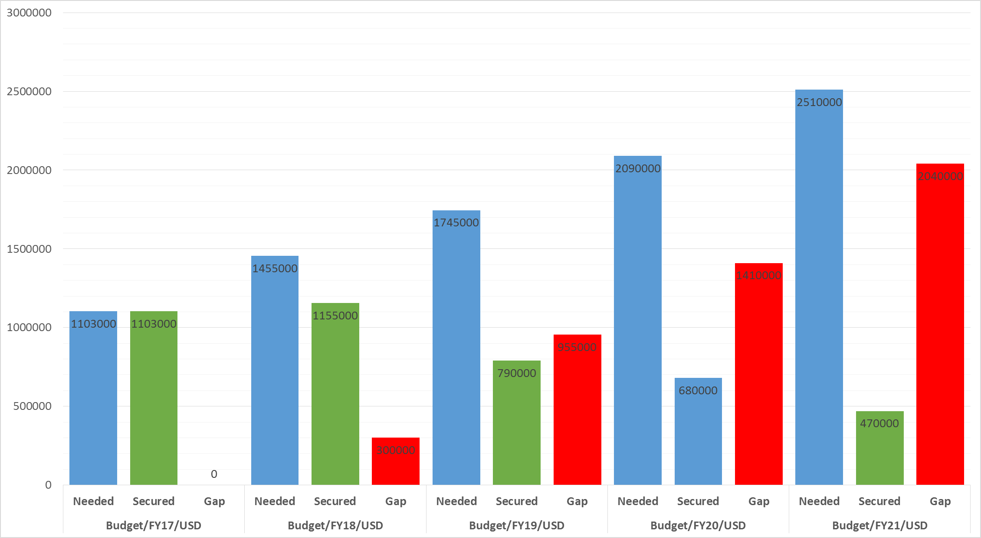

Annex 4. Organigram of WWF-Mongolia

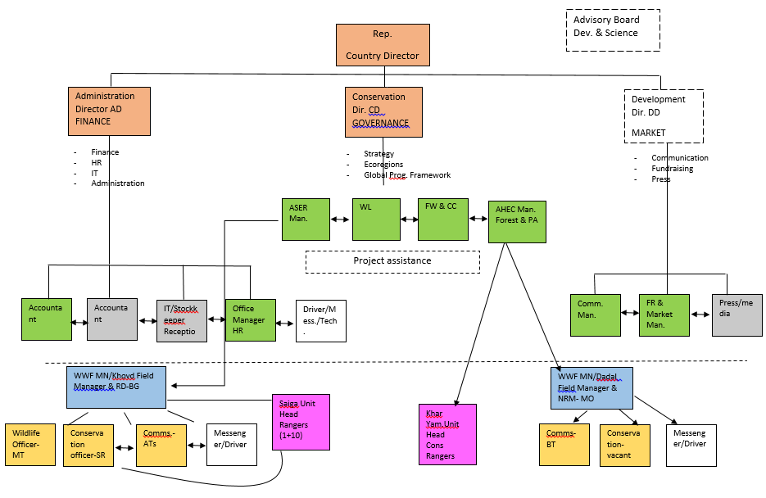
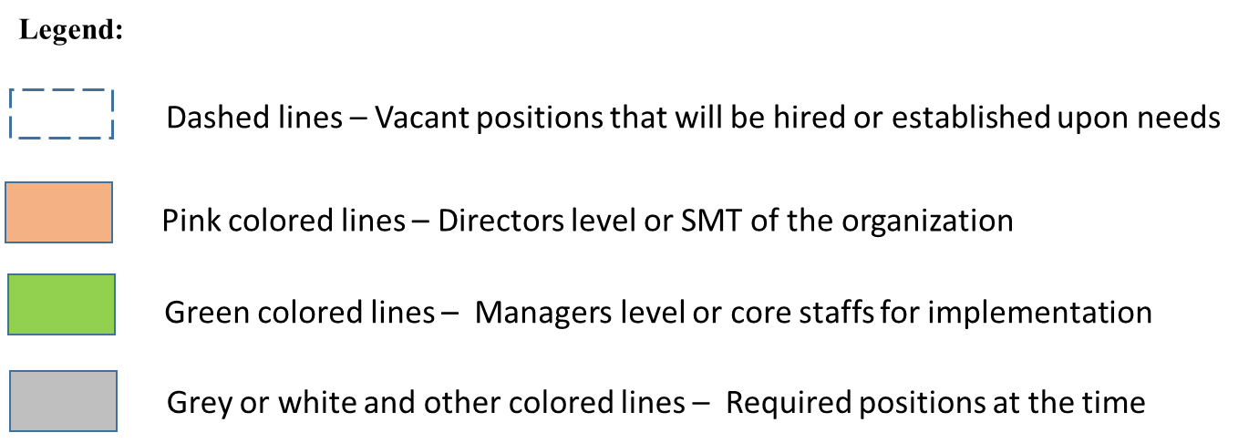

Please note that the previous conservation goals were set up for 10 years until 2021 to cope with longer term vision, yet the programme itself was designed for 5 years.

