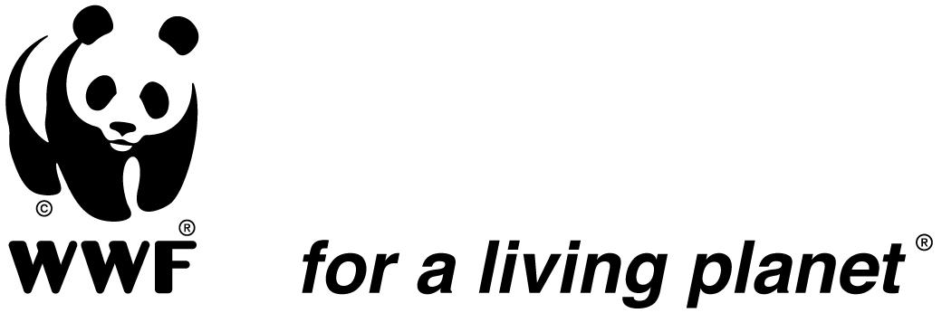

Terms of Reference

Position title : WWF-Pacific Communications Officer: Solomon
Islands
Department : Communications Department
Location : Suva, Fiji
Position title of supervisor : Communications Manager
Hours : 37.5 hours per week
Contract period : Three months (3 months)

- Organisational background :
The WWF-Pacific is considered a regional hub for the Pacific Islands Region. As well as continuing to implement conservation on the ground in Fiji, PNG and the Solomon Islands, the office seeks to ensure that engagement with the key regional level organizations, donors and stakeholders in the Pacific are coordinated and effective on the issues of (i) Climate Change; (ii) Offshore Fisheries; (iii) Coastal Management / Fisheries and Marine Managed Areas (MMAs); (iv) Marine Species Conservation; and (v) GAA engagement. As such, WWF-Pacific aims to ensure that the desired messages and ensuing policy and behavioral changes are communicated and supported towards wider sustainable management of Pacific Islands Region resources. This is undertaken in line with and in support of Pacific Island Government priorities in an inclusive and harmonized manner.

Under the 2010 – 2014 five year strategic plan, WWF- Pacific will continue to focus its efforts on achieving healthy, recovering and resilient marine ecosystems that provide improved biodiversity, food security, livelihoods and well-being for dependent communities.

WWF- Pacific’s approach is therefore one of empowering key stakeholders and conservation practitioners, working at community, national, regional and international levels to strengthen, where necessary establish and implement effective regional and national policies, governance processes, capacities and knowledge sharing mechanisms which support sustainable resource management and biodiversity conservation.

Nature and Scope of Position
- Work Performed
The Communications Officer works in close collaboration with the Communications Manager to ensure the effective exposure of the Solomon Islands country office to enable the achievement of conservation objectives. The position holder works closely with the Solomon Islands Conservation Team.

The Communications Officer also contributes significantly to event planning and management, as and when required and in coordination with the Communications team and responsible event lead staff, for instance Official Launch of the Micro-finance Revolving Fund.

- Challenges/Problem Solving
Challenges for the position include:
- staying abreast of current affairs related to relevant conservation work in the Solomon Islands;
- establishing contacts and continuous networking to identify and develop relationships with the media;
- demonstrating an appropriate communication style and understanding of local protocols, and maintaining professional standards of appearance and manner in order to uphold WWF’s reputation;
- the development of products and concepts that align with WWF Solomon Island’s conservation plan;
- collaborating with conservation, communications and other relevant staff to develop proposals for funding;
- writing of articles, features and social media posts.

- Decision Making
The position:
- consults with the Communications Manager on areas of uncertainty or ambiguity in relation to communications;
- conforms to internal sign off processes on all conservation, marketing and communications materials produced;
- refers the final decision on work related matters to the Communications Manager.

- Communication
The position communicates:
- regularly with the Communications Manager to ensure that all work undertaken fits with the PPO’s overall communications strategy and in the development of any external communications material.
- regularly with the Communications Manager on the delivery of the agreed work plan objectives;
- weekly with other relevant staff to share information and facilitate synergies and regularly with staff that are engaged with corporate partners;
- regularly with conservation and communications teams for ongoing product development and to establish media activities and ensure that corporate partnerships deliver both fundraising and conservation outcomes;
- regularly with corporate partners and/or suppliers to facilitate growth and maintain positive, beneficial relationships;
- with media contacts in pursuit of new opportunities;
- as required to represent WWF-Pacific at events.

Key Accountabilities

- Assist with the implementation of the communications strategy.
- Strong writing and communication skills and the aptitude to engage an audience in meaningful discussions
- High command of English to be able to articulate conservation priorities that are in line with WWF’s brand.
- Liaison between WWF-Pacific, partners, stakeholders and suppliers for projects.
- Assist supervisor in liaison with the internal team members (conservation staff and volunteers) as needed, to produce communications tools
- Understanding of utilizing social media platforms (Facebook, Twitter, Instagram, You Tube, Vimeo, Flickr, Hootsuite, etc)
- Implementation and monitoring of Social Media activities
- Travel to the field with the conservation team as and when required, to cover events for communications needs
- Works closely with other WWF-Pacific staff to ensure that all marketing initiatives are coordinated as part of the overall strategy;
- Ensures that all WWF-Pacific staff and communications materials adheres to the branding guidelines
- Observes all occupational health & safety, security and equal employment opportunity initiatives to contribute to a safe, healthy and ethical workplace;
- Participates in the WWF-Pacific performance management program as required;
- Works in accordance with all WWF-Pacific policies and procedures.

Also taken to include Marine Protected Areas (MPAs), No-Take Zones (NTZs), Locally Marine Managed Areas (LMMAs)

