**HARIYO BAN NEPALKO DHAN PROGRAM**

**Monitoring and Evaluation Plan**

**25 November 2011 – 25 August 2016**

**(Cooperative Agreement No: AID-367-A-11-00003)**

**Submitted to:**

**THE UNITED STATES AGENCY FOR INTERNATIONAL DEVELOPMENT (USAID), NEPAL MISSION**

Maharajgunj, Kathmandu, Nepal

**Submitted by:**

**Judy Oglethorpe, Chief of Party, Hariyo Ban**

**WWF in partnership with CARE, FECOFUN and NTNC**

P.O. Box 7660, Baluwatar, Kathmandu, Nepal

**28 November 2011**

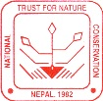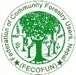

TABLE OF CONTENTS

LIST OF FIGURES i

LIST OF ABBREVIATIONS AND ACRONYMS ii

1. Introduction 1

2. Hariyo Ban Program overview 2

2.1 Biodiversity Conservation 4

2.1.1 Major activities 7

2.1.2 Key results and outcomes 7

2.2 Sustainable Landscapes (REDD+ Readiness) 7

2.2.1 Major activities 7

2.2.2 Key results and outcomes 10

2.3 Climate Change Adaptation 10

2.3.1 Major activities 13

2.3.2 Key results and outcomes 13

2.4 Gender and social inclusion (GSI) 13

3. Plan for M&E implementation in Hariyo Ban Program 13

3.1 Hariyo Ban M&E Approach 13

3.2 M&E Plan preparation 14

3.3 Hariyo Ban M&E Plan 14

3.4 M&E Plan implementation strategy and processes: 17

3.5 Learning agenda 18

3.6 M&E Unit 18

3.7 M&E Budget 19

3.8 Selected indicators for regular reporting to the USAID 19

Annex -1 20

# LIST OF FIGURES

**Figure 1:** Project/Program Cycle…………………………………………………………………2

**Figure 2:** Hariyo Ban conceptual model……………………………………………………… …3

**Figure 3:** Biodiversity Component Conceptual Model..…………………………………...……..5

**Figure 4:** Biodiversity Component Results Chain ………………………………………...……..6

**Figure 5:** Sustainable Landscapes Component Conceptual Model …………… ..………….……8

**Figure 6:** Sustainable Landscapes Component Results Chain …………… ..……………………9

**Figure 7:** Climate Change Adaptation Component Conceptual Model ………………………… 11

**Figure 8:** Climate Change Adaptation Component Results Chain…………………………….... 12

**Figure 9:** Results framework…………………………………………………………...…16

# LIST OF ABBREVIATIONS AND ACRONYMS

**AEPC** Alternative Energy Promotion Center

**BZMC** Buffer Zone Management Committee

**CA** Constitution Assembly

**CAMC** Conservation Area Management Committee

**CAP** Community Adaptation Plan

**CARE** Cooperative for Assistance and Relief Everywhere

**CBA** Community-based Adaptation

**CBAPO** Community-based Anti-Poaching Operations

**CBOs** Community Based Organizations

**CC** Climate Change

**CCAC** Community Capacity Adaptation Coordinator

**CCBA** Climate, Community and Biodiversity Alliance

**CCN** Climate Change Network (Adaptation)

**CF** Community Forest

**CFCC** Community Forest Coordination Committee

**CFM** Collaborative Forest Management

**CFOP** Community Forest Operation Plans

**CFUG** Community Forestry Users Group

**CHAL** Chitwan – Annapurna Landscape

**CNP** Chitwan National Park

**COP** Chief of Party

**CS** Citizen Scientist

**CSO** Civil Society Organization

**CVCA** Climate Vulnerability and Capacity Analysis

**DADO** District Agriculture Development Office

**DCOP** Deputy Chief of Party

**DDC** District Development Committee

**DFO** District Forest Officer

**DIO** District Irrigation Officer

**DLAs** District Line Agencies

**DLSO** District Livestock Services Office

**DNPWC** Department of National Parks & Wildlife Conservation

**DoF** Department of Forest

**DSCO** District Soil Conservation Officer

**FECOFUN** Federation of Community Forestry Users in Nepal

**FRA** Forest Resource Assessment

**GHG** Green House Gas

**GIS** Geographical Information System

**GLAs** Government Line Agencies

**GLOF** Glacial Lake Outburst Flow

**GPS** Global Positioning System

**HWC** Human Wildlife Conflict

**ICS** Improved Cooking Stove

**IGA** Income Generating Activity

**IoF** Institute of Forestry

**LAPA** Local Adaptation Plan for Action

**LHF** Leasehold Forestry

**LiDAR** Light Detection and Ranging

**LIP** Livelihood Improvement Plan

**LRP** Local Resource Person

**MAP** Medicinal and Aromatic Plant

**MIST** Management Information System Technology

**MOAC**  Ministry of Agriculture and Cooperative

**MOE** Ministry of Environment

**MOFSC** Ministry of Forest and Soil Conservation

**MOLRM** Ministry of Land Reform and Management

**NRM** Natural Resource Management

**NTCC** National Tiger Conservation Committee

**NTFP** Non-Timber Forest Products

**NTNC** National Trust for Nature Conservation

**PA** Protected Area

**PES** Payment for Environmental Services

**PGA** Participatory Governance Assessment

**PHPA** Public Hearing and Public Auditing

**PIMS** Program Information Management System

**PM**&**E** Participatory Monitoring and Evaluation

**PVSE** Poor, Vulnerable and socially excluded

**PWBR** Participatory Well-being Ranking

**REDD** Reducing Emissions from Deforestation and Degradation

**SAWEW** South-Asian Wildlife Enforcement Network

**SES** Social and Environmental Standard

**SWR** Suklaphanta Wildlife Reserve

**TAL** Terai Arc Landscape

**TNA** Training Need Assessment

**ToT** Training of Trainers

**TU** Tribhuvan University

**UNFCC** United Nation Framework for Climate Change

**USAID** United States Agency for International Development

**USG** United States of Government

**VA** Vulnerability Assessment

**VCS** Verified Carbon Standard

Hariyo Ban Program

**Monitoring and Evaluation Plan**

# 1. Introduction

The Hariyo Ban Nepalko Dhan Program (Hariyo Ban) is an ambitious USAID-funded initiative designed to benefit nature and people in Nepal. The Program period is five years, from August, 2011 to August, 2016. The Hariyo Ban Program is implemented by four core partners: WWF Nepal as prime recipient, with the Cooperative for Assistance and Relief Everywhere (CARE), National Trust for Nature Conservation (NTNC), and the Federation of Community Forestry Users in Nepal (FECOFUN). It works on three core interwoven components – biodiversity conservation, sustainable landscapes and climate change adaptation – with livelihoods, gender and social inclusion being important cross-cutting themes.

Monitoring and evaluation (M&E) is an overarching priority of Hariyo Ban Program. Objectives of M&E in Hariyo Ban are:

* to ensure that program interventions are directed towards attaining intended results
* to provide evidence on the effectiveness of program interventions, enabling managers and partners to make more informed decisions on any needed adjustments to maximize program success in a cyclical process of adaptive management
* to demonstrate accountability to stakeholders including Hariyo Ban core partners, communities, government agencies and donors
* to generate and integrate learning in the program cycle.

This M&E plan covers the period from 25 November 2011 to 30 September 2012, and its draft results framework has been designed for use over the next five years. The plan presents an overall description of Hariyo Ban, the results framework on which it is based, and a conceptual model of the program. This is followed by a description of the three program thematic components (Biodiversity Conservation, Sustainable Landscapes and Climate Change Adaptation) and their major results and outcomes. Results chains illustrate program activities in each component, and the assumptions that the activities will result in the desired outcomes, to achieve the anticipated results. Cross-cutting components are integrated in these results chains. This is followed by a description of the Performance Management Plan (PMP), which summarizes the indicators, baseline data, desired results, plan for how the monitoring will be done, and risks and assumptions. Definitions of indicators are also provided. The M&E plan then goes into operational details on implementation.

Hariyo Ban will broadly follow the WWF Standards for Program and Project Management ([www.panda.org/standards](http://www.panda.org/standards)). However, it has modified some of the Standards processes to ensure integration of development with conservation. The project/program cycle used in the Standards is a general one appropriate for any program or project; it is shown in Figure 1.

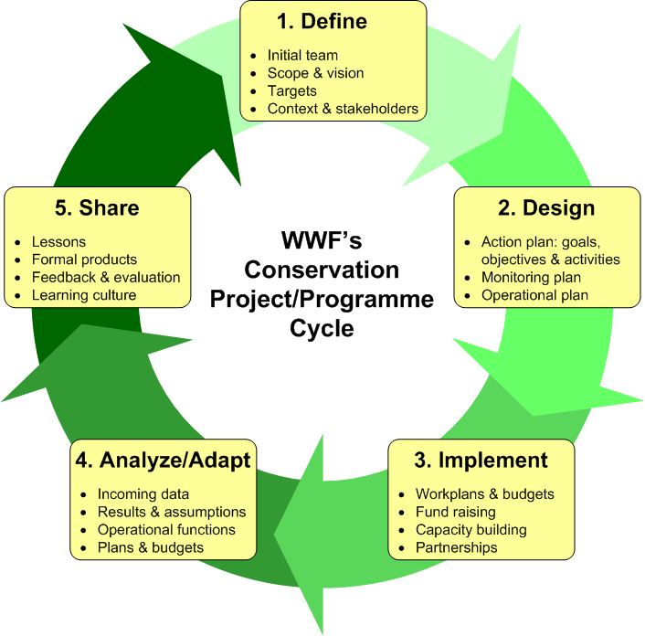

**Figure 1: Project/Program Cycle**

# 2. Hariyo Ban Program overview

The overall goal of the Hariyo Ban Program is ***to reduce adverse impacts of climate change and threats to biodiversity in Nepal***. The objectives of the Program are:

* to reduce threats to biodiversity in target landscapes,
* to build the structures, capacity and operations necessary for an effective sustainable landscapes management, especially reducing emissions from deforestation & forest degradation (REDD+) readiness
* to increase the ability of target human & ecological communities to adapt to the adverse impacts of climate change.

The conceptual model for Hariyo Ban is illustrated in Figure 2. The model illustrates the drivers of deforestation and forest degradation, direct and indirect threats and the ultimate human and ecosystem results intended to be achieved through the efforts of the Hariyo Ban Program. It provides a broad framework showing intrinsic linkages among these elements.

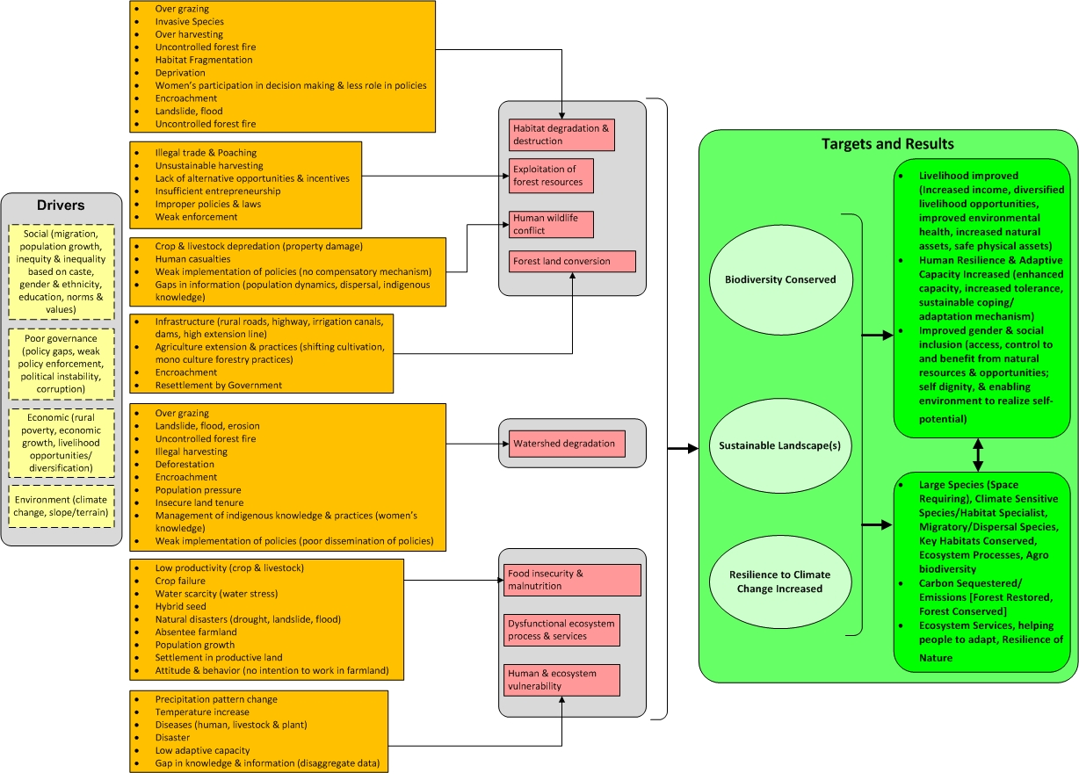

**Figure 2: Hariyo Ban conceptual model**

## 2.1 Biodiversity Conservation

*IR-1 Biodiversity conserved*

The Biodiversity Conservation Component focuses on reducing threats to species and ecosystems at landscape level. The focal species include tiger, rhino, elephant, grey wolf, snow leopard, ghariyal, musk deer, red panda, swamp deer, giant hornbill, dolphin etc. The program will adopt a threats-based approach to biodiversity conservation. The landscape conservation approach will continue to link protected areas through biological corridors to meet the ecological requirements of focal species. Provision for land and water corridors, sound river basin management and climate refugia will be incorporated into landscape conservation design, and strategies developed to facilitate species movement, hydrological flows and continuation of other ecosystem functions.

The results chain for the Biodiversity component is illustrated in Figure 3. Enhanced conservation of biodiversity will be attained by the efforts of the Hariyo ban program through improving understanding of the ecology and behavior of the focal species and applying it in management; addressing site specific threats to species and habitats; strengthening anti-poaching operations, improving habitats, strengthening the governance of natural resource management, improving livelihoods of the forest dependent communities, and creating a more enabling policy environment.

This component is very closely linked with the REDD+ and climate adaptation IRs. The overall Hariyo Ban strategy is to ensure climate-resilient conservation landscapes for biodiversity conservation, functioning ecosystem services, strengthened governance of NRM institutions, safe communities, sustainable livelihoods and economic development and a policy framework conducive for conservation.

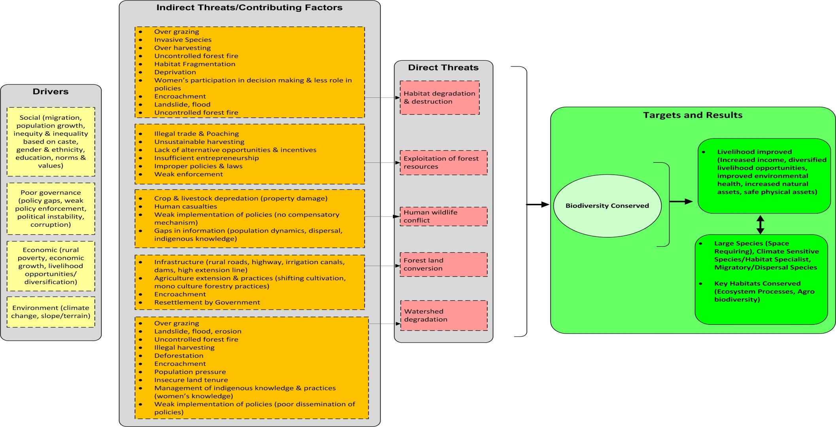 **Figure 3: Biodiversity Component Conceptual Model**

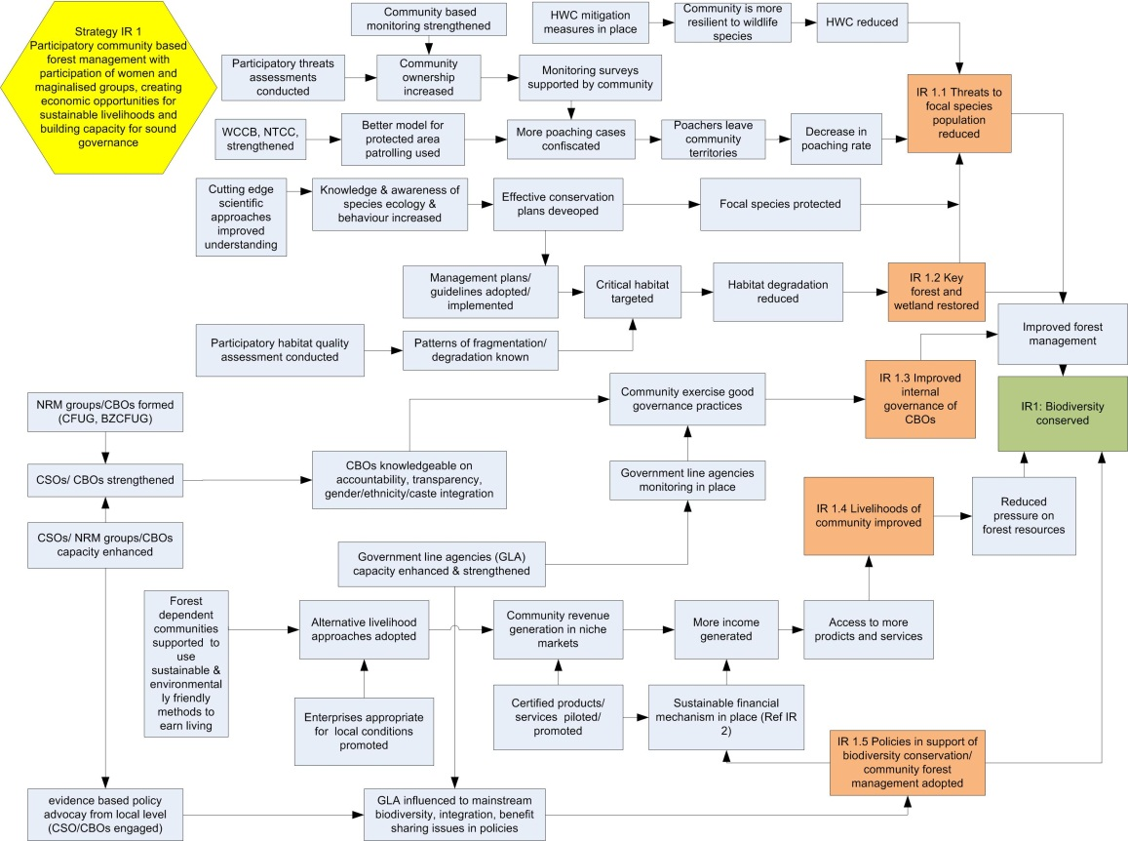

**Figure 4: Biodiversity Component Results Chain**

### 2.1.1 Major activities

Key activities under this component include: threat assessment at species and ecosystem level; applied research for management inputs on ecology, behavior and habitat use of focal species, strengthening of community based anti-poaching operation units; training to enhance government capacity and motivation for protection, monitoring and patrolling in protected areas; prioritizing critical corridors and ecosystems and bringing them under community management; governance assessment, well-being ranking and public hearing and auditing in NRM groups to strengthen their internal governance; supporting communities to generate sustainable sources of income through green enterprise promotion; and supporting government to review and reform existing conservation related policies.

### 2.1.2 Key results and outcomes

* Threats to focal species from loss, fragmentation and degradation of habitats, poaching and trade, and human-wildlife conflict significantly reduced; habitat connectivity restored; climate refugia and corridors for climate sensitive species under conservation management.
* Critical ecosystems including forest corridors in CHAL and TAL restored to state where they will support threatened focal species, and provide ecological services and sustainable forest resources
* Governance for forest management improved
* Livelihoods improved and community stewardship for biodiversity conservation strengthened
* Existing conservation related policies reviewed and reformed to make them biodiversity friendly, inclusive and pro-poor

## 2.2 Sustainable Landscapes (REDD+ Readiness)

*IR: 2 Greenhouse Gas (GHG) emissions, reduced and sequestration enhanced*

Deforestation and forest degradation are the major sources of GHG emission in Nepal. Nepal ranks 11th in the world for GHG emissions from deforestation and other land uses. REDD+ presents an opportunity to address the drivers of deforestation and forest degradation through sustainable landscape management, at the same time enhancing the wellbeing of forest-dependent communities including minority and socially excluded groups. During the first year, this program will support development of national policies for REDD+ Readiness, initiate capacity building on GHG emission monitoring, identify and address drivers of deforestation and forest degradation in both CHAL and TAL, and initiate a feasibility study of payments for environmental services (PES) in both landscapes. The component has the following sub-IRs:

### 2.2.1 Major activities

Support to formulation and strengthening of REDD related policies including National REDD+ strategy; support to National Land Use Policy that includes enabling provisions for REDD+; support for strengthening the institutional framework including the National REDD Cell to implement REDD+ strategy and RPP; support to development and implementation of REDD+ Social and Environmental Standards; enhancing capacity of government staff, networks, federations, individuals and local resource persons related to MRV, forest carbon literacy, benefit sharing mechanism etc.

The results chain for the Sustainable Landscapes component is illustrated in Figure 4. The Hariyo Ban program will contribute to sustainable landscapes making efforts to achieve interlinked results such as supporting creation of enabling REDD+ policies including National REDD+ strategy, national land use policy, Social and Environmental Standards, and Low Carbon Strategy, and their initial implementation; identifying and addressing the drivers of deforestation and degradation; enhancing capacity for GHG monitoring; and testing and expanding payments for carbon credits and other ecosystem services.

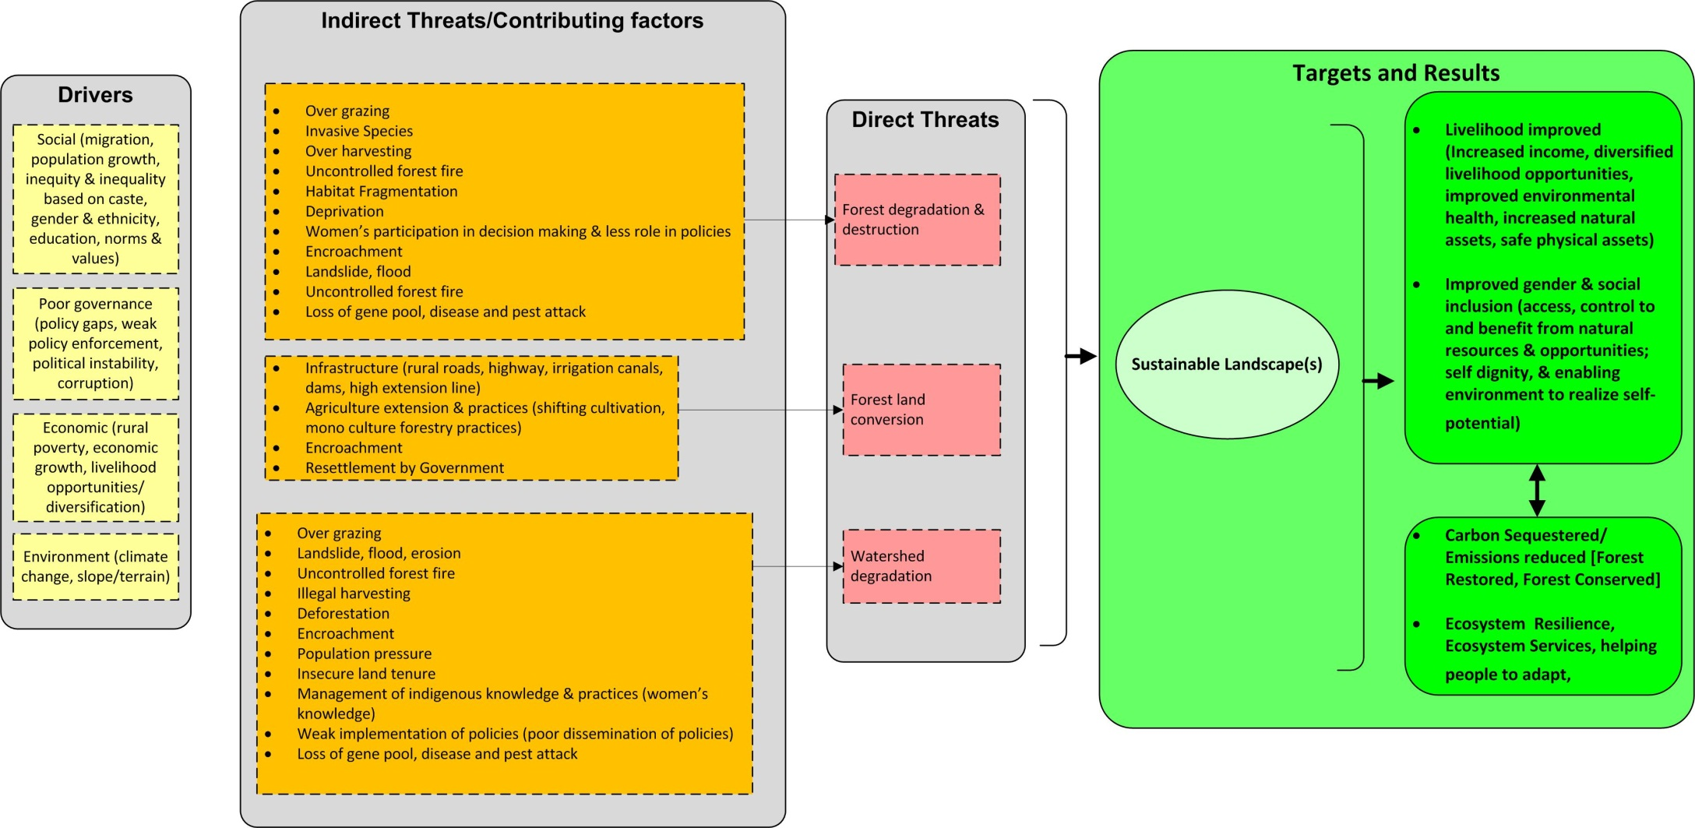

**Figure 5: Sustainable Landscapes Component Conceptual Model**

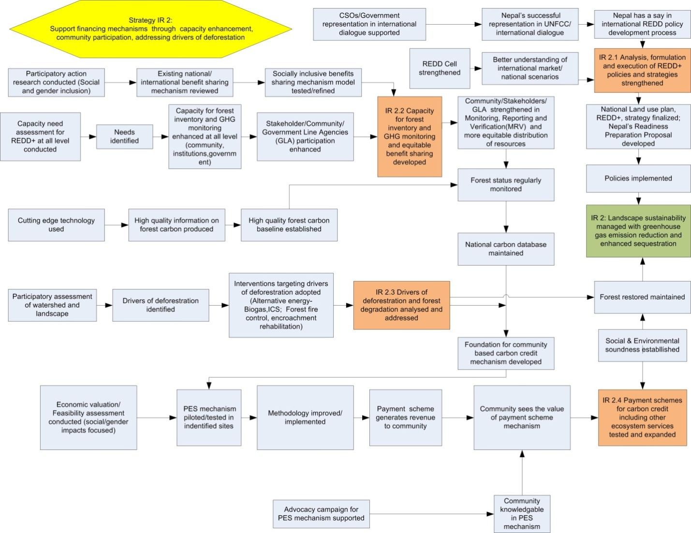

**Figure 6: Sustainable Landscapes Component Results Chain**

### 2.2.2 Key results and outcomes

* Policies for REDD+ and other forest policies strengthened, formulated, endorsed and executed.
* Capacity for REDD+ implementation including MRV enhanced at local and national levels.
* Use of cutting edge technologies piloted and results and lessons documented and shared within Nepal and Globally.
* Reference scenarios (baselines) on carbon stock established for CHAL and quality of sequestered carbon in CHAL and TAL monitored.
* Early signs of reversal of forest loss and degradation visible in project area including evidence of project-related forest restoration in the Seti and Marsyangdi sub-basins, Churia range and TAL.
* Benefit sharing mechanisms evaluated and initial pilot mechanism developed and tested.
* Payment schemes for carbon credit pilot developed and tested.

## 2.3 Climate Change Adaptation

*IR 3: Capacity to adapt to adverse impacts of climate change improved*

Climate change poses one of the greatest threats to sustainable development in Nepal, as climate hazards are increasingly posing adverse impacts on vulnerable human as well as ecological communities. Human vulnerability to climate change is linked with poverty rates, reliance on rain-fed agriculture, lack of basic services and limited livelihoods alternatives as well as gender inequality and social exclusion. Climate change is projected to reduce the livelihoods assets of vulnerable people, especially those who are dependent on biodiversity and ecosystem services (access to food, water and shelter), as well as increasing disasters.

Hariyo Ban will enable better understanding of the nature of adaptation priorities for people and ecosystems, develop processes for community led adaptation that are rooted in local institutions and linked with ecosystem services, identify equitable, inclusive and cost effective actions for integrated adaptation approaches, and explore how best to link with bottom up and top down adaptation efforts in Nepal.

The results chain for the Climate Change Adaptation component is illustrated in Figure 5. This component will strive to build resilience to climate change in both ecosystems and human communities through: enhancing understanding of human and ecosystem vulnerability to climate change across different levels; strengthening communities’ capacity for vulnerability assessment and preparing and implementing Community Action Plans of adaption; establishing participatory and simplified systems for vulnerability and adaptation monitoring; and creating a more favorable policy environment to support adaptation and help scale it up.

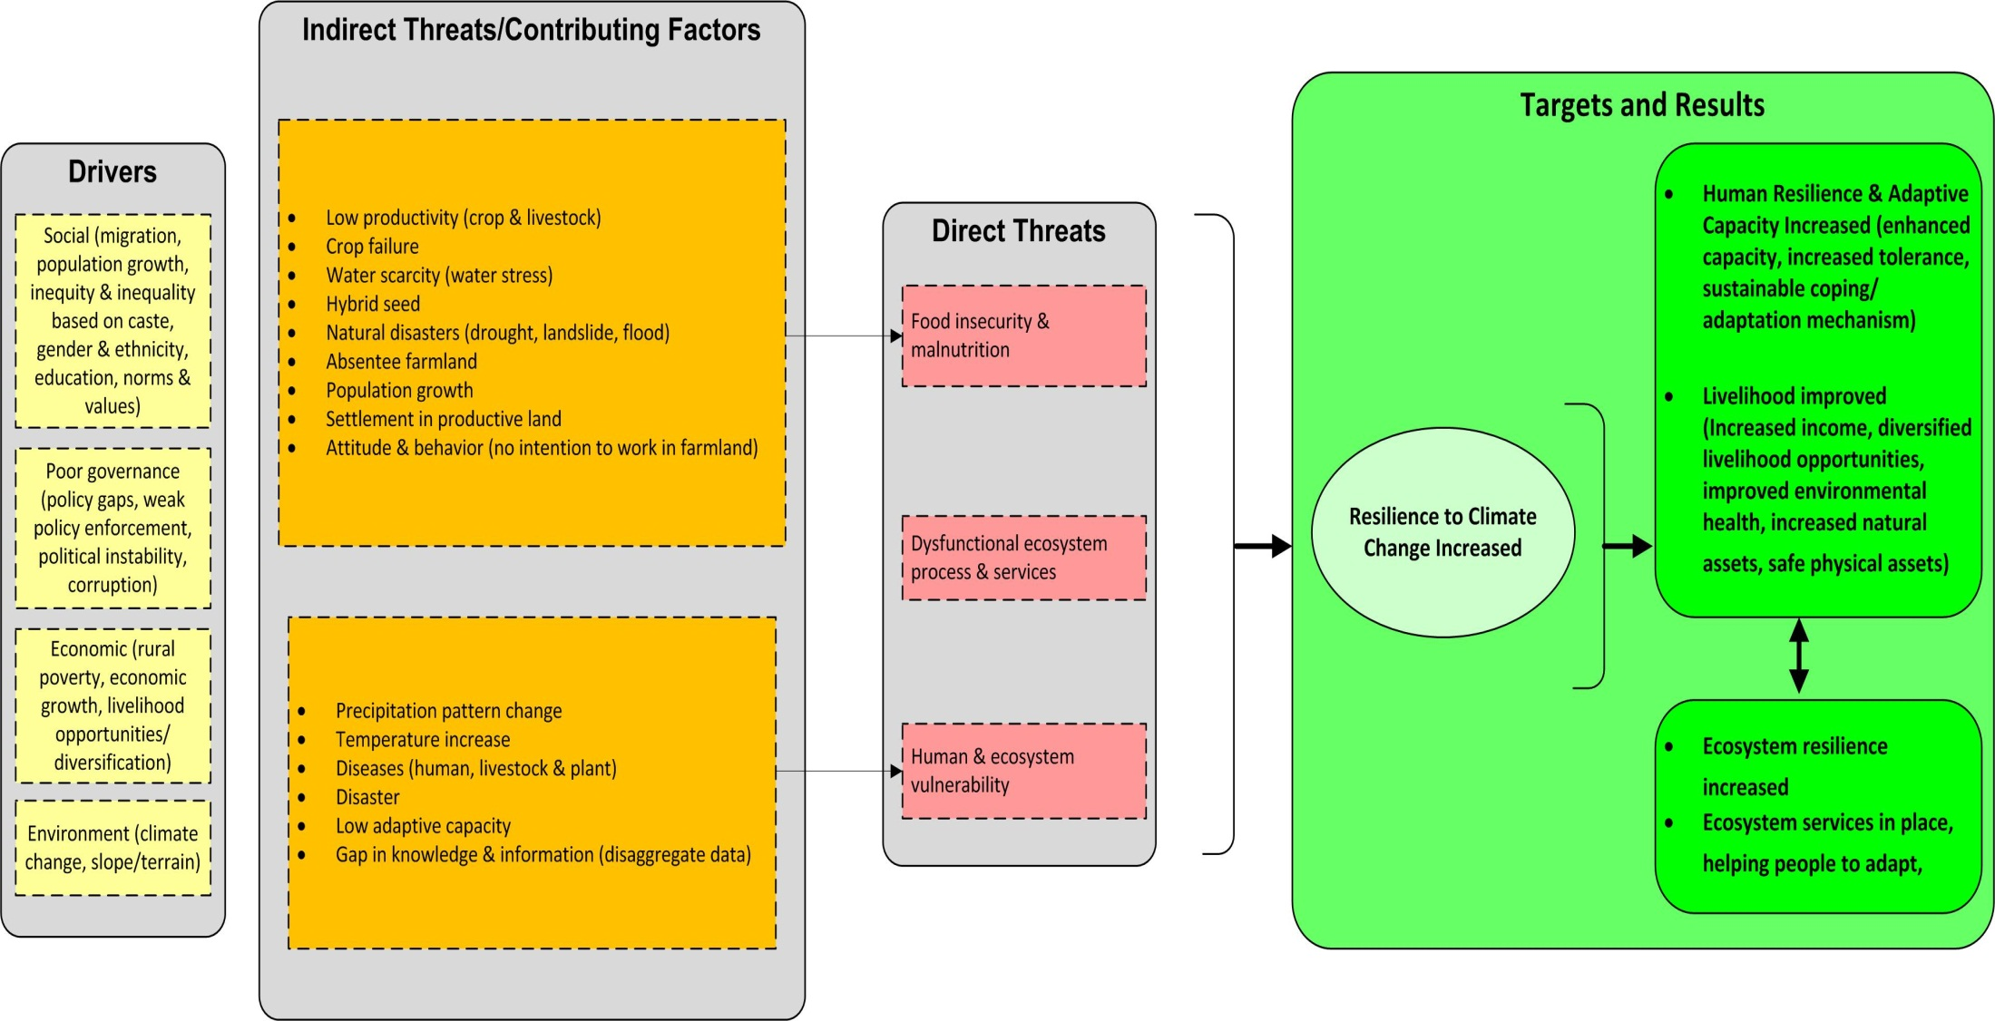

**Figure 7: Climate Change Adaptation Component Conceptual Model**

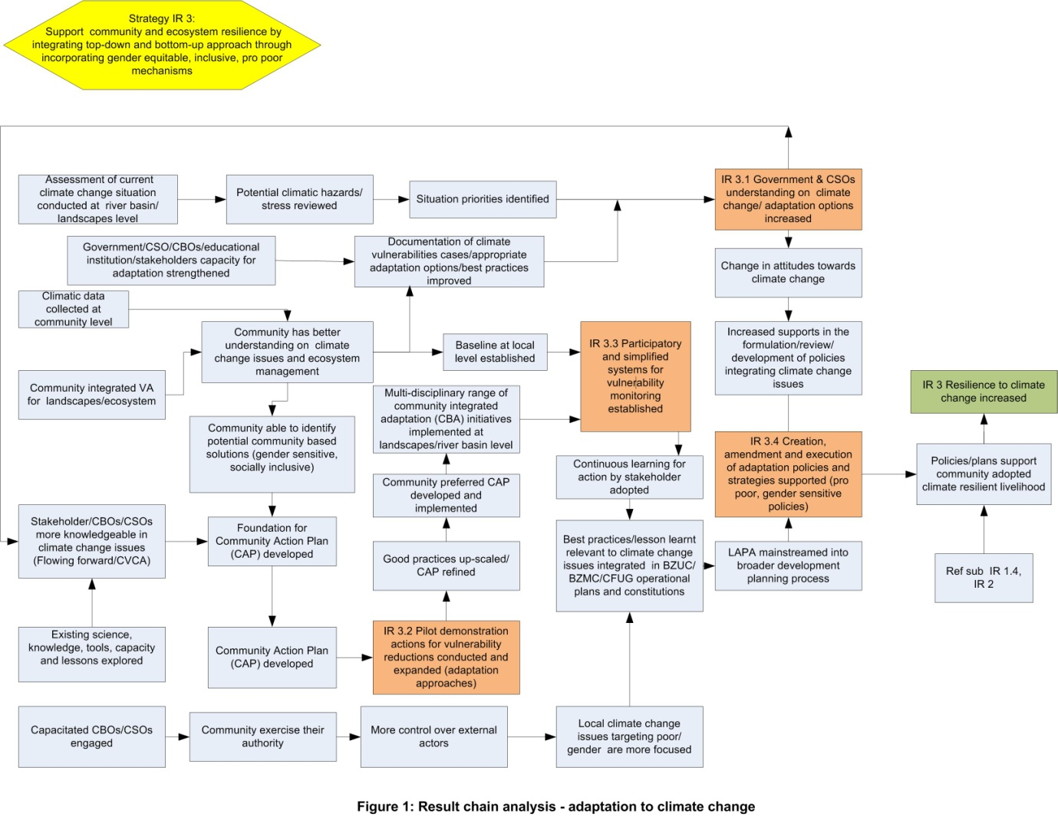

**Figure 8: Climate Change Adaptation Component Results Chain**

### 2.3.1 Major activities

Major activities under this component include capacity building of government officials, local authorities, media personnel, and civil society groups on climate change related issues including mainstreaming of LAPA into broader economic planning; testing, piloting and refining PM&E tools and methodologies for vulnerability monitoring; conducting vulnerability assessments, preparing climate adaptation plans (CAP) and supporting their implementation; supporting climate change adaptation policy feedback and reform processes; and supporting local authorities at district level in program landscapes to integrate climate change adaptation into existing development planning and disaster risk management processes through the LAPA process.

### 2.3.2 Key results and outcomes

* GON, community and NGO understanding of climate change, climate impacts, vulnerability and adaptation options increased in the project areas and at national level
* Adaptation approaches at household, community and landscapes/sub-river basin levels piloted, refined and documented, and successful approaches expanded,
* Participatory and simplified systems for vulnerability monitoring tested and implemented
* Support provided to GON and civil society for improved policies, strategies, plans and guidelines that promote sound climate adaptation approaches
* Increased number of Government, civil society, media and community groups receiving and undertaking capacity building activities related to climate change adaptation.

## 2.4 Gender and social inclusion (GSI)

Hariyo Ban Program has adopted gender and social inclusion as key approach to make the processes and outcomes more inclusive across all levels. The key outputs and results from GSI include increased access to benefits and services by women, poor, Dalit and marginalized Janajatis; changed attitudes and behavior of men and women; more inclusive policies, strategies and enabling environment etc. Hariyo Ban outputs and results will be disaggregated to monitor the level of participation, equitable benefit sharing and changes observed in women, poor, Dalit and marginalized Janajatis.

# 3. Plan for M&E implementation in Hariyo Ban Program

The Hariyo Ban Program’s M&E Unit’s main responsibilities include:

* establishing the M&E system including preparation of the M&E plan
* database management
* Reviewing reflection on progress, issues and challenges of program implementation
* Collaborating in periodic evaluations (including mid-term/final by external evaluators); research/studies
* Participating in documentation of learning and in knowledge management.

## 3.1 Hariyo Ban M&E Approach

The Hariyo Ban Program adopts a ***three-tiered monitoring system*** – participatory monitoring of activities by program beneficiaries; monitoring of progress, effectiveness and results by field offices; and output and outcome level monitoring by country offices. We consider participatory M&E to be part of good governance, a feedback mechanism integrated at all levels of decision making. Participatory monitoring will be conducted at the community level, with regular monitoring by community members with support from program extension staff. This will mostly be related to input process and output monitoring.

The second level of monitoring at the program site level will be done by program staff. Extension and technical staff will be responsible for collecting information from community groups. The technical staff will maintain a regularly updated database system for the purpose. New data formats will be developed based on the activities of the three IRs and the M&E Plan. Program level monitoring will include periodic progress review and reflection (quarterly and annual performance reviews), field visits, sample surveys, joint monitoring with partner agencies, program records and results chain monitoring.

Central program monitoring and other technical staff will maintain records, and collect, collate and analyze information from the program site offices. This will provide output and outcome level monitoring results.

## 3.2 M&E Plan preparation

The Hariyo Ban M&E Plan builds on the initiatives, achievements, learning and experiences from the SAGUN Program, Global Conservation Program, SCAPES Program, on-going TAL Program, and USAID’s M&E guidelines and indicators. The M&E Plan preparation process adopted a participatory and interactive approach as far as time allowed in the first three months of Hariyo Ban, so as to address diverse views of key stakeholders. This included a participatory and interactive three-day M&E workshop in Kathmandu. The M&E Plan preparation process was enriched through cross-fertilization of the rich experiences of the Core partners.

Since REDD+ and Climate adaptation are relatively new fields for Nepal we needed to expand the initial M&E framework submitted to in the original proposal to USAID and design additional indicators, if needed. We adopted relevant USAID Global Climate Change (GCC) indicators including the mandatory indicators for the respective components have been incorporated. The M&E Unit worked closely with the USAID Hariyo Ban in the indicator selection, and rigorously scrutinized indicators to select those that would best measure the respective results. Duplications were screened out.

The following process was followed during the preparation of this revised M&E plan:

* Review of SAGUN M&E plan
* Review of existing M&E planning process of WWF
  + Review of Annual Work Plan
  + Incorporation of suggestions provided by the partner organizations
  + Incorporation of comments from USAID

## 3.3 Hariyo Ban M&E Plan

The M&E plan is instrumental to operationalize the results framework ***(Figure- 6)*** of the Hariyo Ban Program. It is a dynamic and living document which will be revised and updated based on periodic review of the effectiveness of the M&E system in monitoring activities and results, the validity of the underlying assumptions, and the usefulness of the indicators to test those assumptions and monitor both outputs and program impacts. In this respect the program’s conceptual model and results chains are a key part of the monitoring plan, tying the indicators to the activities, assumptions and anticipated results. We expect to make revisions to the results chains during the course of Hariyo Ban, as our understanding grows of the linkages between drivers, threats and opportunities, and we make adjustments to our approach through a process of adaptive management.

We will refer to relevant USAID guidelines to plan, document, and monitor data collection, analysis and utilization processes.

Annex 1 comprises the performance measures summary, which shows the intended results and indicators at a glance with set targets and time frames to achieve them. The detailed Performance Monitoring Plan (PMP), at the heart of this plan, is presented in Annex 2. The PMP shows results at Intermediate Result (IR) level and Sub-IR level, with corresponding indicators at each level. The table also provides operational definitions, information on data collection methodology, tools, frequency, persons responsible for collecting the information, and intended users.

***Level of data disaggregation:*** Where possible, all relevant data will be disaggregated based on sex, caste, and ethnicity. From a caste/ethnicity perspective, Dalits and non-dalits will be disaggregated and marginalized Janajatis will be recorded from an ethnicity point of view. Geographical disaggregation will be made according to landscape (TAL and CHAL), critical sites such as corridors, bottlenecks, watersheds etc; and by district. In order to visualize the interventions and the outputs, GIS will be used wherever relevant. Hariyo Ban M&E unit will closely work with WWF GIS unit to input the data to the GIS and retrieve relevant maps and other information.

The outputs will also be disaggregated by program components – Biodiversity Conservation; Sustainable Landscape and Climate Change Adaptation.

***Links with the Annual Work Plan:*** The goal level indicators have been coded as G1, G2… G6. IR level indicator indicators have been coded as 1.1…; 2.1…and 3.1 … respectively for biodiversity conservation, sustainable landscape and Climate Change Adaptation components respectively. Similarly, the sub-IR level indicators for three components have been coded as 1.1.1 …; 2.1.1 … and 3.1.1 respectively. The Program team will assess how closely activities, outputs and results are linked as monitoring progresses.

***Baseline values:*** Hariyo Ban Program is being implemented in two important landscapes. A lot of activities are being implemented in TAL area by CARE, WWF, FECOFUN and NTNC and baseline values for many indicators in TAL have been drawn from secondary sources from the TAL area. However, CHAL being a new landscape, there is a considerable information gap at landscape level, making it very difficult to establish a comprehensive baseline. Hence where the baseline information are not currently available, it is shown as ‘to be estimated’ or ‘TBE’. Considering the array of indicators embedded in the Performance Management Plan, various methods will be deployed to establish baseline values for different indicators. The complete collection of the baselines for all relevant indicators may take three to four months.

**Figure 9: Results framework**

**IR 3:** Capacity to adapt to adverse impacts of climate change improved

Ind.1: # of people with improved adaptive capacity to cope with adverse impacts of climate change

Ind. 2: % of prioritized vulnerabilities in the target landscape

**HARIYO BAN NEPALKO DHAN (“Hariyo Ban”) PROGRAM**

Ind 1: Quantity of greenhouse gas emissions, measured in metric tons of CO2 equivalent, reduced or sequestered as a result of USG assistance

Ind 2: Number of people receiving USG supported training in global climate change including UNFCCC, greenhouse gas inventories, and adaptation analysis

Ind 3: Number of hectares in areas of biological significance under improved management as a result on USG assistance

**Intermediate Results**

**Illustrative Activities**

**Sub-Intermediate Results**

**IR 1:** Biodiversity conserved

Ind. 1: Hectares of biodiverse forest area under improved biophysical condition

Ind.2: Level of threat to biodiversity in the target landscape

**IR 2:** Greenhouse gas (GHG) emissions reduced and sequestration enhanced

Ind.1: # Hectares of deforested and degraded forest area under improved management

Ind.2: Rate of deforestation and forest degradation in the target landscape

**Development Context:**

* Nepal is rich in natural resources (forest, water and biodiversity)
* Nepal Himalayas have largest concentration of glaciers outside the poles
* These resources are critical to the human development of Nepal
* These resources are under threat and vulnerable to adverse impacts of GCC
* FUG and other CBOs are excellent vehicle for development assistance

**Critical Assumptions:**

* Security situation does not deteriorate further
* New federal structures will not interfere with activity implementation at local, landscape and national levels
* No large scale natural disasters that significantly impede progress
* Political will among political parties for conservation does not diminishes
* UNFCCC recognizes CFs in Nepal for easy carbon credit inflows
* Participatory biodiversity threats assessment in the target landscape, identification of target species and their habitats, assess the condition of habitat of targeted species – tiger, rhino, elephants, etc., identification of targeted groups and core areas for interventions, participatory governance capacity assessment of the target groups/institutions, participatory formulation/review and amendment of operational plans, conservation education, record keeping, public hearings and auditing, well-being ranking, support for livelihoods improvement, piloting/expansion of payment for ecosystem services , bio-fuels and essential oils, improved cooking stoves, biogas plant, forming/activating/networking anti-poaching units and patrols, conservation and development training, rehabilitation of warden posts, biodiversity registration, hi-tech resources mapping, equitable sharing of benefits/resources, networking and issue based advocacy for policy creation, amendment and enforcement of biodiversity policies, etc.
* Analysis, formulation and execution of REDD+ policies and strategies, participatory assessment of drivers of deforestation and forest degradation in the target landscape, identification of deforestation and forest degradation sites, assessment of condition of forests in the target area, identification of targeted groups and core areas for interventions, development of sustainable landscape management guidelines/specifications, participatory formulation/renew/amendment of forest operational plans in line with REDD+, conducting various trainings, establishing participatory system for carbon monitoring, reporting, and verification, establishing participatory and equitable system for benefit sharing, testing and expanding payment for environmental services schemes, networking and issue based advocacy for policy creation and execution of REDD+ policies, strategies, and guidelines.

Sub-IR 1.1 Threat to targeted species and/or landscapes reduced

Sub-IR 1.2 Internal governance of community groups responsible for ecosystem management strengthened

Sub-IR 1.3 Income from sustainable sources of livelihood for forest dependent communities increased

Sub-IR 1.4 Creation, amendment and enforcement of biodiversity policies and strategies supported

Sub-IR 2.1 Analysis, formulation and execution of REDD+ policies& strategies supported

Creation, amendment and execution of sustainable landscape policies and strategies supported

Sub-IR 2.2 Capacity for forest inventory and GHG monitoring, and equitable benefit sharing developed

Sub-IR 2.3 Drivers of deforestation and forest degradation Analyzed and addressed

Sub-IR 2.4 Payment schemes for carbon credit including other ecosystem services tested and expanded

Sub-IR 3.1 Government and civil society understanding on vulnerabilities of climate change and adaptation options increased increased

Sub-IR 3.2 Participatory and simplified systems for vulnerability monitoring established

Sub-IR 3.3 Pilot demonstration actions for vulnerability reduction conducted and expanded

Sub-IR 3.4 Creation, amendment and execution of adaptation policies and strategies supported

* Participatory assessment of vulnerabilities of climate change in the target landscape, identification of existing/potential risk levels to ecosystems and communities, identification of target groups and appropriate measures for risk reduction, participatory formulation/renew/amendment of plans, conducting various trainings, establishing system for periodic vulnerability monitoring, reporting and updating coping strategies, testing/expanding actions for vulnerability reduction, establishment of early warning systems, identification/review/analysis of existing indigenous knowledge and strategies, conducting climate change awareness TOT/classes/campaigns, integration of adaptation strategies into the local planning processes, networking and issue based advocacy for policy creation, amendment and execution of appropriate climate change adaptation policies and strategies.

## 3.4 M&E Plan implementation strategy and processes:

Once the M&E plan is approved by the donor the Hariyo Ban team together with the partner organizations and stakeholders will develop appropriate instruments for data collection. The data collection and management system will be closely integrated with the current system used by WWF.

***Refining the baseline:*** As mentioned above, we will refine the baseline during the first year of Hariyo Ban once we collect more information, particularly for CHAL.

***Developing data collection and processing mechanisms:*** Data collection and recording instruments in as appropriate formats will be developed as needed. In order to have efficient data processing systems, necessary software will also be purchased/developed. M&E Unit staff will be mobilized in the data collection, recording and processing in coordination with landscape unit teams and M&E personnel from the Country Office.

***M&E capacity building of partner organizations:*** An M&E capacity assessment will be conducted in the beginning to take stock of the current level of knowledge and skills in the relevant staff of partner organizations and a plan for capacity development will be prepared accordingly to fill gaps. The M&E capacity assessment will be integrated with the overall training needs assessment planned to be conducted for all components. The scope of capacity development will be closely linked to the requirements of the Hariyo Ban Program.

***Tracking progress of M&E indicators:*** The indicators in the M&E plan will be tracked periodically as per the frequency in the plan. There will be specific activities to review the progress of M&E plan on a six-monthly basis. Progress on each indicator will be reviewed on an appropriate time frame to that indicator.

***Field visits for monitoring of progress on the ground:*** Frequent field visits will be made in order to monitor the activity implementation status and processes followed in the field. This will involve members of core Hariyo Ban team including staff of the M&E Unit, and staff of partner organizations. Joint monitoring visits will be undertaken with policy makers including political leaders, Government of Nepal officials, and senior management team members from the core partners, in order to show the field level activities and results and also to receive feedback for further improvements.

***Internalization and institutionalization of M&E processes:*** All interventions and efforts of Hariyo Ban program are directed towards achieving program goal and objectives. Therefore, clear understanding of program strategies and the processes through which the results will be achieved is essential across all levels of the Hariyo Ban team and in the core partners. M&E will facilitate the process of strengthening linkages between achieving results and effective program implementation, making M&E information available in a timely and reliable fashion. The M&E team will also ensure that there is periodic review and reflection meetings in which in-depth discussion will be held to understand whether the program interventions are headed towards right direction or not. There will be a major emphasis on learning from failures as well as success, and we will endeavor as much as possible to create a safe environment to explore and learn from failure. Key learning will be documented and shared. We will encourage a strong adaptive management process, regularly adjusting our approaches as we learn the best recipes for success. At the same time, we are conscious that we are operating in a rapidly changing environment – politically, demographically, economically, socially, and not least, climatically. As our climate adaptation component constantly reminds us, we will never get things completely right because of ongoing change – climate adaptation is a continuous process, as is adaptive management in general. The M&E program will play a key role in helping Hariyo Ban to monitor, reflect, share and adapt.

***Synthesis of M&E Information and dissemination to wider audience***: The data collected by the Hariyo Ban Program will be processed and synthesized into meaningful piece of information to be used for improved decision making, and, enhanced understanding of the situation and outcomes of the program. As part of its demonstrating the accountability, Hariyo Ban program will share the information generated to the wider audience including donor, Government of Nepal, relevant stakeholders and the communities by using different forums such as Program Steering Committee, Community Reflection and Learning Centers etc. The Program will systematically document and disseminate learning and best practices. M&E unit will closely work with the Communications unit to produce appropriate materials for dissemination to wider audience.

***Revisiting the results framework and refining the Performance Measurement Plan:*** We will continuously assess the value and relevance of indicators in this plan to see how effectively they measure results, and how effectively they test the assumptions between activities, outputs and results in the results chains. As needed the indicators will be further refined in the PMP. Given the rapidity with which this plan was revised during the first three months of Hariyo Ban, we plan to undertake a further revision in late 2011/early 2012, as an activity in the first annual work plan.

***Mid-term and Final Evaluations:*** External evaluators will conduct the mid-term and final evaluation of the program. They will scrutinize the relevance, effectiveness, efficiency, impacts and sustainability of the program. Meanwhile, Social Welfare Council (SWC) of GoN will do monitoring and evaluation of the program in the landscapes. SWC is mandated with monitoring, mid-term and final evaluation of projects in Nepal.

***Sustainability monitoring:*** Hariyo Ban Program will make deliberate efforts and strategies from the beginning so that the processes and outcomes of the Program have sustainable effects in the ecosystems and communities beyond the life of the program. This has been described in detail in the Annual Work Plan. M&E will monitor the sustainability aspects as stipulated in the Work Plans and exit strategies. Active participation and ownership of key stakeholders including Government and the communities are key aspects for strengthening sustainability aspects.

## 3.5 Learning agenda

The Hariyo Ban Program is an ambitious and innovative initiative which will provide excellent learning opportunities during the next five years. It offers programmatic learning opportunities both within the individual program components, and more broadly (for example around landscape conservation, scaling up, and integrating conservation and development approaches). It also offers learning around process elements of Hariyo Ban, including the effectiveness of partnerships, capacity building and sustainability. We are developing a draft learning agenda, which will contain a set of cutting edge learning hypotheses and questions based on priority issues, challenges and gaps in knowledge around Hariyo Ban’s sphere of operation. The learning agenda was initially discussed during the M&E planning process, and will be further refined in the first two months of the period of this work plan.  We may also draw on inputs from the USAID quarterly partners’ meeting for the learning agenda.

## 3.6 M&E Unit

Hariyo Ban Program has an M&E unit led by a full-time M&E specialist. The unit has three M&E Assistants deployed in Kathmandu, Pokhara and Chitwan. The M&E Specialist is responsible for designing and putting into practice an M&E framework, which will provide both quantitative and qualitative performance and impact indicators for program implementation along with their corresponding means of verification. Following the WWF Standards, the M&E framework will be based on adaptive management principles, ensuring feedback mechanisms at the different implementation levels – community/CFUGs; landscape; and national level. The M&E unit will work closely with Hariyo Ban’s thematic and cross-cutting components. It is backstopped by WWF’s Design, Monitoring and Planning Unit.

## 3.7 M&E Budget

The total budget for Monitoring and evaluation for Year 1 amounts **US$ 273,149** which includes both operations cost related to M&E and various activities under it.

## 3.8 Selected indicators for regular reporting to the USAID

The following indicators will be reported to the USAID on a periodic basis.

|  |  |  |  |  |  |
| --- | --- | --- | --- | --- | --- |
| **USAID Standard Indicator Number** | **Indicator Title** | **Type** | **Baseline** | **Target for 2012** | **Related indicators in the M&E Plan** |
|
| 4.8.1-6 | Number of persons with increased economic benefits derived from sustainable natural resource management and conservation as a result of USG assistance |  | 31320 | 575 | IR 1.4.1; 1.4.2; |
| 4.8.1-26 | Number of hectares of biological significance and/or natural resources under improved natural resource management as a result of USG assistance | Output | 1,592,500 | 1000 ha | IR 1.1;  IR 2.1 |
| 4.8.1-29 | Number of person hours of training in natural resources management and/or biodiversity conservation supported by USG assistance | Output | NA | 2432 | IR 1.2.2;  IR 2.2.1; 2.2.2; 2.3.3 |
| 4.8.2-6 | Person hours of training completed in climate change supported by USG assistance | Output | 2772 | 35277 | IR 3.1; 3.1.2 |
|  | Number of climate vulnerability assessments conducted as a result of USG assistance |  | NA | 10 | IR 3.2.2 |
| 4.8.2-26 | Number of stakeholders with increased capacity  to adapt to the impacts of climate variability and change as a result of USG assistance | Outcome | NA | 2000 | IR 3.1.1 |
| 4.8-7 | Quantity of greenhouse gas (GHG) emissions, measured in metric tons of CO2e, reduced or sequestered as a result of USG assistance | Outcome | 1.9m Mt | NA[1] | IR 2.3 |
|  | ***NA- not available;*** |  |  |  |  |

# Annex -1

Performance Measure Summary

|  |  |  |  |
| --- | --- | --- | --- |
| **Goal** | **To reduce adverse impacts of climate change and threats to biodiversity in Nepal** | | |
| OVI | G 1: By August 2016, amount of GHG emissions (MT of CO2 equivalent) will be reduced or sequestered from X amount of baseline by Y with cumulative figure at Z level as a result of USG assistance   |  |  |  |  | | --- | --- | --- | --- | |  | **X** | **Y** | **Z** | | MT of GHG (CO2e) | 1.9 | 1.1 | 3.0 |   G 4: By end of August 2016, a total of 117428 people will participate in USG supported REDD+ and climate adaptation activities. | G 2: By end of August, 2016, a total of 15,502 people will receive USG supported training in global climate change including UNFCCC, greenhouse gas inventories, and adaptation analysis  G 5: By end of August 2016, hectares of biological significance (forest, wetlands, and grasslands) under improved management will increase from the current X level by Y with cumulative figure at Z level.   |  |  |  |  | | --- | --- | --- | --- | |  | **X** | **Y** | **Z** | | TAL | 1592500 | 50000 | 1642500 | | G 3: By end of August, 2016, a total of 50,190 people will directly benefit from IGAs and alternative energy in priority sites in TAL and CHAL.  G 6: By end of August, 2016, % of men and women consider the ecosystem status improved in the last five years and their livelihood improved through benefits from ecosystem services will increase by 10% from baseline. |
| Thematic Component | 1. Biodiversity Conservation | 1. Sustainable Landscapes (REDD+ Readiness) | 1. Adaptation to Climate Change |
| Component Specific Objectives | ***Reduce threats to biodiversity in target landscape(s)*** | ***Build the structures, capacity and operations necessary for effective sustainable landscape management, especially reducing emissions from deforestation & forest degradation (REDD+) readiness*** | *Increase the ability of target human & ecological communities to adapt to the adverse impacts of climate change* |
|  | IR 1: Biodiversity conserved  **1.1:** By end of August 2016, hectares of biodiverse area (forest, wetlands, grasslands) under improved management will increase from the current X level to the Y level with cumulative figure at Z level.   |  |  |  |  | | --- | --- | --- | --- | |  | **X** | **Y** | **Z** | | TAL | 1592500 | 50000 | 1642500 |   **1.2:** By end of September, 2016, populations of focal species in CHAL and TAL will increase from the current X level by Y with cumulative figure at Z level.   |  |  |  |  | | --- | --- | --- | --- | |  | **X** | **Y** | **Z** | | Tiger | 155 | 43 | 198 | | Rhino | 534 | 116 | 650 | | Ghariyal | 102 | 15 | 117 | | Snow leopard | 47 | 9 | 56 | | IR 2: Greenhouse Gas (GHG) emission, reduced and sequestration enhanced  2.1: By end of August 2016, hectares of deforested and degraded forest area under improved biophysical condition will increase from the current X level by Y with cumulative figure at Z level   |  |  |  |  | | --- | --- | --- | --- | |  | **X** | **Y** | **Z** | | Area (Ha.) | 8000 | 4884 | 12884 |     2.2: By end of August 2016, rate of deforestation and forest degradation in the target landscape will be reduced from current X level to Y level   |  |  |  | | --- | --- | --- | | **Area** | **X** | **Y** | | Terai (TAL) | 1.3% | 1.25% | | Hills (CHAL) | 2.1% | 1.7% |   2.3: By end of August 2016, 1.1 million MT of GHG emissions (MT of CO2 equivalent) will be reduced or sequestered as a result of USG assistance   |  |  |  |  | | --- | --- | --- | --- | |  | **Baseline** | **Target** | **Cumulative** | | MT of GHG | 1.9 | 1.1 | 3.0 | | IR 3: Capacity to adapt to adverse impacts of climate change improved  3.1: By end of August 2016, a total of 12000 persons will have improved adaptive capacity to cope with adverse impacts of climate change    3.2: By end of August 2016, rate of deforestation and degradation in forests, and degradation in wetlands (e.g. invasive species, sedimentation and conversion agriculture) from non-climate stresses will be reduced.  (Level reduction from baseline)   |  |  |  | | --- | --- | --- | |  | **X** | **Y** | | Rate | Medium | Low |   3.3: By end of August 2016, a total of 150 organizations (government and civil society) will mainstream climate change adaptation into their policies and plans and implement them. |
|  | Sub-IR 1.1: Threat to targeted species reduced  1.1.1: By end of August, 2016, the annual rate of rhino poaching will be reduced to 3 per year from the current rate of 15 per year.   |  |  |  |  |  |  | | --- | --- | --- | --- | --- | --- | | **Baseline** | **Y1** | **Y 2** | **Y 3** | **Y4** | **Y5** | | 15 no. | 10 | 8 | 6 | 5 | 3 |   **1.1.2:** By August 2016, # of CBAPOs formed, strengthened and mobilized will increase from the current X level by Y with cumulative figure at Z level.   |  |  |  |  | | --- | --- | --- | --- | | **CBAPOs** | **X** | **Y** | **Z** | | TAL | TBE | 29 |  | | CHAL | TBE | 25 |  |   Sub-IR 1.2: Threat to targeted landscapes reduced  **1.2.2:** By end of August2016**, #** of people in TAL and CHAL areas receiving training in NRM and/or biodiversity conservationwill increasefrom 574 persons in TAL area to 7000 persons in the TAL and CHAL area with cumulative figure of 7574.  1.2.3: By end of August 2016, a total of 8 sub-watershed management plans will be developed and implemented in TAL and CHAL areas (baseline to be established).  Sub-IR 1.3: Internal governance of community groups responsible for ecosystem management strengthened  1.3.1: By end of August 2016, number of NRM groups with strengthened governance practices will increase by 20% from the baseline.  Sub-IR 1.4: Income from sustainable sources of livelihood for forest dependent communities increased  1.4.1: By end of August 2016, number of forest dependent people with increased economic benefits from sustainable natural resource management and conservation will increase from the current X level by Y with cumulative figure at Z level   |  |  |  |  | | --- | --- | --- | --- | |  | **X** | **Y** | **Z** | | # of People | 31,320 | 8,526 | 39,846 |   1.4.2: By end of August 2016, 1670 people will benefit from green enterprises (revenue generated from green enterprises), number of people increased from the current X level by Y with cumulative figure at Z level   |  |  |  |  | | --- | --- | --- | --- | |  | **X** | **Y** | **Z** | | # of People | 2500 | 1670 | 4170 |   Sub-IR 1.5: creation, amendment and enforcement of biodiversity policies and strategies supported  1.5.1: By end of August 2016, GoN will be supported to review and analysis of 7 existing policies/strategies and formulate 2 new policies/ strategies related to bio-diversity conservation..  1.5.2: By end of August 2016, 237 issue based campaigns will be supported from the current number of 33 making a total of 270. | Sub-IR 2.1: Analysis, formulation and execution of REDD+ policies and strategies supported.  2.1.1: By end of August 2016, three national REDD+ related policies and strategies will be proposed, approved or implemented.  Sub-IR 2.2: Capacity for forest inventory and GHG monitoring and equitable benefit sharing developed  2.2.1: By end of August 2016, a total of 6194 persons from government and civil society will receive capacity building training in forest inventory and GHG monitoring, equitable benefit sharing, and REDD+ issues (baseline: 334 persons in 2010)  2.2.2: By end of August 2016, a total of 40893 persons will participate in GHG monitoring, equitable benefit sharing and REDD related activities.  Sub-IR 2.3: Drivers of deforestation and forest degradation analysis and address  2.3.1: By end of August 2016, 140 community forest operation plans will be revised/prepared in line with REDD+ guidelines from the current X level by Y with cumulative figure at Z level.     |  |  |  |  | | --- | --- | --- | --- | |  | **X** | **Y** | **Z** | | # of FOPs | 100 | 140 | 240 |   2.3.2: By end of August 2016, a total of 41664 people will directly benefit from alternative energy (biogas, ICS, metal stoves) reducing threats to deforestation and degradation; number of people will increase from the current X level by Y with cumulative figure at Z level   |  |  |  |  | | --- | --- | --- | --- | |  | **X** | **Y** | **Z** | | # people | 87,094 | 41,664 | 1,28,758 |   2.3.3: By end of August 2016, a total of 750 PVSE and marginal farmers (traditionally including marginalized ethnic minority/religious minority groups) will receive skill based training (baseline – 536 persons)  2.3.4: By end of August 2016, level of key threats will be reduced in priority sites (e.g.: forest fires, grazing and illegal timber felling) from the current X level to Y level   |  |  |  | | --- | --- | --- | | **Threats** | **X** | **Y** | | Forest fire (TAL & CHAL) | Very High | Medium | | Grazing (TAL and CHAL) | High | Medium | | Illegal timber felling (TAL) | Very High | Medium |   Sub-IR 2.4: Payment schemes for carbon credits and other ecosystem services tested and expanded  2.4.1: By the end of August 2016, revenue generated from successfully piloted PES schemes e.g. biogas, forest carbon, ecotourism, hydropower etc in CHAL and TAL will increase from the current X level by Y with cumulative figure at Z level   |  |  |  |  | | --- | --- | --- | --- | |  | **X** | **Y** | **Z** | | Revenue generated (US$) | 230,375 | 529,265 | 759,640 | | Sub-IR 3.1: Government and civil society understanding on vulnerabilities of climate change and adaptation options increased  3.1.1: By end of August 2016, 1500 organizations (government, civil society and academia) will undertake capacity building activities related to climate change vulnerability and adaptation.  3.1.2: By end of August 2016, 9308 persons (government and civil society) will receive training in climate change adaptation.  3.1.3: By end of August 2016, 76,535 persons will participate in climate change adaptation related activities and events  Sub-IR 3.2: Participatory and simplified system for vulnerability monitoring established  3.2.1: By end of August 2016, 12000 vulnerable people will benefit from the implementation of Community Adaptation Plans (CAPs)  3.2.2: By end of August 2016, 80 vulnerable sites will be showing improved biophysical condition after implementing CAPs.  Sub-IR 3.3: Pilot demonstration actions for vulnerability reduction conducted and expanded  3.3.1: By end of August 2016, 120 organizations (government and civil society) will be using standard participatory vulnerability monitoring system and tools.  Sub-IR 3.4: Creation, amendment and execution of adaptation policies and strategies supported  3.4.1: By end of August 2016, three policies and strategies on climate change adaptation will be proposed, adopted or implemented (new and/or amended).  3.4.2: By end of August 2016, advocacy campaigns of 55 civil society organizations will be supported.  3.4.3: By end of August 2016, 300 local level plans (watershed management plans, LAPAs, Forest Operational Plans, VDC Annual Plans etc. ) will integrate climate change adaptation. |
| Major Results | * Threats to focal species from poaching, human-wildlife conflict and habitat loss significantly reduced; habitat connectivity restored; climate refugia and corridors for climate sensitive species under conservation management. * Key forests in CHAL and TAL restored to state where they will support threatened, focal species, provide ecological services and sustainable forest resources, contribute to integrated river basin management, build resilience to climate change and contribute to the national economy and to continued peace and security. * Governance for forest management improved through capacity building and promotion of equitable and transparent processes in local community. * Livelihood improved and community forest stewardship improved by establishing and empowering community NRM groups in important corridor areas. * Existing policy revised and new policies developed at national and sub-national level policy in support of biodiversity conservation and community forest management. | * Policies for REDD+ and other forest policies strengthened, formulated and starting to be implemented. * Effective Nepal specific social and environmental safeguards and standards for REDD+ established and starting to be implemented. * Capacity for REDD+ implementation including MRV enhanced at local and national levels. * Use of cutting edge technologies piloted and results and lessons documented and shared within Nepal and globally. * Reference scenarios (baselines) on carbon stock established for CHAL and quality of sequestered carbon in CHAL and TAL monitored on a regular basis. * Early signs of reversal of forest loss and degradation visible in project area including evidence of project-related forest restoration in the CHAL and TAL. * Benefit sharing mechanisms evaluated and initial pilot mechanism developed and tested. * Payment schemes for carbon credit pilot developed and tested. | * The GoN, community and NGO understanding of climate change, climate impacts, and vulnerability and adaptation options increased in the project areas and at national level. * Adaptation approaches at household, community and landscape/sub-river basin levels piloted, refined and documented and successful approaches expanded. * Participatory and simplified systems for vulnerability monitoring tested and implemented. * Support provided to GoN and civil society for improved policies, strategies, plans and guidelines that promote sound climate adaptation approaches that are just, gender sensitive, socially inclusive, and integrate ecosystem and human approaches. |

1. will be reported in 2014 and 2016