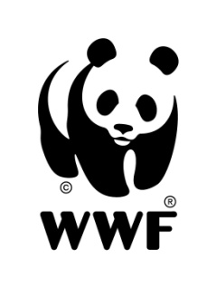
WWF-Mongolia is seeking a Monitoring and Evaluation officer for the Mongolia Programme Office based in Ulaanbaatar, Mongolia

I. Major Functions:

- Assist in coordination of the Amur-Heilong Ecoregional Complex (AHEC) programme, especially in terms of recording and reporting of progress made by the three implementing offices against the AHEC ecoregional plan
- Support the implementation of the WWF-Mongolia Strategic Plan and fund raising through active exploration of new and strategic donors. Support the office to strengthen report quality in compliance with donor’s requirements. Ensure monitoring the strategic indicators in the Strategic Plan Monitoring System (SPMS) and support the office in instilling adaptive management. Create fundraising and partnership portfolio and necessary fundraising materials under the leadership of programme manager.

II. Minimum requirements:

- University degree (preferably Masters) in conservation, natural resources management, natural sciences or related field. Relevant work experience in fundraising may be substituted for higher academic qualification.
- Technical proficiency in the field of nature conservation and natural resource management, with at least 3 years professional experience in programme/project development, management and M&E
- Ability to work in a team and liaise effectively with stakeholders
- Excellent oral and written communications skills in English

Application deadline: Monday, 22 April 2013
Please e-mail a CV (with 2 references) and a cover letter to: info@wwf.mn prior to the specified deadline. Only short-listed candidates will be contacted.

