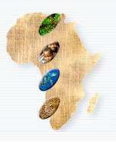
Africa &
Madagascar
"meeting the challenge"

Eastern Africa Coastal Forests Ecoregion

Kaya Kinondo Ecotourism Project
A Community Conservation Initiative


- Summary
Kaya Kinondo is one of the oldest of the indigenous sacred forests on the South Kenyan coast, and is one of the 38 sites that have been gazetted under The Antiquities and Monuments Act It is located in one of the most intensively developed tourist destinations at the coast in Kwale district. These forests have survived pressures of tourism developments and population growth because of the cultural beliefs of the mijikenda people.
The mijikenda use Kayas, sacred forests, to commune with their ancestral spirits through worship and sacrificial offerings. Prayers for the sick and troubled, for rain and good harvests, for wisdom and strength are held in Kayas. Atonement for offences against nature, rites of passage and other rituals are undertaken here.Within its 30 hectares, Kaya Kinondo has 187 plant species, 48 species of birds and 45 of butterfly, representing five per cent of Kenya’s known butterfly species, the rare Zanj Elephants Shrew and threatened Colobus Monkey, among others.

The National Museums of Kenya and WWF-EARPO have been working together to accord the Kayas official protection as national monuments, and to ensure appropriate policy and legislation is in place for their conservation. A wealth of scientific data on their biodiversity has been amassed through research and training.
More recently, with support from WWF-EARPO, the Ford Foundation, the Kaya Kinondo Ecotourism Pilot Project was formulated to improve community livelihoods by opening up the rich biodiversity and fascinating culture to tourists. The project, owned and managed by the local digo community, is testing the viability of ecotourism as a means of yielding real tangible social and economic benefits for communities engaged in conservation. The three years project has come to an end with rich lessons learned and experiences which will continue shaping the project and offer direction to other similar undertakings within Kwale District and later to other parts of the EACFE.
2. Objectives
The overall goal of the project is to promote long-term conservation of Kaya Kinondo and other coastal forests through sustainable management practises.
This is being achieved through the following specific objectives,

- To raise awareness on the cultural and conservation values of the Kaya, and it’s potential for generating tourism revenue.
- To build community capacity to effectively participate in ecotourism developments and management.
- To establish an effective ecotourism management and conservation strategy for Kaya Kinondo.
- To contribute to the improvement of livelihoods and welfare of the local people.

Duration:

2002 to 2004
Funding Status:
Continues with small grant from CEPF and WWF-EACFE
Operating Budget:
USD 40,000 per annum
Executing Agency:
National Museums of Kenya-Coastal Forest Conservation Unit and the Kaya Kinondo Community

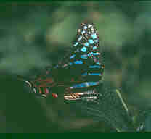A butterfly in Kaya Kinondo. The sacred forests along Kenya’s coast harbour rich biodiversity that can now be enjoyed by taking a nature walk, one of the attractions of the Kaya Kinondo pilot ecotourism project

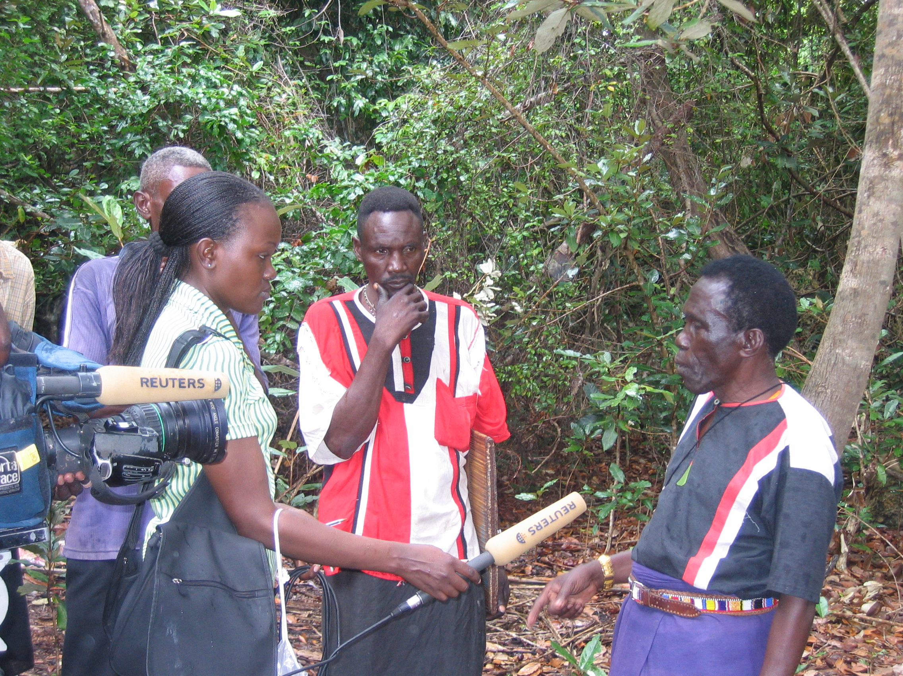
Reuters interview with Kaya Kinondo elder during filming of Africa Journal feature

6. Contact
John Salehe – WWF-EARPO EACFE Coordinator, Nairobi, Kenya.
Email: JSalehe@wwfearpo.org
Elias Kimaru, CFCU/WWF-EACFP-Kwale

P. o Box, 86, Ukunda Kenya
Tel. +254 722 344 426
E-mail: wwfkwale@yahoo.com


Traditional cultural practices are responsible for the conservation of the Kaya forests and their rich natiral resources, that science is only beginning to unravel

5. Needs
- There is a need for focused development of the project sustainability strategic plan as well as forest management plan which will encompass marketing plan among others to guide the project development.
- The capacity of Kinondo community to manage the project is still limited and need strengthening in some specific areas.
- Enhancement of site quality to improve visitor enjoyment by enhancing the standards of visitor centre currently under construction.
- Enhance sharing lessons with other similar initiatives.
3. Achievements
- Establishment of community conservation groups (Kaya Kinondo conservation and development group) for targeted awareness creation and capacity building
- Paid visits to Kaya Kinondo started and going on well. For the last two years since the visits started the community has earned more than USD. 7000. The funds are already being utilised to support community projects such has schools, cultural ceremonies, village bank, etc.
- Organisation of familiarisation visits for community members, target tour companies and hotel managers started and going on.
- Birds and small mammal species of Kinondo inventoried
- Hired and trained a community site manager
- Trained the tourism officer on various courses of ecotourism and forest management.
- Organised conservation awareness competition for schools surrounding Kaya Kinondo. More than 65 awards given out to the winners.
- Construction of a visitor centre is complete and several traditional features rehabilitated with close consultation with Kaya Elders.
- Development of ecological and cultural monitoring systems is on-going
- Community study visits regionally and locally done e.g. a visit to Zanzibar and Tanzania
- Kaya Kinondo Village bank, established and functional.
- Won an international award from WWF-Sweden for involving villagers in conservation efforts.
- Got support from CEPF to address various gaps identified so far
- Shared lessons with Taita Taveta(Kenya), Zanzibar and Pugu (Tz).

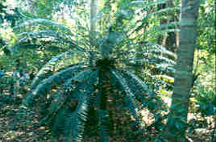
An ancient giant cycad dating a few centuries. One of the unique plants that best thrives in these sacred coastal forests.

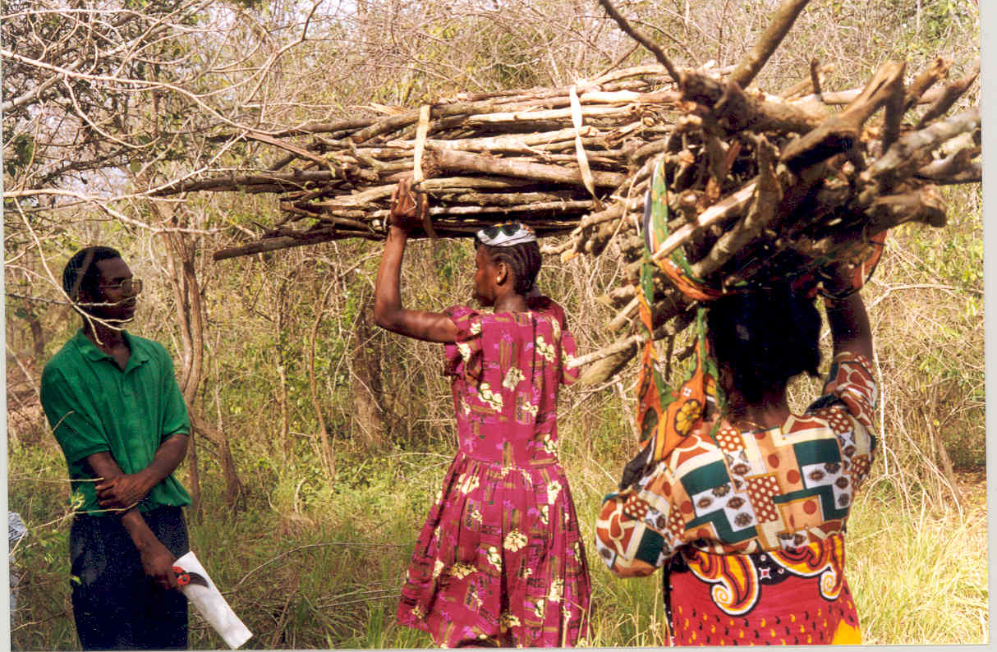The ecotourim project leader, Elias Kimaru with women.
The forests provide for numerous needs of the communities, but the growing populations and the increasing demand for land are a threat.

4. Perspectives
Conservation of Coastal forests along the eastern coast of Africa continues facing many challenges due to increased population pressure and poverty among others. The future therefore lies in developing sustainable management practises where all stakeholders are involved including community living next to the forests. Kaya Kinondo ecotourism project offer applicable lessons which could easily be integrated to other sites. Initial results indicate that the project has good community support, and that the tourism industry is responsive and interested in such ventures.

