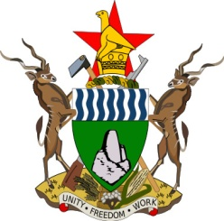
GOVERNMENT OF ZIMBABWE

HWANGE SANYATI BIODIVERSITY CORRIDOR PROJECT

INDIGENOUS PEOPLE PLANNING FRAMEWORK (IPPF)

DECEMBER 2013
ACRONYMS
HNP Hwange National Park
HSBC Hwange Sanyati Biological Corridor
IP Indigenous Peoples
IPDP Indigenous Peoples Development Plan
IPPF Indigenous Peoples Planning Framework
NGO Non-Governmental Organization

TABLE OF CONTENTS
ITEM PAGE
1.1 Introduction 4
1.2 Legal Framework 4
1.3 Purpose of the IPPF 6
2.0 Screening of IP 6
3.0 Social Assessment 6
4.0 Consultation of IP 7
5.0 Impact Identification 7
6.0 Impact Management 8
7.0 Implementation and Monitoring 9
8.0 Time Frame 10

  - INTRODUCTION
The HSBC project area is inhabited by a mix of various cultures and ethnic people. Preliminary assessment shows that the HSBC is home to the Ndebele, Nambia, Tswana, Suthu, Chewa, Tonga, Shangwe and the San Peoples. The History of the landuse in the corridor reflect that the Tonga people were displaced from the Zambezi valley to pave way for the construction of the Kariba Dam and the San people were displaced from the HNP area for the creation of the HNP. There are some NGOs that are working in the respective areas to advance the interests of the displaced people. The people displaced Tongas are now resident in Binga and are the majority in that area. The displaced San People are now clustered in the Tsholotsho district. Though they are fighting for full recognition and relevance in development processes of the country they will not be treated as Indigenous Peoples because they are the majority in Binga where CAMPHIRE subproject will be implemented. In Binga there is an active NGO called BASIWIZI, which was specifically formed to stand for the rights of these displaced ethnic group. Binga district is exposed to human wildlife conflict as it borders protected areas such as Chizarira National Park, Sijarira forest and Chete safari area. In fact the district forms a natural link between Hwange National Park and other protected areas found within the corridor.

The San People are located at the corner delimited by the Zimbabwe-Botswana border to the west, the Hwange National Park buffer zone to the southwest and the greater part of Tsholotsho to the east and south in wards 7,8 and 10. Though the immediate CAMPFIRE project area does not include the San People inhabited areas, the San People will be affected by the Human –Wildlife conflict arising from their proximity to the Hwange National Park. The San People are a minority group in Zimbabwe and do qualify for consideration under the Indigenous Peoples Policy of the World Bank. Interviews with the local district administrator, the district social welfare officer for Thsolothso and the Executive Director of the Tsoro-o-tso verified that there are San People within the Tsholotsho district. They are a distinct ethnic group that can be easily identified by colour, physical outlook, social and cultural background. They speak a unique Koisan language. Whilst the Constitution of Zimbabwe recognizes the Koisan language as one of the national languages, it is not being taught at any education institution in the country.
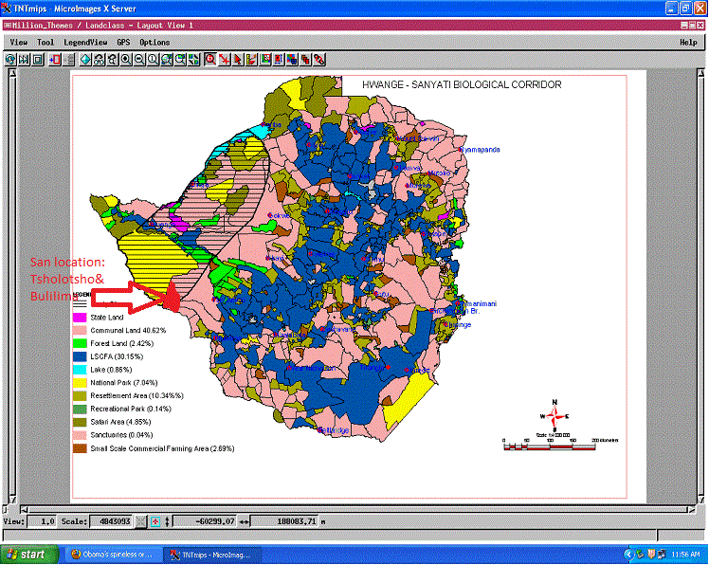
Fig 1.1 Zimbabwe Map showing San people location

1.2 LEGAL AND POLICY FRAMEWORK AFFECTING THE SAN PEOPLE
The constitution of Zimbabwe recognizes the following languages, namely Chewa, Chibarwe, English, Kalanga, Koisan, Nambya, Ndau, Ndebele, Shangani, Shona, sign language, Sotho, Tonga, Tswana, Venda and Xhosa as the officially recognised languages of Zimbabwe. The San People are therefore conferred with an equal status accorded any other Zimbabwean. The constitution also acknowledges the Government’s responsibility to develop these languages. Though the Koisan language has equal status in the constitution, the San People are a minority group. Legislation also provides for the registration of any non-governmental organizations including those that are aimed at preserving and advocating for the fair and equal opportunities for development in the San communities. At the moment, there are several NGOs working specifically in the championing of the san people affairs. These NGOs include the Tsoro-o-tso San Development Trust, Matabeleland Constitutional Reform Agenda, Creative Arts and Education Development Trust and the Habbakuk Trust. Matabeleland Constitutional Reform Agenda is working with the San on leadership development. Creative Arts and Education Development Association is working with the San on cultural and language revitalization. The Minority Voice is working on amplifying the voices on minorities in Zimbabwe (including the San) at regional and international levels.Though the San People are governed through the same representative system to the other tribes in Zimbabwe, the fact that they are a minority group makes it difficult to get to the mainstream government structures.

1.3 PURPOSE OF THE IPPF
The purpose of this IPPF is to ensure that the Ministry of Environment, Water and Climate through its implementing agencies (PWMA) identifies all the Indigenous Peoples affected by the project so that the project does not culturally, socially or economically isolate them. The IPPF will also ensure that when potentially negative effects on Indigenous Peoples are identified, they are avoided, minimized, mitigated or compensated. This IPPF can be applied to any of the HSBC subprojects as implemented by the respective agencies above though the preliminary indications are that the Parks component in the Hwange National Park and CAMPFIRE to some extent are the one that will utilize the IPPF most.

- SCREENING OF PROJECT AFFECTED INDIGENOUS PEOPLES
Through the implementation of a detailed social assessment, this IPPF shall identify Indigenous People within the particular subprojects as anyone or a group of people or formally constituted organization that exhibits any of the following characteristics;
- Self-identification as members of a distinct indigenous cultural group and recognition by others.
- Collective attachments to geographically distinct habitats or ancestral territories in the project area and to natural resources in these habitat and territories.
- Customary cultural, economic, social or political institution that is separate from those of the dominant society and culture.
- An indigenous language, often different from the official language of the country or region.
The preliminary screening shows that the San People do qualify for consideration as Indigenous Peoples. The respective subprojects (Parks and CAMPFIRE) will undertake a detailed social scan to ensure that any other groups that do qualify are not excluded.

- SOCIAL ASSESSMENT
As part of the implementation of IPPF, the Ministry will engage qualified and experienced Social Scientist (individual or corporate), to carry out a detailed social assessment where project affected Indigenous Peoples are identified. The social assessment shall include and not limited to the following aspects;
- The legal and institutional framework applicable to the Indigenous Peoples.
- Baseline information on demographics, social, cultural, economic, political characteristics of the affected Indigenous Peoples communities.
- Special consideration will be made to the land tenure and related natural resources, commercial development of natural and cultural resources and physical relocation where applicable.
The general information on the San community show that there is an attempt by the San People and the Government extension services to adapt the San people to a farming based livelihoods. There are challenges that are accompanying this endeavour. The observation is that the persistent hunter-gatherer way of life that the San are used to, is not sustainable considering that the San are restricted from hunting in the HNP and the stock of wild animals are dwindling and they cannot follow them back into the HNP. There are conflicting reports within the district on the attitudes of the San People. Some stakeholders consider the San people as uncooperative and resisting modernization while others consider them as just being conservative to their cultural heritage. The local NGOs working on the welfare on the San People allege that the San People are marginalized. It is important that the subproject considers more closely the socio-economic background of the San People. Indications on the ground also show that the San People are generally poor and need assistance in the form of food and expertise for them to undertake meaningful farming activities as an alternative to the hunter-gather way of life.

- CONSULTATION OF INDIGENOUS PEOPLES
Through this IPPF, the implementing agencies shall ensure that, in their respective subprojects, Indigenous Peoples have been consulted based on a free, prior and informed basis. The consultation process will be maintained throughout the project life. This will include the use of the appropriate consultation methods depending on the social scan. The consultation methods will include and not limited to;
- Community focus group meetings in their native language.
- Notification of the various NGOs working for the interest of the San People.
- Publications in print media in local language.
Consultations with Mr Khumbulani Maphosa, the Executive Director of Tsoro-o-tso, an active San Development Trust in Tsholotsho show that most San People do speak Ndebele language in addition to their Koisan language. It is therefore important that the subproject consultations takes into consideration the need to interpret from one language to another especially. It will be important to target to use the Koisan language or Ndebele during consultations. The community meetings are likely to be the most effective method of consultation.

- Impact identification
Where a subproject is screened and determined to be affecting the indigenous peoples, the nature and extent of adverse impacts shall be clearly identified, documented, analysed and evaluated. The impacts identification shall include and not limited to impacts on the following;
- Access to forests, water, land wildlife and other protected natural resources areas.
- Cultural and spiritual values. The project will respect the cultural values when dealing with the San. Gives examples
- Land tenure. The history of the landuse in the HNP area show that the San People were relocated from their ancestral territory to pave way for the creation of the HNP. Currently the San People are located in communal areas where the land tenure is communal owned. The project has no land use conflicts though the proximity of the San to the HNP results in human wildlife conflicts. The HSBC project aims at reducing such conflicts, a positive impact of the project.
- Livelihoods. The San People are hunter-gatherers though there is immense pressure for them to modernise and adopt sustainable farming methods. There is also some livelihoods support from NGOs working in the Tsholotsho district. Government extension services are also being deployed to ensure that the San People become effective farmers. There is however indications that the attempt for framing is hampered by the human-wildlife conflict that results in crop destruction and animal killings by lions and other predators.
- Language. The San People speak the Koisan language. Though it’s not taught in schools at the moment, the constitution recognizes it as one of the local languages. For effective communication in the subproject consultations, there is need to ensure interpretations.
- Human-wildlife conflict. The current status on this impact is that the wild animals from the HNP traverse the settled areas and affect their crops and animals. Cases of villagers losing herds of cattle were reported. The San community is also affected like any other communities in the impact zone of the HNP. The project initiatives targeting the reduction of human-wildlife conflict will target all areas in the impact zone. The major intervention on the human-wildlife conflict is the provision of adequate water in the HNP, resulting in the animals being retained within the park areas for water supply. The whole selection of the water point within the HNP therefore needs to ensure that the positive impact is felt across even the San communities. This could be achieved through consultations with the impacted areas on best locations besides the geophysical survey that are technical.

- Impact Management
In the event of presence of project affected Indigenous Peoples, the respective subproject shall compensate in a sustainable manner. The management initiatives will include and not limited to;
- Promoting inclusion of the indigenous peoples at all project phases in access to project benefits to cushion their livelihoods.
- Protection of indigenous knowledge within the Indigenous Peoples through documentation.
- Addressing gender and intergenerational issues of Indigenous People.

While the San People are present in the HSBC, they are not located in the subproject implementation area. The only project activity interacting with the San People is the Parks component. Specifically the San people will not experience any incremental adverse impact arising from the project, but will be part of the beneficiaries of the Parks’ activities to reduce human-wildlife conflict within the project area. The San People’s interaction with the Parks operation will also be catered for using the process framework that has been put together as mitigation for the involuntary restriction to the parks area. It’s important to note that the project is not generating any additional restriction to the already existing restriction.

- Implementation and Monitoring mechanism
The implementation of this IPPF will be the responsibility of the Ministry of Environment, Water and Climate through its implementing agencies and coordinated by WWF. The implementing agencies are responsible for the screening of their respective subprojects and ensure that the appropriate level of this IPPF is effectively administered. The key players in the implementation of this IPPF are;
- PWMA
- CAMPFIRE
- WWF
- Related NGOs
Each implementing agency will liaise with the networks and structures on the ground to ensure effective implementation of this IPPF. The local networks will include and not limited to the following;
- Local Traditional leaders (Chief and Village head). The local leadership will be very instrumental in making sure the local communities are mobilized for meetings and participation in the project.
- Local District Administrators. The DA’s office is instrumental in giving the overall local government blessing to the project. The DA mobilizes local government departments for screening and monitoring of any impacts that fall in the respective government departments’ jurisdictions.
- Government departments. They give technical support in subproject screening and impact identification and management.
- NGOS on the ground. The NGOs if mobilized can be used as a very effective communication vehicle to access the locals. Usually the support of the NGOs is important in the overall perception of the project by the locals.
- RDC. The RDC hosts the project in that the impact zones where people are settled belong to the RDC.
It is important to note that before implementation of the Parks component, an IPP will be formulated. The San have an equal opportunity to benefit out of the project like any other citizen. The following indicators may be useful in monitoring the extent to which the San people will benefit out of the project;
- Number of San People consulted.
- Number of San People utilization project tools for human wild life conflict.

- TIME FRAME
When the subproject activities are being implemented in the San community, the subproject will prepare and IPDP and submit to the Bank for review and approval.

